EUROPEAN COMMISSION

DG XII (CONTRACT SOE2 CT97 2020)
Science Teacher Training in an Information Society (STTIS)

Difficulties in teaching and learning with pictorial representations

Fani Stylianidou, Fiona Ormerod
and Jon Ogborn

WP2 UK National Report

UNIVERSITY OF SUSSEX
Institute of Education,
Education Development Building,
Falmer, Brighton BN1 9RG, UK
Tel: +44 1273 678039
Fax: +44 1273 678568
mailto: f.stylianidou@ioe.ac.uk,
f.ormerod@lancaster.ac.uk,
jon.ogborn@iop.org
February 2000
ABSTRACT
This report discusses the findings of the part of the ‘Science Teacher Training in an Information Society’ (STTIS) project concerned with teaching and learning from pictorial representations.
In the first part, the report discusses the possible difficulties the pupils have when ‘reading’ science textbook pictures about ‘energy’. The second part looks at whether teachers are aware of these difficulties and at how they respond to them. Six documents were selected on the basis that they had some of the textual/graphical features previously identified by the project as potentially presenting difficulties to pupils. The pupils’ readings of these were investigated using a questionnaire and a follow-up interview. The teachers’ reactions were then examined using also questionnaires. The results confirm the hypothesis that the ‘reading’ of science textbook pictures is not at all trivial for pupils and conclude that teachers are in need for training which would help them both to identify and cope better with these difficulties. The analysis also suggests that the list of textual/graphical features used in this research is a good starting point for this kind of critical examination.
CONTENTS
ABSTRACT 2

CONTENTS 2

WP2.1
ANALYSIS OF SCIENCE TEXTBOOK PICTURES AND PUPILS’ READINGS OF THEM 2

1. INTRODUCTION 2
2. DATA COLLECTION AND ANALYSIS 2
3. DOCUMENT ‘ENERGY’ 2
3.1 About the document ‘Energy’ 2
3.2 Pupils’ difficulties with the document ‘Energy’ 2
3.2.1 Selecting, highlighting or missing elements in a representation (SEL) 2
3.2.2 Mixing narrative and conceptual visual structures (CS) 2
3.2.3 Reading images through ‘theoretical lenses’ 2
3.2.4 Summary 2
4. DOCUMENT ‘HOT ON THE TRAIL’ 2
4.1 About the document ‘Hot on the trail’ 2
4.2 Pupils’ difficulties with the document ‘Hot on the Trail’ 2
4.2.1 Real world objects versus schematic or symbolic entities (R/S) 2
4.2.2 Selecting, highlighting or missing elements in a representation (SEL) 2
4.2.3 Similarity of symbols (SIM) 2
4.2.4 Integration of the reading of one or more representations (INT) 2
4.2.5 Reading verbal elements (VE) 2
4.2.6 Summary 2
5. DOCUMENT ‘MAKING FUELS GO FURTHER’ 2
5.1 About the document ‘Making fuels go further’ 2
5.2 Pupils’ difficulties with the document ‘Making fuels go further’ 2
5.2.1 Reading images through ‘theoretical lenses’ 2
5.2.2 Real-world versus schematic or symbolic entities (R/S) 2
5.2.3 Selecting, highlighting or missing elements in a representation (SEL) 2
5.2.4 Reading of compositional structures (C/S) 2
5.2.5 Similarity of symbols (SIM) 2
5.2.6 Reading verbal elements (VE) 2
5.2.7 Integration of the reading of one or more representations (INT) 2
5.2.8 Pupils’ responses to the task 2
5.2.9 Summary 2
6. DOCUMENT ‘WHAT IS ENERGY?’ 2
6.1 About the document ‘What is energy?’ 2
6.2 Pupils’ difficulties with the document ‘What is energy?’ 2
6.2.1 Reading images through ‘theoretical lenses’ 2
6.2.2 Real-world versus schematic or symbolic entities (R/S) 2
6.2.3 Selecting, highlighting or missing elements in a representation (SEL) 2
6.2.4 Similarity of symbols (SIM) 2
6.2.5 Reading verbal elements (VE) 2
6.2.6 Integration of the reading of one or more representations (INT) 2
6.2.7 Summary 2
7. DOCUMENT ‘MAKING FUELS INTO ELECTRICITY’ 2
7.1 About the document ‘Making fuels into electricity’ 2
7.2 Pupils’ difficulties with the document ‘Making fuels into electricity’ 2
7.2.1 Real-world versus schematic or symbolic entities (R/S) 2
7.2.2 Selecting, highlighting or missing elements in a representation (SEL) 2
7.2.3 Integration of the reading of one or more representations (INT) 2
7.2.4 Similarity of symbols (SIM) 2
7.2.5 Reading of compositional structures (CS) 2
7.2.6 Reading verbal elements (VE) 2
7.2.7 Summary 2
8. DOCUMENT ‘TANYA’S DAY’ 2
8.1 About the document ‘Tanya’s Day’ 2
8.2 Pupils’ difficulties with the document ‘Tanya’s Day’ 2
8.2.1 Reading of compositional structures (CS) 2
8.2.2 Selecting, highlighting and missing elements in a representation (SEL) 2
8.2.3 Reading images through ‘theoretical lenses’ 2
8.2.4 Reading verbal elements (VE) 2
8.2.5 Summary 2
9. DISCUSSION OF RESULTS 2

WP2.2
ANALYSIS OF TEACHERS’ UNDERSTANDINGS OF STUDENTS’ DIFFICULTIES IN READING SCIENCE TEXTBOOK PICTURES 2

1. INTRODUCTION 2
2. DATA COLLECTION AND ANALYSIS 2
3. DOCUMENT ‘ENERGY’ 2
3.1 Teachers predicting pupils’ difficulties with the document ‘Energy’ 2
3.2 Teachers accounting for pupils’ difficulties with the document ‘Energy’ 2
4. DOCUMENT ‘HOT ON THE TRAIL’ 2
4.1 Teachers predicting pupils’ difficulties with the document ‘Hot on the trail’ 2
4.2 Teachers accounting for pupils’ difficulties with the document ‘Hot on the trail’ 2
5. DOCUMENT ‘MAKING FUELS GO FURTHER’ 2
5.1 Teachers predicting pupils’ difficulties with the document ‘Making fuels go further’ 2
5.2 Teachers accounting for pupils’ difficulties with the document ‘Making fuels go further’ 2
6. DOCUMENT ‘WHAT IS ENERGY?’ 2
6.1 Teachers predicting pupils’ difficulties with the document ‘What is energy?’ 2
6.2 Teachers accounting for pupils’ difficulties with the document ‘What is energy? 2
7. DOCUMENT ‘MAKING FUELS INTO ELECTRICITY’ 2
7.1 Teachers predicting pupils’ difficulties with the document ‘Making fuels into electricity’ 2
7.2 Teachers accounting for pupils’ difficulties with the document ‘Making fuels into electricity’ 2
8. DOCUMENT ‘TANYA’S DAY’ 2
8.1 Teachers predicting pupils’ difficulties with the document ‘Tanya’s day’ 2
8.2 Teachers accounting for pupils’ difficulties with the document ‘Tanya’s day’ 2
9. DISCUSSION OF RESULTS 2

ACKNOWLEDGEMENTS 2

REFERENCES 2

APPENDICES | 86
APPENDIX 1: DOCUMENT ‘ENERGY’……………………………………………… | ....86
APPENDIX 2: DOCUMENT ‘HOT ON THE TRAIL’……………………….………. | ....87
APPENDIX 3: DOCUMENT ‘MAKING FUELS GO FURTHER’…………………. | ....88
APPENDIX 4: DOCUMENT ‘WHAT IS ENERGY?’.……………………….………. | ....89
APPENDIX 5: DOCUMENT ‘MAKING FUELS INTO ELECTRICITY’....………. | ....91
APPENDIX 6: DOCUMENT ‘TANYA’S DAY’………………………..…….………. | ....92
APPENDIX 7: TEACHER QUESTIONNAIRE – PREDICTING PUPILS’ DIFFICULTIES………………………………………………………… | ....94
APPENDIX 8: TEACHER QUESTIONNAIRE – ACCOUNTING FOR PUPILS’ DIFFICULTIES………………………………………………………... | ...100

WP2.1

Analysis of
science textbook pictures about ‘energy’
and pupils’ readings of them

Fani Stylianidou, University of Sussex, UK
Fiona Ormerod, University of Lancaster, UK
Jon Ogborn, University of Sussex, UK
1. Introduction
As part of the research conducted for STTIS (see STTIS 1998), we undertook to investigate the possible difficulties pupils face when reading science textbook pictures about ‘energy’.
The fact that ‘energy’ is indisputably deemed one of the most important and yet one of the most difficult topics of secondary school science made the topic an excellent candidate for a project which aims to produce findings which are valid across different countries. Secondly, although many research findings already exist on the difficulties the pupils have with the ideas involved, there have been considerably fewer studies of difficulties with representations of these ideas.
The research framework within which we operated has identified a provisional list of textual/graphical features of images which may present difficulties for students in reading and/or interpreting documents* containing images. The ones which are relevant to our investigation and which were used in the analysis of the textbook pictures are the following:
• Images requiring interpretation of the roles of elements representing both real world and schematic or symbolic entities. (R/S)
• Images whose interpretation requires certain elements to be given importance or be highlighted, often in relation to textual/graphical features which makes them salient, or do not make them salient. (SEL)
• Images containing elements which require appropriate readings of symbols, and which contain examples of synonymy, homonymy and/or polysemy of symbols. (SIM)
• Documents with images requiring verbal elements to be read as an important part of the whole, including verbal elements included within the image or used as captions. (VE)
• Documents containing more than one image requiring interpretation of relationships among the different images. (INT)
• Images which make important use of compositional structures requiring the reading of spatial distributions and different representational structures. (CS)
Our understanding for this last category is based on Kress and Van Leeuwen’s ‘Reading Images: The Grammar of Visual Design’ (1996). According to them there are two types of representational structure, the narrative and the conceptual (Fig.1):
Figure 1. Main types of visual representational structure
• the narrative representation depicts some kind of transaction between participants in a transitory relationship; it can be either naturalistic (e.g. painting of action at a particular moment) or abstract (e.g. lines indicating weather patterns on a particular day);
• the conceptual representation depicts permanent, fixed relationships and characteristics: a thing can be categorised in a given way or has given characteristics; they always exist in this relationship to each other; this too can be either naturalistic (e.g. a realistic drawing of an object which draws attention to its features) or more abstract (e.g. a diagram indicating how an electrical circuit works).
Narrative and conceptual representations may be mixed.
Moreover, the conceptual representations can be seen as being of three main kinds, namely classificational, analytical and symbolic.
• “Classificational processes relate participants to each other in terms of a ‘kind of’ relation, a taxonomy”(p81). Examples include arrangements of bottles representing the variety of products marketed under a brand name, and diagrammatic tree structures depicting the hierarchical structure of an organization.
• “Analytical processes relate participants in terms of a part-whole structure”(p89). Examples include maps, the schematic drawing of a car engine with all its parts labelled, and fashion shots.
• “Symbolic processes are about what a participant means or is”(p108). Examples include expressionist landscapes and abstract representations.
In the analysis of the textbook pictures we will be making use of these ideas and terms.
2. Data collection and analysis
Six documents containing pictures were selected from popular science textbooks about ‘energy’ on the basis that they had some of the features identified in the above list, and thus were open to the danger of creating difficulties to the pupils-readers. We also took care that these documents had different representational structures (in the sense outlined above), so that we could investigate the effects of these different structures on the meanings the pupils draw from a document.
The documents were first analysed within the above framework and a questionnaire was designed for each of them based on this analysis. It was a feature of the design that the wording and style of the six questionnaires were very similar, and where appropriate identical. They prompted the pupils to look at the relevant documents and answer questions such as:
• What do you notice first about this/these picture(s)?
• Every picture tells a story. What is the story behind this/these picture(s)?
• What do you have to do or think about to make sense of this/these picture(s)?
• What do you find difficult to make sense of in this/these picture(s)?
In addition, for three of the textbook documents, the pupils were requested to do a written task. These tasks were selected from the ones set in the corresponding textbooks for the pupils to do and required that pupils acted on their interpretations of the document(s). They included filling-in words to complete the captions of some pictures, sketching a pie chart, and drawing ‘Energy Transfer Diagrams’ for two contraptions - all based on the information provided by the pictures. The pupils had to do the tasks and then write about how the pictures had helped them or not with the activities, in the related questionnaires.
Two sets of three documents each together with their corresponding questionnaires were distributed to a total of 104 pupils – each pupil received only one set (of three documents). Twenty of these pupils were subsequently interviewed on their answers to the questionnaires. After an initial examination of the data, 24 pupils’ questionnaires (twelve from each set) were selected for thorough analysis. Interview data existed for most of the selected pupils.
3. Document ‘Energy’
3.1 About the document ‘Energy’
This document is found in the first page of the chapter on ‘Energy’ in the Nuffield (1987) science textbook for 12-year-old pupils. It consists of a picture, which covers approximately three quarters of the page and some text (see Appendix1).
The picture on its whole is very ‘busy’ and ‘crowded’ and conveys activity and movement. It can be described as consisting of many smaller images put on a continuous background, like a ‘collage’. These smaller images are the realistic drawings of eleven different means of transport. All of them appear in three-dimensional perspective, the perspective being chosen to highlight (make salient) the motion (with the exception maybe of the train). Thus, all of them give the impression to be on the move heading in different directions and mostly out of the page towards the reader. They look like vectors scattered erratically in space.
Moreover, the train in 2-D crosses the page from left to right at the middle of the page, thus splitting the picture in two parts. The upper part is smaller, lies on the right of the page, and is more ‘crowded’. The forms of transport depicted there are those of air and water. The bottom part is bigger, covers totally the bottom half of the page and is less ‘crowded’. The means of transport in it are those that travel on the ground; perhaps they are the more real ones compared to the ideal ones in the top part. The earth-water-air organisation of the elements in the picture is worth noticing in our opinion. In addition, the picture attempts to evoke the notion of depth by showing the objects increasing in size from the top to the bottom of the picture, and thus the objects in the upper part look as being further away from the reader than the ones in the bottom part. Having said this, all the objects are drawn in roughly the same amount of detail, which also suggests that they are intended to be seen as equally salient.
Without looking at the text, it is hard to guess what is the common feature all these objects have, apart from being ‘moving carriers’. The fact that they are all on the move becomes particularly salient when one attempts to make connections between the picture and the title of the chapter - ‘Energy’ - which features in big bold letters on top. The designers obviously knew that for many children energy is equated with movement and action. Watts (1983) reports that in this case, energy is identified only when there is an outward display of activity; movement of any kind is often given as a reason for energy being involved. However, how is energy involved in this observed movement of the depicted objects? The picture does not help in answering this question. It is only by looking at the text that one finds explicitly what the authors intended the pupils to think. In particular, it is the last question in the text that betrays the relevance of the picture to the title of the chapter. The text starts by explaining what ‘a technological society’ is and then with the aid of the picture attempts to define the notion of ‘technological forms of transport’. After asking the children to count the different forms of transport depicted in the picture and to think of any others not depicted, comes the question: “Can you work out what all these forms of transport need to make them go?” This question points, according to the associated teacher’s notes, to the key-idea intended to be conveyed by the document, i.e. the idea that energy is needed to ‘make things go’.
Finally, taking all these characteristics of the document into consideration, and using Kress and Van Leeuwen’s framework, we would suggest that, the picture as a whole can best be described as a naturalistic conceptual structure, in that realistic drawings are used to present information about a number of things which exist in a permanent categorical relationship to each other: they are all forms of transport and they all use energy; the intended message it seems, is conceptual.
Research questions
The research questions for this document are:
• Given the observation that the document seems to capitalise on, if not to reinforce, the fact that energy is strongly associated by children with visible motion, how do the pupils “work out what all these forms of transport need to make them go”?
• How will the pupils respond to the naturalistic conceptual structure of the document? ‘Realistic’ features (such as perspective, detail, people in action) are often associated with narrative structures, while conceptual representations often take a more abstract form. Here, a large number of representative items (as in an abstract structure) is presented ‘realistically’ in a semi-naturalistic setting (as in a narrative structure). Does this give rise to any difficulties in the reading of the document?
3.2 Pupils’ difficulties with the document ‘Energy’
Given the above research questions the categories which proved pertinent in analysing the data collected from the pupils in relation to this document are:
(i) Selecting, highlighting or missing elements in a representation (SEL);
(ii) Mixing narrative versus conceptual visual structure (CS);
(iii) Reading images through ‘theoretical lenses’.
3.2.1 Selecting, highlighting or missing elements in a representation (SEL)
Selection and highlighting
While some of the children, such as Rita, enjoy the complexity of the picture:
“It is very lively and busy and interesting to look at…, it’s quite cartoony as well so it’s nice to study all the details in it.”
others indicate that the number of elements in the small space, and lack of highlighting of specific elements, make the picture difficult to understand - it is hard for them to work out which elements are intended to carry the most meaning. Farida, for example, explains:
“The picture is quite confusing because all the cars and buses and trains and others are all muddled up. I find it quite difficult because all the pictures are in the same side on top of the other.”
This confusion is dealt with in different ways. Some children, like Farida, feel that the picture is difficult, but that it rewards close detailed observation, focusing on individual elements. She says, “It did look complicated at first but then I looked at it in detail and it was okay”.
Some point out that it is important to try to see connections between the different components; Felicity, for example, suggests “Just look at them and try to link everything up”. (The various ways in which different children attempt to do this are discussed further below.)

Missing information
The images are not simply intended to be understood as representations of modes of transport, but to carry another meaning, beyond this, about different forms of technology and related energy transfer and use. However, this meaning is not made explicit; the use of energy is only implied. Predictably, not all the children grasp the full intended meaning, as the idea of ‘transport’ overrides other possible interpretations.
Most of the children mention transport. Some focus very generally on what they see; for example, Jimmy says “This is a good picture - I thought we were talking about transport”, and Rita thinks “It’s obvious what it’s about: Transport”. Some children focus on particular aspects of the vehicles; for example, Samina notes specific body parts: “nearly all of the things have wheels on it”; and several children, such as Raymond, focus on the representation of speed: “a lot of vehicles, and they all seem to be moving fast”.
The majority do not move beyond the images of vehicles. Farida, however, appears to sense that the picture is intended to tell her more, but that it is not communicating fully its intended message. She says it is “too difficult –I don’t understand any of it”; the problem, as she sees it, is that the picture simply shows which kinds of transport we can use. “Cos there’s nothing else there”.
Only around half the children see the vehicles as a starting point for thinking about energy (a few comment on the helpfulness of the title and written paragraph in leading them in this direction). Several children realise that the picture is about energy in connection with transport, but feel confused as to what they are meant to understand, because of the lack of explicit information. Three children point out that it would be helpful if labels were provided, explaining what the things are, what they are for, and how they work, or as Louise puts it “how they work, the energy in them, how the energy works”. Left without any helpful signposts, these children have to make sense of what the picture tells them about energy by drawing on their own scientific knowledge. (Their various interpretations are outlined in the relevant section below.)
3.2.2 Mixing narrative and conceptual visual structures (CS)
The mixing of narrative and conceptual visual structures in the document ‘Energy’ may account for the different approaches that the children take in drawing meaning from the images on this page, and for some of the difficulties they encounter in trying to make sense of the visual arrangement of images.
A primarily ‘conceptual’ approach
Most of the children do appear to understand the picture primarily as a conceptual structure, representing a particular category of related things: different forms of transport, or different examples of energy use.
Two children take their analyses slightly further. Rita thinks it is about different forms of transport and how transport is developed over the years, and Felicity interprets the vertical arrangement of the vehicles as representing hierarchical sub-categories of transport types: “it goes from top to bottom in rank of the fastest to the slowest and the heights they can go”. Since the intended purpose of the picture is not to convey information about height, speed, or historical development, these interpretations may be distracting, rather than helpful.
Raymond takes a conceptual approach but expresses concern about the size and position of objects in the picture, indicating that the ‘realistic’ characteristics of the images and layout is in a way misleading, since in real-1ife these things are not all seen at once in a small space. He points out “you have to realise that this isn’t the usual size and the way they are usually placed in the city”. He is drawing attention to a contradiction between the realistic and less realistic features of this representation, which distract from the communication of conceptual meaning.
A mixed ‘narrative- conceptual’ approach
A few children appear to interpret the picture as carrying both narrative and conceptual meaning. As a whole it is seen as conceptual (about transport) but individual sections are seen as narrative (about particular events).
Yusuf interprets the bottom section of the picture as carrying narrative meaning: “people late for work, using more petrol, wasting more energy, and travelling very fast” and some of the vehicles “stuck in a traffic jam and wasting fuel”. His comments on energy seem to relate directly to the use of fuel in this particular situation. It seems that size and perspective are leading him to interpret this section as ‘new’, ‘foregrounded’ information, and thus are maybe narrowing his focus. At the same time, his criticism of the picture, “it only shows transport of traveling in road or flying, it doesn’t show people walking”, indicates a conceptual interpretation: it depicts different forms of transport, but does not, in his view, contain enough information to provide a complete picture of what transport means.
Similarly, Samina interprets the top right part of the picture as a narrative about a helicopter rescuing people and an “airplane which has just flown up in the air”. She experiences problems with some of the layout, explaining “What I find difficult is why is the rocket right next to the boat”, and expresses concern about the close proximity of electricity and water in the picture, which she knows can be dangerous. She would like the artist to have been more careful in their arrangement of components on the page. Here, the realistic characteristics of the picture are leading her inwards, to the specifics of a particular moment, rather than towards more general concepts. However, she also makes a number of general statements, pointing to commonalities between the objects depicted, indicating that they represent a category of things: types of transport. She focuses on physical structure: “nearly all of the things have wheels on it”; on how much they are used: “many people use nearly everything”; on where they are used: “in the UK” and “all around the world”; on how they are made: “people make them using technology”; and their effect on the environment: “all the things… cause a lot of pollution”. She is clearly trying to extract as much meaning as possible, both narrative and conceptual, from the images, but this does not lead her to understand the picture to be about ‘energy’.
All these responses in this section suggest that the depiction of a large number of representative ‘types’ of object, within a ‘semi-naturalistic’ setting, in this document, appears to lead to difficulties in understanding the relevance of the individual components and how these are intended to work together to convey meaning.
3.2.3 Reading images through ‘theoretical lenses’
Those children who actually comment on energy (only just over half the group) talk about it in a variety of ways, revealing different understandings. Some of these understandings are not surprising, others are less predictable.
Energy is associated (as predicted) with action and movement; energy can be fast or slow; humans use energy to walk (although this is not depicted); energy is associated with different forms of transport: vehicles contain, use and make energy; fuels are seen to provide or trigger energy; different things possess different types of energy; and fuel and energy can be wasted, through speed, or other forms of excessive use. Energy is also associated, for two pupils, with electricity; and for one, water and electricity together are associated with electrocution.
These ideas indicate that the children are approaching the document from a range of starting points, some of which may be more useful than others.
3.2.4 Summary
The children’s responses indicate that problems associated with this document seem to stem:
• firstly, from the crowded layout, lack of highlighting, and a mixture of representational modes, which lead to ambiguity of focus and conflicting narrative and conceptual interpretations; and
• secondly, from the lack of explicit verbal or visual information about energy, which leads them to miss the main message about energy altogether, or to have to rely on their own prior knowledge in trying to make sense of what it tells them about this.
4. Document ‘Hot on the trail’
4.1 About the document ‘Hot on the trail’
This is a single picture covering almost all of the top-half of the page of a science textbook (Dobson 1987a) for 13 year-old pupils. The heading “Hot on the trail” seem to imply that something is hidden and on the move and one should look hard to trace it. This ‘something’, as this section is in the chapter about ‘energy’, can be assumed to be ‘energy’. Indeed the first sentence which introduces the picture reads: ‘Tracing energy through a complicated system can be quite interesting.’ We would suggest that this sentence serves many functions:
• to remind the reader what is the entity s/he should be looking for;
• to caution the reader that the picture s/he is looking at is a complicated one;
• to tell the reader what sort of (mental) activity s/he is expected to be engaged with when reading this picture;
• to dispose the reader positively towards the suggested activity by pre-empting that s/he is going to find it ‘quite interesting’.
Let’s now look at the picture (see Appendix 2). At first sight one takes it to depict the water cycle. It is basically a narrative image (with analytic aspects) which holds the conceptual structure of a cycle. The image works on two levels: on the one hand it is a schematic/symbolic representation of a process; on the other, it represents elements within a realistic landscape. Within the landscape certain features are more ‘realistically’ depicted than others. The hill, sun, and water are presented fairly realistically but using familiar conventions (e.g. the sun is completely circular, with dotted rays coming out from it; the horizon is depicted by a straight line; the surface of the sea is indicated by lots of little wiggly lines; the fluffy clouds would look at home in a children’s story book; rain is indicated by broken vertical lines); the dam is drawn schematically, but using 3D perspective to indicate its form; the power station is represented by a simple rectangle; the pylons are quite realistically drawn; and the current flowing between them is indicated by loose, broken, flowing lines. The result is a picture which has elements of a children’s story book illustration, and elements of a more conventional scientific diagram, all mixed up together.
In the picture, a set of arrows following one another depicts a circular motion. The arrows do not actually form a closed circle and that helps one identify where is the point one should start the narrative from. There seems to be an imaginary diagonal line from the bottom left to the top right (running alongside the slope of the mountain) which splits the image in two parts. In the top part of the image the arrows refer to changes to water, whereas in the bottom part the arrows refer to energy changes. In the top part, moreover, the arrows have multiple roles: they attempt to show the physical transfer of the water from the sea to form clouds, they indicate a sequence (by linking the various stages in the process, which are described with words), and finally, in some cases they also indicate direction (rising vapour, or falling rain). The arrows in the bottom part of the image seem to serve different functions as well. Whereas the arrow connecting the dam on top of the mountain to the power station some distance below can be thought of as showing the flow of water towards the power station, it is difficult to see what the arrows, running through the power station and coming out of it represent - the electrical current? One can easily mistake them to show the flow of water downhill, especially because they run alongside some wavy lines which can be thought of as representing a river. Moreover, the arrows pointing downhill appear to show the direction of the electric current, but this is misleading.
The use of the verbal elements (words and phrases) is also similarly ambiguous. In the upper part of the picture all mentions of (forms of) energy appear in italics, whereas mentions of water appear in simple small font and object labels, such as ‘sun’, ‘sea’ and ‘power station’, in simple capital font. So, under the word ‘SUN’ which lies on top of the schematic picture of the sun one can read ‘Nuclear energy’; then one can read the word ‘radiation’ on top of the sun rays again in italics, which could imply that this is another form of energy; and then the elliptic phrase ‘Gains gravitational energy’ under the arrow showing vapour forming into water drops. This last sentence obviously refers to water and would have been better placed under the arrow showing vapour rising. The phrases in the bottom part are different. Firstly they have a different syntactic structure; they do not any more refer to changes but work as labels of the entities (real or abstract) the reader should be focusing on. So, it is not anymore ‘water evaporates’ or ‘vapour rises’ but ‘water in dam’ or ‘energy as electric current’. Secondly, two out of the three talk about energy (as opposed to the ones in the upper part which mostly refer to water) and are clearly the dominant ones as they take most of the space of this bottom part of the image; the one which refers to both water and energy is confined in the top right position. Moreover, the ‘energy’ phrases in this part talk of ‘energy of X’ or of ‘energy as X’ (‘energy of movement’ and ‘energy as electric current’) and not of ‘X energy’ (‘gravitational energy’ or ‘nuclear energy’) as before, and in this way seem to be telling the reader that the principal actor/entity to look for is ‘energy’, which is one and the same although found in different disguises.
Concerning the salience (or absence) of the various elements in the picture, we observed the following: In the picture, the dam and the power station are clearly intended to be salient. The dam, as already mentioned, appears shaded and drawn in 3D perspective, and the power station is labelled in large letters which make it stand out from the other verbal elements. However, there appears to be a fair amount of information ‘missing’ from this section of the diagram which is likely to raise a number of questions in the mind of the reader: what actually happens in the dam, and in the power station; what is the precise role of the turbine; and where exactly does the current go after it leaves the power station? Moreover, the electricity cables seem to come to an end in mid-air; there is no indication of any destination for the electric current, although superficially it looks as if the electricity might flow into the sea.
We take the aim of this picture to be to engage the pupil-reader to think about and identify the transfer of matter and energy in the depicted system. However, following the above discussion, we would suggest that the ambiguity and/or inconsistency of symbols and verbal elements in the document, in conjunction with the particular salience of the various elements in it, may encumber the attainment of this aim. Having said this, we need also to concede that some of these ambiguities may be accounted by the intention of the authors (Dobson 1987b). In particular, the distinction between movement of substance and transfer of energy seems to be acknowledged as conceptually very difficult for pupils to make, and hence as counter-productive for the teacher (and perhaps also the textbook) to make. In their own words:
“Pupils, of course, find it very difficult to distinguish the abstract notion ‘energy’ from the ‘thing’ associated with it (the moving wheel, light, steam, ‘electricity’). And they would need to learn a lot more about the ‘things’ to be able to do so. Hence it is counter-productive to be too definite about what energy ‘is’ at this stage.”
For the purpose of this research, we will not deal with the conceptual difficulty of this distinction, we will however investigate whether and how the pupils cope with the mixing of the two ideas in the document under consideration.
Research questions
The research questions for this document are:
• How does the combination of schematic and realistic representations in the document affect the meanings the pupils draw from it?
• How are the selection and highlighting of the represented elements interpreted and assessed by the pupils?
• How do the pupils deal with the ambiguity of symbols and/or verbal elements identified?
• How will the pupils extract an integrated meaning from the different elements (words, drawings, arrows) in the document?
4.2 Pupils’ difficulties with the document ‘Hot on the Trail’
Given the above research questions the categories which proved pertinent in analysing the data collected from the pupils in relation to this document are:
(i) Real world objects versus schematic or symbolic entities (R/S)
(ii) Selecting, highlighting or missing elements in a representation (SEL)
(iii) Similarity of symbols (SIM)
(iv) Integration of the reading of one or more representations (INT)
(v) Reading verbal elements (VE)
4.2.1 Real world objects versus schematic or symbolic entities (R/S)
The children seem to be drawn to those parts of the picture which seem more familiar to them. More children talk about the upper part of the diagram, involving natural elements, than the right side and lower areas, depicting modern technology. Comments on the upper part tend to be much more detailed than those on the right hand part. The lower section of the diagram appears to have been ignored by the majority; only three children mention the ‘current’ and only one of these mentions the pylons. Saira admits “all that stuff I don’t know about… I didn’t really notice it… I guess I didn’t look”. She also points out “I wouldn’t know that’s a dam”; the schematic representation does not carry any meaning for her. Ruth, too, complains “I find it difficult because the pictures are not drawn clearly”.
Taking familiar ‘real-life’ features as a starting point, the children interpret the diagram in different ways. These are outlined below.
Environmental features in relation to weather and water cycle
The children appear to focus primarily on, and draw more meaning from, the real-life depiction of familiar environmental features in this diagram. Saira, for example, sees the picture as a whole outdoor scene: “It’s a picture of a hilly area near the sea”. Most of the children see the sun and water as particularly salient. Some think the picture is about the weather, and energy in connection with the sun.
Other children interpret the diagram as simply showing a water cycle. Mahmoud, for example, says:
“I first notice that the diagram is showing a water cycle. […] I notice that the cycle starts off with the rain falling from the clouds and finishing at vapour forms into water drops. […] The story behind this picture is that water can be very useful. It tells us that water is not wasted. It shows us how water takes each step. It shows us how it gets to the sea and how it becomes water vapour again.”
This interpretation focuses on the conversion of substances, rather than on the idea of energy being ‘converted’ from one form to another.
It is also thought by some of the pupils as showing just the first part of the water cycle. Marcia, for example, thinks,
“The story behind this picture is a type of rainfall. The sun heats the sea (water) the water evaporates, the vapour rises, it then condenses in a cloud and then precipitation – meaning it rains. The rain then falls in a dam.”
Interestingly, Marcia stops at this point; she does not even attempt to understand the other representations. She explains further,
“To make sense of this picture you have to think about rainfall and you have to think of evaporation, condensation and precipitation”.
Others, on the other hand, start off interpreting the diagram in this way, but then see the other representations and realise that they need to rethink. Rajab explains, “When I see the sun and the water and some clouds there, I just…, I got a feeling…”, but “them two (the dam and power station) were unexpected for me”, they lead him to see that it is “a bit of both, rain cycle and making electricity”.
Landscape (variation in height) in relation to the lower half of the diagram
The realistic hilly landscape setting can be seen as both helpful and distracting. The idea of height is important for an understanding of some aspects of the process, but not for others. It is important in relation to water rising from the sea and the fact that it falls from the dam is crucial for an understanding of how the turbine works, but it is not at all relevant for an understanding of how electricity flows through cables. Moreover, as explained previously, the depiction of the electric cables can be misleading.
In fact, five children experience difficulty with this section: they all think the lines represent water travelling downhill to the sea. (There are other problems with this particular part of the diagram, which are dealt with in the following sections.)
In conclusion, it seems that the drawings of natural features are in general more easily accessible to the children; some children are taking more meaning from the realistic elements than from the other features; and some of the realistic features may seriously mislead the reader.
4.2.2 Selecting, highlighting or missing elements in a representation (SEL)
As discussed previously, the roles of the dam and the power station in the picture, though salient, do not seem at all obvious. Some examples of the children’s understandings of these are outlined below.

What happens in the dam?
Habiba makes sense of the water in the dam as follows: “it just goes down, so some of it is being used and dropped, some of it is just going on the floor and then it travels down to the sea”. She expresses frustration with the image: “the picture is very poor… it doesn’t explain it properly… there isn’t energy or movement; it doesn’t tell you it’s dropping down… it doesn’t say it clearly enough, that’s not right”. Another pupil thinks that the water is formed into electricity while it is in the dam, but similarly complains: “It doesn’t show how the energy is formed here, the electricity”. He further suggests that there could be “a separate picture next to it, like showing clearly how, how it goes into the dam and how it comes out again”.
What happens inside the power station; what does the turbine do?
Several children express confusion about the power station and turbine. A typical comment is: “It’s to do with the power station, I don’t actually understand that”.
Some children skip briefly over this section of the diagram, whereas others attempt to make some sense of the information. Marcia suggests that electricity somehow helps the water to move: “the electric currents help it flow”. Habiba, on the other hand, has a vague idea that the water is turned, but is very unsure about this: “I think it’s being turned by a turbine engine inside but I don’t know”; for her the turbine seems to perform some kind of magical transformation: the water is (literally) ‘turned into electricity’. For these children, water seems to be a passive substance which is acted upon in some way.
Finally, only two pupils seem to have a fairly clear understanding of what happens inside the power station. One of them Rajab describes it: “The water drives the turbine which makes electricity energy as current flowing through pylons to people’s houses”; “…making electricity with hydro-electric power”.
This part of the diagram is clearly not self-explanatory. The children are filling in the gaps in whatever way they can based on their own understandings, some more successfully than others. For some of them it is too difficult to even attempt to understand. Mahmoud concludes: “I think more information should be added to help understand”; “It should have explained more from that stage to this stage” (i.e. the dam to the power station).
What happens after the power station?
There is some confusion as to what ‘form’ the energy takes, what it does, and where it goes, when it comes out of the power station.
Marcia and Habiba seem to think that water leaves the power station, but they are not sure where it goes from there. Marcia asks, “I think it, the water goes right down, does it go down to the sea, or does it stay in? I’m not sure where it goes after that”. Habiba says “it’s been a bit built like a river… it to go down, but to go from the power station as a source of electricity”.
For Belinda and Fran water leaves the power station and goes back down to the sea. Mahmoud, on the other hand seems to think that electricity leaves the power station, and the current (or the wires containing the current –it’s not quite clear what he means) ends up in the sea: “energy as electric current goes… through the (Int: wires) …wires, into the sea” but he also says “It shows us how it gets to the sea and how it becomes water vapour again” suggesting that he may be thinking of the lines as representing both water and electric current.
Rajab, as before, is the only child who indicates some understanding of the missing elements in the final part of the process: “It goes as energy in electric, as electric current, to homes and power stations”.
Clearly this lower part of the diagram is very difficult to understand. One of the reasons could be the fact that there is no clear destination shown for the electric current. However, there are other possible reasons for the difficulties here, which are considered both in the previous and in the following sections.
In conclusion to this section, the missing information in the dam, the power station, the turbine and the destination of the electricity could all be contributing to difficulties in making sense of this part of the diagram.
4.2.3 Similarity of symbols (SIM)
Problems associated with arrows
One of the problems with this picture is that the arrows do not all mean the same thing, as discussed previously. This contributes to the difficulties, already mentioned in the previous two sections, that the pupils have in connection with the lower section of the diagram.
Similarly, the arrangement of the arrows so that they almost form a complete circle give rise to erroneous interpretations, as predicted; some children interpret the diagram as representing a cycle. Drawn to familiar environmental features (see corresponding section above) they tend to interpret the arrows as indicating movement of substance, rather than transfer of energy, and may then interpret the whole document as a diagram of the ‘water cycle’.
Problems associated with flowing lines
We also suggest that the similarity of the representation of the electric cables with this of the lower slopes of the hill - both are depicted as light, broken, flowing lines – may partly explain why some of the children (see sections above) interpret the electric current to be running downhill towards the sea. Furthermore, the fact that the lines representing the electric cables look very much like the kind of lines conventionally used to represent running water may also explain why some of the children think that they represent water flowing downhill.
4.2.4 Integration of the reading of one or more representations (INT)
In order to understand this diagram, the reader has to move through it, extracting meaning from the different elements (words, drawings, arrows) which are intended to work together to convey meaning. The reader has to decide which direction to read in and how to read relationships between components. In one of the pupil’s words, “This is not a very complicated piece but you need to (?) read it in a special way”. We have suggested that it is actually quite deceptively complex.
Problems associated with reading the diagram as a cyclical set of connected images
The arrows indicate that the pictures and words are intended to be read clockwise, from left to right and round from right to left. Some children see it as a series of ‘steps’: Fran, for example, says: “I can see the system which starts from the sea to energy as electric current. And all the steps which show it”. The idea of a cycle is helpful as a starting point, for getting a sense of direction in reading, as one of the pupils points out: “You need to read the cycle going round clockwise”; he talks about going on “a trip around the cycle”.
However, the idea of a cycle is not helpful, if adhered to too closely. Mahmoud says, “To make sense of the picture you have to see where the cycle starts off. You have to follow the arrows and read each step until you get to the end of the cycle”, but as Saira points out, a cycle has “no starting or finishing point”, so this analogy is misleading. There is a ‘finishing point’, in the sense that electricity ends up being used in all sorts of places (e.g. people’s homes), but this ‘end point’ is not represented in the picture.
Marcia, faces a different kind of problem. Having interpreted the diagram as a depiction of the ‘water cycle’, she says, “I find it difficult to make sense of why the power station and electric currents are in this picture”. The idea of a cycle restricts her interpretation.
Problems associated with integration of visual and verbal elements
Some children comment on the need to read the verbal information. Fran explains: “You read the sentence written at the top of the sheet. Then starts from the beginning then read each step and go along until you finish. Then you can see what is happening”.
However, this is not always straightforward. Habiba found the words in the area to the left of the clouds confusing: “How can it just go up, if it’s like in little drops?” Because the words ‘vapour forms into water drops’ are positioned to the left of the cloud, this suggests to her that the water is already in drops before it becomes a cloud.
Similarly, Matthew understands that the water vapour gains gravitational energy “just before water vapour goes into drops”, because the words ‘gains gravitational energy’ are positioned slightly to the left of ‘vapour forms into water drops’. He found this quite difficult to understand; he says he “had to think about what that means”.
Problems associated specifically with verbal information will be dealt with in the next section.
Problems in interpreting individual visual elements and relationships between them
The children had particular difficulties in understanding the processes represented by the pictures of the dam, the power station and the electric cables, and the arrows which link the three. These are indicated in previous sections.
4.2.5 Reading verbal elements (VE)
Difficulties in understanding particular words and phrases
In this document, the words carry a good deal of the meaning. Some children have difficulties because they do not understand particular words or phrases.
Fran says, “I find it difficult when it says ‘water in dam (still with gravitational energy)’; I don’t really get that.” Rajab too has problem with the word ‘gravitational’ and also with ‘nuclear’. He says, “The ‘nuclear energy’, ‘radiation’ and ‘water in dam (still with gravitational energy)’. Because… the word ‘nuclear’ makes me confused. The ‘water in dam’ also confuses me because I (doubt?) if the moon (drag?) the gravitational or if it’s the Earth. Another word which causes confusion is ‘turbine’”.
Marcia says, “I find it difficult to make sense of why the power station and electric currents are in this picture, although it says ‘Energy of movement in water and in turbine’”. She has written a question mark under ‘turbine’ and underlined it, indicating, we assume, that she does not understand the meaning of the word.
Difficulties arising from insufficient written information
For most children the diagram does not contain sufficient information about the process for them to fully understand the process depicted. Ruth says she found it difficult because, “there are not enough words to describe it”. The problems resulting from lack of information in general are outlined under the category SEL.
Salience of particular words
Some words (notably the title and words in italics) are mentioned or repeated by the children in their explanations.
Rajab points out that, “The title ‘Hot on the trail’ makes me think of the sun giving nuclear energy and the water gets hot by radiation.” In fact he moves beyond this, but other children may not.
When describing the picture, some children seem to focus on the words in the upper part of the diagram: Belinda says “Sun is in this picture and it is a form of energy. There are different types of energy, e.g. gravitational and nuclear”; Simon thinks, “The picture shows how water is evaporated and how it gains gravitational energy”; Fran explains, “The picture shows a system from the sea which evaporates in steps vapour rises – vapour forms gravitational energy”. That is to say that the ideas of evaporation and gravitation appear salient to these children. Interestingly, some of these words are precisely the ones identified as unfamiliar by some other children.
4.2.6 Summary
Overall, this document seems to cause substantial difficulties to the pupils.
• The presentation of schematic representations within a realistic landscape creates confusion; in addition some of the realistic features seem to mislead the reader.
• A fair amount of information is missing from several parts of the diagram and the words which refer to them are heavily loaded in meaning and content knowledge; as a result the children need to depend on their own understandings to make some sense of these parts.
• Finally, the use of arrows to represent different things and their arrangement, which implies a cyclical process, contribute further to the ambiguity and obstructs the intended reading of the document.
5. Document ‘Making fuels go further’
5.1 About the document ‘Making fuels go further’
This picture is found in the chapter on ‘Energy’, on the right page of the double-page-spread section called ‘Running out of energy’ and appears under the heading ‘Making fuels go further’ in a science textbook (Coles et al 1989) for 12-year-old pupils. It is a quite complicated picture (see Appendix 3): It spreads over more than half of the page, it includes a variety of symbolic and realistic representations and there are very few linguistic clues about how one should go about reading it. It is a conceptual picture to be worked on. All its elements are drawn schematically at eye level and front on, on a neutral flat background. They represent generic categories of entities; each is very selective about what is relevant.
There are two horizontal lines which split the picture in three parts or levels. Each level relates to the one below with the aid of thick arrows. There is a very weak narrative spanning the whole of the picture, but there are strong analytical and classificatory aspects in it. In general, one might say that from the top to the bottom one moves from the more general (whole) to the more specific (parts), or from the ‘given’ to the ‘new’. Each level seems to have a different organisation and thus different features prevail. On the first (top) level one finds the schematic pictures of an oil rig and of a crane on top of a coal mine. From these two pictures, which the reader is invited to consider as representing one thing (hence one arrow splits in three), three thick arrows lead to the pictures of a factory, a car and a house in the second level. The sentence immediately preceding the picture explains what these arrows represent. It says: “Almost all our energy goes on our homes, transport and industry”. Above each of these three pictures one can read the generic name of what they stand for, that is, ‘industry’, ‘transport’ and ‘homes’ and a percentage showing how much energy goes to each. The pictures of the first and second levels have a whole-parts relation, thus their combination is analytical descriptive. This is further testified by the fact that the percentages of the three parts add up to 100%.
Now from each of these objects-categories two examples are given vertically, one below the other in the third part/level of the picture. An arrow invites the reader to examine each category and its examples separately. Here the arrows do not show transfer of any sort, they simply link the superordinate category with its examples. A ‘kind-of’ classificational relation links the second with the third levels. All participants in the third level are distributed symmetrically across the picture space; vertically in each of the three categories one moves from the more efficient to the less efficient, and in two cases also from the larger to the smaller; horizontally, the analytic relation introduced in the second level is restated. Efficiency is implied, since next or above each of the schematic pictures showing for example a large and a small power station there is a bar chart showing how much of the energy is given off as electricity and how much as heat and sound. A large power station is thus more efficient than a small power station, a diesel engine more efficient than a petrol engine and a fluorescent light more efficient than a normal light bulb. The way the bar charts are drawn invites the reader to compare for each example how much of the energy ends up as heat compared to as other forms. It is also implicitly suggested that energy can become or is electricity, sound, heat, movement and light.
Overall, the individual components seem to be weighted equally, in terms of the amount of space taken up, although the items at the top are presented rather more substantially, with heavier shading. This could be misleading, as the most important part of the message seems to be carried by the images and figures in the lower half, and particularly below the second set of arrows. The arrows themselves are highlighted through shading and size, and clearly intended to be salient. The figures indicating the amount of energy used by industry, transport and homes are highlighted in bold; this could suggest that they are more important than the figures lower down, although we do not necessarily think this is intended. The bars showing ‘wasted’ energy are shaded, but none of the related figures are highlighted in any way.
The aims of the section in the textbook where the picture is situated are identified in the associated teacher’s guide (Coles et al 1988) by reference to the relevant National Curriculum (DFE 1995) recommendations for the teaching of energy. These latter specify that pupils should:
• explore the generation of electricity from different energy sources;
• survey national and global sources of energy;
• be introduced to the idea of energy efficiency.
We take the main aim of this picture in particular to be the last one, i.e. to introduce to the pupils the idea of energy efficiency. In order to understand the intended message, the pupils, as already said, are expected to follow the arrows and focus on the ‘new’ information at the bottom of the page, specifically the different figures associated with wastage, and to understand the comparison being made: some items are more efficient than others. In other words, they are expected to by-pass the previous upper section fairly quickly and concentrate on the lower half. We suggest that this may not be so straightforward; the particular highlighting of the upper part may distract pupils and lead them to unhelpful interpretations.
To conclude, this picture undoubtedly requires hard work from the part of the reader. It contains a mixture of representations, even knowledge representations such as bar charts; it is organised differently at different levels; in it arrows serve different functions. How will the pupils cope with all these features?
Research questions
The research questions for this document are:
• What do the pupils see as the main message of this document?
• Does the fact that the document contains a mixture of representations, from realistic to knowledge representations, such as bar charts, give rise to any difficulties in the reading of the document?
• How do the pupils extract an integrated meaning from the different representations?
• How do the existing highlighting of particular elements and the mixing of different compositional structures in the document affect the meanings the pupils draw from it?
• How do the pupils deal with the fact that the arrows are assigned different roles in different parts of the document?
5.2 Pupils’ difficulties with the document ‘Making fuels go further’
Given the above research questions the categories which proved pertinent in analysing the data collected from the pupils in relation to this document are:
(i) Reading images through ‘theoretical lenses’
(ii) Real-world versus schematic or symbolic entities (R/S)
(iii) Selecting, highlighting or missing elements in a representation (SEL)
(iv) Reading of compositional structures (CS)
(v) Similarity of symbols (SIM)
(vi) Reading verbal elements (VE)
(vii) Integration of the reading of one or more representations (INT)
We also looked at the pupils’ responses to one of the tasks set by the document. This required pupils to use the information in the pictures to sketch a pie chart to show where most of our energy is used. An analysis of these responses is included as part of the discussion of the above categories.
5.2.1 Reading images through ‘theoretical lenses’
The children’s responses indicate that they are bringing a range of ideas with them which contribute to their interpretations, but not always in a helpful way. Saira, Belinda and Habiba provide some interesting examples.
Saira says:
“The story behind this picture is the way fuels are used and where they are used. It also shows how one fuel can be used to release more than one type of energy.”
This interpretation, focusing on production of different kinds of energy, rather than the wastage of an ‘unwanted’ type of energy, may have its roots in earlier classroom work. It may be partially explained by another comment, made by the same child, indicating association of particular images with particular scientific content and showing a connection in her mind with other work that has been done in school:
“There are pictures of things I always see in science text books. I see these pictures on the sections about energy and transfer of energy.”
For Belinda the idea of energy waste is associated with what humans can do in the home to prevent wastage, rather than with how different items ‘waste’ different amounts of energy. For her the main message is
“That we use too much electricity when we could cut down instead of wasting it, by turning things off… It helps you understand why you should cut down in using things as it uses a lot of electricity.”
This information is not illustrated in the diagram; the child is clearly drawing on her own previous knowledge about fuel wastage. She does recognise that the picture is about energy efficiency, and the idea of some things being more efficient than others, and suggests: “you could cut down on using fuel and things like that by using, by compromising using different things” but her responses to the examples indicate some confusion: “I’m not sure… that you can cut down”. She understands the lower set of examples to show ‘different results’ to the examples above, but has difficulty explaining their significance. The problem seems to stem from a general focus on use rather than transfer of energy.
Belinda and Habiba both seem to be approaching the document with the idea that energy is used as well as ‘produced’ by the items in the lower half, and interpreting the ‘wanted form’ of energy in the first two pictures as representing use rather than transfer. Belinda notes “the diesel engine used like a lot more movement and in the petrol engine it only had 25% movement”; her response seems to indicate that she thinks the petrol engine is more efficient because it ‘uses’ rather than ‘produces’ less movement. When trying to understand the smaller power station Habiba says “the less electricity is used but still the more heat and sound is wasted”, and when focusing on the car she says “the less it uses, it wastes more”. She finds this confusing since she is bringing with her the understanding that using electricity on a large scale is generally more economical than on a smaller scale: “if you use large quantities, the less is wasted”. However, she finds this theory of ‘bigger is better’ more helpful in relation to the picture of the lights, explaining: “if you had a bigger house and light the whole house you’d still waste less than someone with a smaller house and like four light bulbs in the whole house”.
Belinda also interprets the examples based on the idea that one form of energy produces another:
“I think it was just showing that other things which we use in the industry and in the transport and homes, like electricity, the heat and sound that came from that, and with transport, the movement and the heat that came from the movement, and in the homes, the light and heat that came from the light, so heat was coming from the electricity, the movement and the light”.
She has the idea of a by-product form of energy and thinks it is produced out of the first (‘wanted’) form rather than simultaneously alongside it. Based on this theory she makes an interesting suggestion for an alternative pie chart, saying that she could take each line of examples separately, and add up the non-waste figures (which would actually total 100%). She explains that for the large power station, diesel and tube light “I’d have used the electricity for that, the movement for that and the light for that because the rest is like the result of them, the heat”.
5.2.2 Real-world versus schematic or symbolic entities (R/S)
This does not seem to be a major cause of difficulty, but we found two comments interesting.
For one child the schematic images at the top seem to carry more specific meaning, being associated specifically with nuclear power stations; Ruth says, “The story behind the picture is nuclear power stations and things like that”. In this case, though, the undergeneralising does not seem to adversely effect the child’s understanding of the main points.
For Belinda, the more familiar ‘realistic’ images on the lower right side seem more salient than the more schematic ones on the left. In talking about the items on the right, the house and the lightbulb, which clearly relate to use of energy in everyday life in the home, she appears much more confident than when trying to explain the information about power stations. In this case, associations with the familiar items on the right, and lack of familiarity with the items on the left, may both be contributing to her difficulties, in different ways.
5.2.3 Selecting, highlighting or missing elements in a representation (SEL)
Highlighting
As discussed earlier, in order to understand the message, the reader is expected to follow the arrows and focus on the ‘new’ information at the bottom of the page. However, this is not what the children tend to do. The children do choose to focus on specific parts of the diagram and ignore or deal very briefly with others, but interestingly, they do not all choose to focus on the same parts, and some of them appear to pay little attention to the lower set of examples.
We would suggest that the large shaded arrows may draw attention to themselves in a way which could lead to an unhelpful interpretation. For several children they are an important element which leads them to interpret the ‘story’ largely as the ‘journey’ of fuel from its source to use as different ‘forms’ of energy. For example, Matthew says, “The story behind this picture is in a sort of flow chart and shows where and how fuel is used”. Although wastage may be mentioned, for these children it seems that the ‘life’ of the fuel itself, and its ‘journey’ represented by the arrows, may be equally, if not more salient.
Some of the percentage figures are written in bold. Several children express confusion in relation to the meaning of the figures in bold. For example, in Fran’s view “The story is that everything that uses energy wastes it, i.e. industry 37%, homes 31%, transport 32% of energy wasted”. This response suggests that the child may be interpreting the figures in bold as referring to wastage. Belinda decided to use the figures in bold for her pie chart: “cos they just showed up more than the rest, cos they were the top three, they just showed up”. This may be the response intended, but the use of bold here could possibly be contributing to making the task a bit too easy to complete without very much thought.
The lack of clear highlighting of elements, especially in the lower half, may be why some children focus briefly on all sections: for them the fuels themselves, the places where they are used, the things that they are used for, and how much is used are all salient features. Ali says:
“I have noticed that it shows how we get our electricity, gas and oil, coal, for transport, homes and industry. And the use of these substances through light bulbs, cars (engine) and homes…. […] The story behind this picture is where the energy goes after extracted and the usage of the substances as well as the percentage of the usage”.
In this case there is no mention of energy efficiency. Some children mention wastage, but briefly, in passing, rather than as the main focus. For example, Mahmoud explains,
“The first thing I notice about the picture on it is that the diagram are about fuels. They are used in many things. They are important to us. It tells us how much fuel is used by different things…. Fuel is very important. By using fuel it is helpful but at the same time we waste important energy, at the same time”.
Some children focus largely on the middle and lower sections, but may not fully explain the information in the lower section. They appear to be following the arrows as expected but not moving further beyond them to the lower section. They understand that the ‘story’ is about energy wastage, things that use energy, and their varying efficiency, but they do not mention a distinction between the efficiency of specific types of things (e.g. different types of cars). For example, Simon says “The first thing I noticed about the picture is a picture story of how energy is produced, used and wasted. I noticed that it showed how the energy was used and how efficient some energy-using things are”. Habiba says, “It shows percentages of how much energy goes to different things like cars, industries and homes, it also shows how much energy is wasted”. The idea of wastage is still expressed fairly vaguely; these responses do not indicate a clear understanding of what the pictures and figures represent.
The child who appears to express the clearest understanding of what is represented on this page does not mention the fuel source at the top but moves directly to the parts below the first set of arrows, and focuses mainly on the images in the lower part of the page (the ‘new’ information). Rajab says:
“I notice certain types of industry, cars and homes. Recorded in percentages are the amount they are using for what they are supposed to do and what not, e.g. a car with diesel engine makes 60% heat which we don’t want and makes 44% movement which we want. However, it is making less of what we want than what we don’t want, so the car is inefficient. [...] Every picture tells a story about how energy is getting used up. It is saying that everything that uses energy also wastes it!! It is trying to say that efficient things use energy better and waste less. The picture tells us that most of our environment is making less of what we want than what we don’t want.”
Rajab is making a clear distinction between ‘given’ and ‘new’ information in a way that other children are not.
Missing information
Several pupils complain that they are missing information to make sense of this document, but they are mostly referring to verbal information (e.g. labelling). These difficulties are discussed under the relevant category (VE).
5.2.4 Reading of compositional structures (C/S)
The layout seems to place demands on the children; the mixing of horizontal and vertical layouts, and correspondingly of analytical and classificational structures may be responsible for some of the confusion. (This needs to be seen in combination with the use of arrows - see also section ‘similarity of symbols’ below). Marcia explains “At first it was a bit confusing (the way it is set out) but when you look at it a bit more you can understand it”.
The top-down (analytical) hierarchy in the upper part, with arrows pointing downwards between the levels, leads the reader to expect this hierarchical meaning to continue in the lower half. However, the items positioned one on top of the other at the bottom actually represent alternative possibilities (classificational structure). This is unexpected; they are not laid out side by side, as one would expect, with two diagonal arrows leading down towards them. Instead, they are arranged one on top of the other, as if in a vertical arrangement, with arrows from left to right.
This mixing of horizontal and vertical layout patterns, resulting in an unclear relationship between the main categories and subcategories, may be contributing towards difficulty in interpretation as expressed in those vague responses where the distinction between items of greater and lesser efficiency does not appear to have been fully understood.
5.2.5 Similarity of symbols (SIM)
Ali says “The arrow is difficult to read from the actual pictures”. It is not clear which arrow he is referring to, but either way the comment is not surprising, since the two sets of arrows carry slightly different meanings. The second set of arrows does not represent a clear continuation in the ‘flow’ of energy. Each of the lower arrows leads to two items one above the other, which represent a choice of possible outlets, but with only the one arrow, in combination with the hierarchical layout (see section on ‘reading of compositional structures’ above), the fact that these are alternatives is not made clear.
The following interesting comment points to the lack of clarity resulting from the problems of ‘reading of compositional structures’ and ‘similarity of symbols’. Ruth says, “The story behind the picture is nuclear power stations and things like that produces energy which then goes to three main different places industry, transport, homes. It then separates again and they are showing so much of the energy is wasted on heat and sound which is not needed”. In fact, the arrows do not ‘separate’. It seems to us that Ruth may be trying to make sense of a visual arrangement which does not communicate a very clear meaning, by applying her understanding of a form of visual representation with which she is familiar (i.e. alternative outcomes represented by separate arrows).
5.2.6 Reading verbal elements (VE)
There seem to be two problems in relation specifically to verbal information. Firstly, there seems to be a problem for some children in making connections between the words top left and the visual information and percentage figures, at the bottom. This demands a lot of effort; as Ruth says, “I notice the picture is explaining how fuel go further (guess from the title). I think it looks quite complicated and the picture does not tell me enough for me to understand it properly. Also it looks a bit boring”. The figures and bar charts may in themselves appear helpful, but without further explanation, may not always communicate their full potential meaning to the children. Ali says “The picture helps a bit by giving the percentages, but the rest it doesn’t exactly tell you what it is about”.
As indicated above (under ‘highlighting’), some children do not actually mention wastage. This may be partly due to the fact that the idea of wastage is not made explicit, verbally, in close proximity to the percentages. It seems to us that some verbal explanation in the lower half of the diagram (as well as a change in the layout – see section on ‘reading of compositional structures’) would be helpful, to indicate the difference in efficiency of the items represented.
On the other hand, some children appear to overgeneralise from the information in the paragraph and assume that all the percentages given below indicate wastage. Fran, for example, says
“I read the headline so I can see that it’s about fuels and to do with going further. I read the paragraph which is stating that everything that uses fuel also wastes it. I look at the picture, I can see percentages of amounts of energy waste. [...] The story is that everything that uses energy wastes it, i.e. industry 37%, homes 31%, transport 32% of energy wasted. Another example would be a light bulb, it uses energy to make light. It gets hot which is a waste of energy.”
Here the figures in the upper section are seen as representing waste, and the examples below as a parallel set of examples of wastage, not as representing percentages of the amounts shown above. Clearly, the interpretation of the figures needs to be seen in relation to features such as highlighting and layout (discussed in previous sections).
5.2.7 Integration of the reading of one or more representations (INT)
The relationships between images and percentages in the lower half of the page, and their relationship to the written information top left, seem to have caused particular problems. Issues discussed in the four previous sections (SEL, CS, SIM, VE) are relevant here.
5.2.8 Pupils’ responses to the task
The pie charts drawn, in response to the task the pupils were set, invite attention to some of the difficulties experienced. Although most of the children successfully divided the chart into three carefully proportioned sections and in most cases labelled these ‘industry’, ‘transport’ and ‘homes’ with corresponding percentages, erased lines indicate that for some, getting the proportions right was not all that straightforward. Also, the fact that they have used the expected figures does not mean that they have necessarily understood them, as in the case of Belinda (below). A few of the children produced or suggested fascinating, alternative responses, which appear to demonstrate serious thought and draw attention to ambiguities resulting from the way in which the information is presented on this page.
Belinda simply selected the figures that were most obvious: “cos they just showed up more than the rest, cos they were the top three, they just showed up”. She offers an interesting idea for an alternative diagram for large power station, diesel and tube light, suggesting that she might focus on each line of examples separately and select what she sees as the main form of energy: “I’d have used the electricity for that, the movement for that and the light for that because the rest is like the result of them, the heat”. In fact these figures happen to total 100%.
Marcia actually appears to have taken this approach. She has carefully limited her selection to the percentages of the ‘wanted’ types of energy in relation to the upper set of images of the lower half of the page, deciding to ignore all the others. She divided the chart into three sections: two large sections labelled 40% large power stations and 40% diesel engines, and one small section labelled 20% light. This, again, appears to be a very thoughtful response, as it looks as if she has chosen to eliminate the figures that represent unwanted energy, and focus only on those that produce the required types. However, in the interview it seems that she may not have been using this as the basis for her decision, which appears to have been guided mainly by numerical considerations. She says “I had to work out which ones… made a hundred percent”, so “I think there is only one answer there”; she explains that she did not choose ‘industry, transport, homes’ because: “that was just the overall thing and it would have been better to go in more detail”.
Ruth decided to use the chart to provide information about the percentages of each of the different types of energy that is provided in the bottom section. The chart was carefully divided into 14 sections (roughly proportioned) corresponding to each of the 14 kinds of energy presented in the lower half of the page and labelled with the 12 corresponding percentages. She considers all the many different uses of energy presented here as worthy of inclusion in the chart. She says “I thought to split these up because the large power station and the small one are different, say, you can’t really compare them in the same thing… so I decided to split them up and just use it as the percentages”. Ruth clearly put a good deal of thought into this task. In the interview, she explains how she drew a circle, split it into three parts (for each of three main areas) and then each part in two (one for each of the two things e.g. cars) and again in two so that each percentage (of each type of energy output) was represented as a quarter of the total in each third. This is a very considered response. Ruth also suggests an interesting alternative approach to this task. She suggests that you could add up the two figures e.g. ‘heat and sound’ and ‘heat and sound’ for the two power stations. This would come to 135% which she would then divide by two to give 65%, to show total (average) amount in industry going on heat and sound. The rest (35%) would go on electricity.
Ali took a completely different approach. He decided to divide the chart into six unlabelled sections, roughly one large (just under half), two medium (about a sixth each) and three small (about a twelfth each). While the sections appear to have been very carefully proportioned, it is difficult at first to work out how this decision was reached. However, it appears that the information could come from the figures written in the list, beneath the diagram, showing the expenditure of an average British family, since the proportions in the chart correspond fairly closely to the figures presented here. In fact, it appears from the interview that this is indeed what happened. Again, this indicates a very thoughtful response, in which the child has chosen to make use of information from other parts of the page.
These interpretations in themselves point to possible lack of clarity in relation to both the presentation of verbal and visual information, in the lower half of the page, and the associated task. The charts and figures represent lots of different kinds of information in a very small space, and may appear confusing. Also, it is not necessarily clear which direction they should be read in. As Matthew explains, “At first I didn’t understand where to get the information for the pie chart”, and Ali indicates that he finds the information in the list below the diagram much more easily accessible than that carried by the images and percentages within the diagram, which he explains is “not like really clear”.
5.2.9 Summary
For most children, it is the lower part of the diagram (the information concerning efficiency, represented by drawings and figures) which tends to cause problems. The children appear to be experiencing difficulty in dealing with the ‘new’ information. This suggests that there may be problems with the way in which the information here is presented.
• As indicated above, difficulties could be partly due to highlighting and relative equality in terms of representation of items selected to be depicted in different parts of the diagram, and from missing information, in relation to the images and percentages in the lower half.
• They could also be due to the mixing of horizontal and vertical layout patterns, and to the ambiguous use of arrows, which mislead and result in confusion.
• Finally, the required integration of readings of visual, verbal and numeric information puts a considerable demand on the reader, who may as a result end up relying on superficial and/or familiar associations to make sense of and interpret the document.

6. Document ‘What is energy?’
6.1 About the document ‘What is energy?’
This document appears as an introduction to the topic of ‘Energy’ in a popular science textbook (Johnson et al 1993) for 11-year-olds. It spreads over a page and a half (see Appendix 4) and contains a mixture of representational elements: ‘realistic’ drawings of everyday objects; schematic drawings; arrows; and words.
More specifically, in the top third of the left page (p34) the reader can find: some text and questions about the word ‘energy’ and its everyday use, as well as a photograph of a pop concert - the reader is prompted to look at the photograph and make a list of the energy examples s/he can find in it. The rest of the page instructs the reader about energy transfer diagrams. Three examples of these are given; in each case there is a lifelike drawing of an object, some words about the represented change, and the corresponding energy transfer diagram, which consists of verbal and symbolic information (words and arrows). All these elements are clearly intended to be read in combination. In particular, ‘energy’ itself has to be imagined in connection with the objects depicted in the drawings, and the words and arrows. In the relevant teacher’s guide (Johnson et al 1995) this point is justified as follows:
“Children often believe that ‘energy’ is possessed by people, so it is important to give them examples of objects with energy”.
However, the internal mechanisms of these objects are not depicted, which means that the children would have to draw largely on their own ‘theories’ in making sense of what they see.
In the top half of the opposite (right) page (p35), one finds similar drawings of another six contraptions; the accompanying text asks the reader to try each of these experiments and then for each to sketch a diagram of the equipment and to draw an energy transfer diagram. Here again we have a mixture of representations working together to create meaning, e.g. a small arrow near the picture of a dynamo is intended to contribute meaning it.
For readers completing the energy diagram task, it seems that the diagrams and corresponding pictures to their right on p34 are intended to be equally salient in leading to an understanding of the energy transfer processes associated with the objects depicted on the following page. When addressing the task of producing a diagram in particular, the diagrams are intended to be more salient than the pictures, in providing a possible model. However, the detail, size and position of the pictures, on the right hand side of the page, may suggest that they carry the ‘new’, more important information.
Moreover, the concept of ‘wasted energy’ (represented through words and arrows) is intended to be salient in example 2 (it is explained in writing, with the word ‘wastage’ in bold) and in example 3 (on p34), but not in example 1. The diagrams for example 2 and 3 indicate that these processes each result in two energy transfers. In contrast, example 1 indicates only one; there is no indication of any energy being transferred as sound along with movement, though this is represented in example 3. It is possible to infer, from example 3, that energy as sound would also be ‘wasted energy’ in example 1, but this is not made explicit. Perhaps this is because according to the teacher’s guide the idea that energy is always wasted should be introduced by the teacher only to more-able classes.
Some difficulties may also arise from the fact that the human body is not visually represented in the drawings of the clockwork toys, or the dynamo and the lamp, although the key and handle are intended as prompts for the energy stored in the body. The reader is expected to understand the role of this energy from the written information provided in the earlier example, and from their general knowledge.
Finally, in the document, different kinds of arrows are used for different purposes: firstly, there are small black arrow heads operating as pointers to three activities listed at the top of p35; secondly, there are three large arrows, which make up the middle section of the energy transfer process in the diagrams on p34; and finally, there is a smaller, curved arrow within the picture of the dynamo on p35, indicating the turning motion of the handle. Given the different ways in which arrows can be used symbolically, the messages they carry can often appear ambiguous, so one would expect a range of interpretations from the pupils.
Research questions
The research questions for this document are:
• Given the observation that the document seems to rely on pupils drawing on their own experiences and general knowledge in making sense of it, what are the understandings about energy that pupils display when interacting with it?
• The document contains a mixture of representational elements. How are all these read in combination?
• More particularly, the document matches abstract structures with concrete particular exemplars. How and in which direction is the relationship read by the pupils?
• Assuming one of the didactic intentions of the document to be to get pupils to learn abstract structures (energy transfer diagrams) – both their form and content – by constructing them, how do issues of salience and selection in the images depicted contribute (or not) to the accomplishment of this intention?
• How do the pupils deal with the ambiguity of the arrows in the document? How do they interpret the arrows used in the energy transfer diagrams?
• In many places in the document words are left to stand alone, that is they lack visual support. Does this present any problems to the pupils?
6.2 Pupils’ difficulties with the document ‘What is energy?’
Given the above research questions the categories which proved pertinent in analysing the data collected from the pupils in relation to this document are:
(i) Reading images through ‘theoretical lenses’
(ii) Real-world versus schematic or symbolic entities (R/S)
(iii) Selecting, highlighting or missing elements in a representation (SEL)
(iv) Similarity of symbols (SIM)
(v) Reading verbal elements (VE)
(vi) Integration of the reading of one or more representations (INT)
We also looked at the pupils’ responses to two of the tasks set by the document on p35. These required pupils to use the information on p34 about how to draw ‘Energy Transfer Diagrams’ and to draw one for a clockwork car and one for a dynamo and a lamp. An analysis of these responses is included both as part of and following the discussion of the above categories.
6.2.1 Reading images through ‘theoretical lenses’
General theories
Pupils’ responses indicate a range of understandings about the nature of energy, its production and storage.
Energy is seen as active, it has the power to get other things to happen. Jimmy notices that the objects depicted are all powered by something; Rita observes that all the objects need energy; Louise says “all the pictures show how energy works…, how energy makes things work”. Humans need energy; Farida points out that the people in the photo “probably need loads of energy to see”. She stresses the amount of energy required: “it just explains how much energy you need, I guess”.
Energy is associated with music, light and movement: Ahmed points out that energy can make light (or is light), “energy lightens up the room”, and Louise says we use musical equipment to “make music with energy”. Murad says that the car uses energy to move, and Samina explains that energy can possess movement: “when you have energy, when you eat something you get energy, so it helps you move about, cos it has movement”, but this moving energy can be blocked: “if you have something in the wires, then it stops it coming through, it doesn't work”, and if this happens, energy can also be depleted and run out: “because there’s less energy left in the batteries then, it doesn’t –it won’t really work that much with this –cos it will have no more energy”.
Energy can have many different sources and be produced in different ways. Objects can possess and provide energy. Murad understands that the objects depicted “all have or give energy”. He explains, “there are a lot of things that give energy –like (pause) humans (long pause) [unintelligible word]…and microfilm” and he points out that the torch “gives light energy”. Humans can also produce energy: Ahmed explains that the picture of the two hands is “showing how energy is made by the hand”.
Energy can be controlled. Louise explains that we control energy for our own purposes: “you make the energy work…you use the energy”; winding something up can give it energy, as Louise explains, “if you wind the back of it up it’ll just…go and then have energy in the car” and as a result, “the energy like stores up in the car”. Several children talk about energy being stored somewhere until it is needed. Some refer to this stored energy as ‘potential energy’ (they appear to have already learned this term elsewhere). They know that stored energy has the potential to be used later. For example, Ellen says, “it is stored where it’s been wound, so it’s got potential energy there” and Raymond explains that you use “potential energy in your hand to turn the handle”. More specific ideas about the storage and release of energy are outlined below.
Theories about the storage and release of energy
Some children have a view about the physical environment in which the energy is stored. For example, when talking about the clockwork car, Murad indicates that he associates energy storage with warmth: “Energy is stored in your body. Energy is stored in a warmed up place”. This suggests that the energy may need protection; it has to be kept warm. Another child, Farida, has a clear idea of where exactly it is stored: “Energy stored in a way under the spring” […] “movement energy at the top… sort of like inside the car so it moves the wheels and the car goes. I mean of the top of the wheels, you know it’s got to be something to get it going”. For her, energy is like another component part of the object which takes up physical space within it, existing and functioning in a physical relationship with other components.
Some children give the impression that certain objects automatically contain energy, indicating that it is already stored within them, available for use; they do not explain how the energy actually got there in the first place. In Felicity’s view, for example, “It’s a clockwork car…energy is already stored in it”. Mustafa explains that whatever we do to the object (such as pressing a switch or turning a handle) simply releases energy that is already there: “there’s energy inside the torch, so if you put it on then the torch lights up”; and “there’s already energy in here, so it’s a toy duck, then if you wind it up the energy’s stored in the duck, in the duck’s body, and… you remove it”. (We are interpreting this to mean that it is the winding that causes the release of the spring, since his diagram begins with ‘energy stored in the car’ as the starting point.) For him, the object contains energy and the turning causes its release.
According to Farida, the switching or turning by hand is what causes permanently stored energy to be transformed into some other form. Referring to the drawings of the clockwork car and the dynamo, she likens the process of turning the key or the handle to that of switching on the television which, in her view, causes the energy contained within the TV, or possibly in the plug, to be transformed into other kinds of energy:
“You have to do something like…yeah, you do…say for the TV you’ve got to turn it on, put in the pl…it’d probably be in a plug…turn the TV on, and that’s what like turns on, ehm, stored energy inside the TV into lights, sound, and heat”.
She goes on to explain about the picture,
“It’s a clockwork car…energy is already stored in it…because if you turned the key for the clockwork car, it should be energy in it which transforms into another sort”.
For her, the object contains energy and the turning causes its transformation.
Samina thinks of the clockwork toy as a battery operated object. She explains that you have to put the battery (or batteries) into the toy; she explains that energy is stored in the battery, and turning the key makes the battery release the stored up energy.
“The battery has all the energy stored in it, so you turn this… handle and then it starts to move because the battery makes it move, because the battery has lots of energy in it for the car to move when you turn the handle”.
She appears to be making sense of the unfamiliar object, by drawing on her knowledge of batteries, and her understanding and experience of an object such as a small radio, where you put in a battery, but also have to turn a switch to make it start. For her the object contains a battery, the battery contains the energy, and turning causes the release of energy from the battery.
These varied interpretations provide valuable insight into the children’s developing understandings about the nature of energy and the ways in which it is stored, released, and transformed. They also indicate how these understandings may be contributing to difficulties in fully grasping the intended meaning of the pictures and diagrams in this document.
6.2.2 Real-world versus schematic or symbolic entities (R/S)
As already mentioned, this document contains a mixture of representative elements, however, it seems that the children are often drawn to those representations which seem more ‘real’ to them; all the children focused on the objects that were more ‘realistically’ represented. When explaining their initial understanding of what is represented, several children do not move beyond the real-life image to talk about energy, and when addressing the energy transfer tasks it seems that they tend to take more meaning from the drawings than from the other forms of representation.
Initial responses
Some children start by focusing mainly or completely on the ‘real-life’ aspects of the familiar items depicted. The objects may simply be seen as representative of their type, or as starting points for story telling, and there may be comments on the relevance of the item in relation to their own lives.
Jimmy focuses on the real-life things depicted in the pictures on the left page, seeing them simply as representative examples of the type of event and items depicted: “one of them is a rock and roll festival and the others are objects”. Similarly, focusing on the picture of the clockwork duck Samina comments that “the duck should have some detail so we would know what kind of duck it is”, indicating that she is thinking of the image as representative of ‘duck’ rather than as representative of ‘clockwork toy’. Rita categorises some items as specifically ‘scientific’: “Some of the objects would only be used in science e.g. a Bunsen burner”.
Samina goes on to focus on three of the small pictures and creates a short narrative around each; there is no mention of energy in any of these stories; the people and their actions are what are important to her. Similarly, Yusuf selects a single picture, the picture of the balloon, and tells a narrative about it, showing how it got to be blown up and what happened to it afterwards. Although he has an understanding of the relevance of the various components of the story: the human actor, the act of blowing and running out of breath, the air being released, the balloon “flying everywhere”, this step by step narrative simply describes events without explicitly indicating the cause-effect relations underlying them; he narrates the story without explaining how ‘energy’ fits into this. For him the balloon appears to have assumed far greater importance than any of the other elements on the page, so that the events in the story are, in themselves, what really matter. It is not clear whether he is thinking about energy as a concept, or how far his story expresses understandings about energy.
Responses to energy transfer tasks
In trying to understand the energy transfer process depicted in the examples, it seems that there may be a tendency to take more information from the ‘real-life’ drawing than from other elements (words and arrows).
Taking Task 1 as an example, half of the children do not mention the role of human energy when responding to the first task (the clockwork car). One possible reason for this might be that the human body is not visually represented in the drawing of the clockwork duck, which appears to have been used as a model, in several cases. The reader is expected to understand the role of human energy in the process from the written information provided to the left of the arrow. It is not that the children have not read the written information at all; they have copied the second and third pieces of text word for word. The point is that the information about winding up and movement is perhaps more clearly embodied in the picture of the duck, as well as in the words. The human body is only represented in writing.
Focusing on Task 2, in the picture of the dynamo and the lamp, the arrow next to the handle is intended to help indicate the human action which controls the dynamo, but it does not appear to have been very useful, as fewer than half the children mention ‘body energy’ in their responses to the second task. In relation to this, in the drawing of the torch, its light is clearly depicted, but its heat is not represented visually, although both are mentioned in writing, alongside the split arrow. This may explain why all but one child mention ‘light energy’ in relation to the dynamo lamp, whereas only a few mention heat; the visual representation of light in the picture appears to be a more salient feature for the majority of children.
In conclusion to section 6.2.2, the real-life aspects of the representation seem to dominate in two ways. Firstly, the lack of reference to energy in the children’s initial responses suggests that they start by taking meaning (not necessarily to do with energy) from the ‘real-life’ image. Secondly, in responding to the two energy transfer tasks, there is a lack of reference to those ‘forms’ of energy which do not lend themselves to visual representation or are less obviously associated with the item depicted. This suggests that those meanings about energy which are hinted at visually, through the ‘real-world’ image, are more easily accessible to the children; an imbalance in the type of meaning represented through the different elements (picture, words and arrows) may restrict possible understanding.
6.2.3 Selecting, highlighting or missing elements in a representation (SEL)
In this document, the different representational elements are intended to be read in combination. In the examples, on p34, the size and detail in the drawing, and the size and shading of the arrows indicate their relevance and importance. As indicated in the previous section, it seems that the children are recognising the salience of the drawings, by selecting the ‘realistic’, ‘everyday’ objects as their starting point, but may make less use of information presented in other forms. When focusing on the realistic images, some children move on to talk about energy, but others do not, so although they are recognised as salient their intended meaning is not fully understood. The children’s responses also often indicate difficulties which arise from insufficient information in the drawings, diagrams and instructions.
Problems resulting from selection of specific images
Ahmed, focusing on the clockwork car, explains that he does not think it is a good enough example, it should be more like the model:
“I could have given a different example, a simpler one – an easier one that and kids…like I could have done for… More animal-like, so that it matches there. I put more detail under him… how it works by twisting the handles… You could use a frog…you could use lots of things… I could use a helicopter, like spinning, like spinning the blades at the top [because these are] more interesting”.
Yusuf is clearly looking for connections with his own life and interests outside school. He points out that the choice of examples is not always appropriate for the intended audience; he thinks the pictures are about ‘toys and mechanics’ but points out that “clockwork toys are useless for 12 year old people, these days people like computers”. These ‘real-life’ images divert his attention in an unhelpful way, causing him to waste time feeling frustrated by their irrelevance to his life.
Problems resulting from salience of real-life images in energy transfer tasks
As shown in section R/S above, for most of the children, the pictures seem to convey more information than the diagrams. This may simply indicate that some children find realistic pictures, in general, more easy to understand than other kinds of symbols, but could also, possibly, have to do with their size and position on the page.
Problems resulting from salience of parallel features in pictures
Before completing the energy transfer task, the children are expected to have looked at all three examples on p34, and to then use this information to explain the pictures on p35. From their responses it seems that they tend to focus on examples 1 and 2, rather than example 3, using the first two examples as models. We would suggest that this can be explained through the salience of specific features in these drawings: the key and light on p34, and the handle and bulb on p35.
The children are expected to be drawn to similarities between the two sets of pictures, and to use these parallels to understand the type of energy transfer being depicted in each case. This works fairly well for task 1 but appears to give rise to some difficulties in task 2.
Most children see the duck diagram as a good model for task 1. The pictures of the clockwork toys are very similar, with the key as a common factor linking them. Murad says, “They both have the same energy”; Mustafa says, “they’re both toys, if you wind them up their spring will move and they’ll both be the same”. This leads the children to copy the information about the spring; as Farida explains: “You had to copy this out and scribble this all –because that’s the only energy, the winding up place”. The salience of the key, foregrounded as a parallel feature, is straightforward and seems to prove helpful.
The second task is less simple. The children tend to see ‘light’ as the common factor linking the torch with the dynamo bulb, which leads some to use the torch diagram as a direct model (four have copied the information directly from example 2). Mustafa explains: “the lamp’s the same as the torch, would be the same as the torch. It would light up the room –the energy of the bulb – the energy would heat up the bulb, and the same. They’re the same”. Several children mention the battery as a common element: Murad says “they both use valves, they both use batteries –they both have the same energy –given from the battery”. Some children make a connection between the key in the clockwork duck, and the handle attached to the dynamo. The process of winding is common to each; they interpret this to be connected to the release or transformation of stored energy (see also section 6.2.1 on theories).
These individual parallels do not work very well; the duck, torch, and dynamo each function differently; in fact, none of the examples provide a perfect model for this more complex task. The salient features in each may draw attention to similarities which are misleading. Especially so, since the features which the writers intend as salient may not necessarily be those interpreted as such by the children; other features may appear to carry more meaning, and relationships may be seen between visual features, which may or may not be helpful.
Problems resulting from selected and missing information in pictures and diagrams on p34 and p35, and instructions for energy transfer tasks
Some children express difficulty in understanding the instructions, and think that further explanation would make these clearer. Murad said his problem was: “Understanding what you have to do”; Farida suggests, “I would explain more about what you had to do”.
The children’s responses indicate difficulties which appear to arise from insufficient information in the drawings and diagrams; clearly not all the necessary information is provided for a complete understanding. Farida says she found all the diagrams difficult: “These were the hardest… (Int: The diagrams?)… yes, I don’t understand them properly”. Rita explains that “some of the pictures don’t show you clearly enough what they are meant to be”; referring to the third example, she suggests “The hands could be clapping or even making something”.
Some of the children mention difficulties in understanding how things work, drawing attention to specific kinds of difficulty that they experienced in understanding the mechanisms involved in each case. Farida says that “there should be more information there…how the energy splits and how it goes together” in the diagrams. Referring to the picture of the torch, Farida explains that she does not understand “where the energies fit into…with the light, so the light –the energy of that, when the light, when you light something up and –something like that. I don’t really get it”. Ahmed, focusing on the clockwork toys, explains that there should be some indication of how the key actually works to produce energy: “I put more detail under him… how it works by twisting the handles…”. The ‘dynamo and lamp’ was particularly problematic (this is discussed in more detail below).
As mentioned earlier, only around half the children note the role of ‘energy stored in the body’ in their responses. Although a few more of them do, later in their interviews, mention the action of turning, they do not necessarily associate this with the energy being transferred from the body. (See section 6.2.1 on theories.) Yusuf expresses the need for more contextual visual information, suggesting, for example, that “there should be a person or person’s hand holding” the torch.
Several children point out that the pictures alone are not sufficient. Yusuf says “it does help a bit” but “it doesn’t give you all the information and details you need”. Jimmy says most of the pictures help a lot when you look at them without looking at the paragraph but points out that when you do read the paragraph you get a different story, on the other hand, where some pictures “don’t show nothing”, then “when you read the paragraph you might get something”. Yusuf feels that the words and pictures together are not sufficient: “they should give a bit more writing information”.
Below, we outline problems arising in two specific areas: firstly in relation to the idea of energy waste, and secondly to the process involved in the dynamo and lamp.
‘Wasted energy’
In their responses, some children mention ‘heat energy’ in relation to the dynamo and lamp, indicating that they may well have paid attention to the written information in example 2, and may have connected the ideas of energy as light and energy as heat. However, no-one mentions energy as sound in relation to the clockwork toy; they have not applied the information in example 3 to the drawing of the clockwork toy. One child, Felicity explains in her interview that the clockwork duck produces sound: “It may quack and there makes another sort, makes sound”, but she does not mention this in her written response to task 1.
It seems that the children have not necessarily understood the concept of ‘wastage’, or considered that this may take other forms, as this information is not made explicitly in relation to the other diagrams. They have not generalised from the single example, not recognised fully its potential meaning.
The dynamo and lamp
The dynamo and lamp task seemed to cause the greatest difficulty. In order to complete this task, the children need to be familiar with dynamos and have some understanding of how one works since the internal mechanism of the dynamo is not depicted. (This is also suggested in the teaching notes of the unit.) The responses to this task suggest that for most children the dynamo is indeed unfamiliar and thus absence of information about it and about how it works makes the task difficult. As Ahmed says “It doesn’t say anything really much like…some people probably would not even know which one is the dynamo”. He is quite right: another child, Mustafa, indicates that he does not understand what is being represented in this picture: “there is a bulb on a piece of wood and something on it which I don’t know”. Samina mentions difficulty to do with understanding the purpose of the object. She says of the dynamo and lamp: “I don’t understand what this is used for really…why you need it”; “I would add more detail what does…what are they used for…here” (i.e. with the activity).
The children address the task in a variety of ways. As in the ‘clockwork car’ task, only five children mention energy being transferred from the body, or the spinning movement, as the starting point. Of these, only four see either as necessary for getting the dynamo to work. One mentions ‘human energy’ but does not mention the dynamo. Most of the others see the ‘energy stored in the battery’ as the starting point (four copy all the info directly from example 2 in p34). Ahmed understands there to be two batteries: “it shows the two batteries there with one lamp, and a dynamo just there”. Jimmy refers to ‘energy stored in the bottle’ and ‘energy in the wound-up spring’. Ellen believes the energy is stored in the dynamo:
“as it goes round, the energy from when you wind it up is stored in it, and then the energy from the dynamo lights up the room and heats up the bulb”
but she does not mention a battery or magnetic poles. Samina concludes: “There are many answers, but I don’t really know”.
Farida and Ahmed seem to have a fairly clear understanding of what happens. Farida has copied the information from both example 1 and example 2: ‘energy stored in your body’ followed by double ended arrow, leading to ‘energy lighting up the room’ and ‘energy heating up the bulb’, but in her interview she also explains that she thinks a battery is important. Farida:
“It’s energy stored inside the battery and if say the energy of a wind up thing, if you sort of wind it up then it could get that en…the battery, energy going through…cause you are heating it up and should create electricity so it goes into making the light work”.
Ahmed says:
“I understood…spin inside it…for the lamp, a thing you twist to make it work […] You have to make it work. You have to do it. That’s how it works: like you twist it –that’s different- it’s like rubbing your hands but different –you have to spin it first […] moving that so it works, then it lights - makes the bulb light up”.
He understands the light to be operated by a combination of the handle, dynamo and two batteries: “it shows the power - where the handle goes - it shows the two batteries there with one lamp, and a dynamo just there”.
From these varied responses it is clear that the children are trying to fill-in the gaps in the picture of the dynamo and lamp by making sense of what they see in whatever way they can, with reference to other familiar objects, and the other diagrams and pictures provided.
6.2.4 Similarity of symbols (SIM)
Problems arising in connection with the arrow in the drawing of the dynamo
In the picture of the dynamo and the lamp, the arrow to the left of the handle appears to be intended to represent the direction of the turning motion of the hand, and through this, to indicate energy transferred from the body to control the dynamo. Only one child, Louise, mentioned this arrow; she interprets it as serving the same purpose as the small black arrowheads on p34, suggesting that it draws her attention to the relevance of the handle, in relation to task 2:
“I’ve seen the arrow pointing to the winding thing to make energy go through the wires, and to light up the bulb…and I thought well, I’ll write about that, cos –I know how it’s set up and I know how it works, for that arrow”.
For her this arrow is particularly salient, but not for the reason presumably intended by the writer.
Problems arising in connection with the arrow in example 1
This arrow is seen as carrying different meanings. It is interpreted as representing what happens in the middle part of the process: Raymond says:
“You need to start at the [.] and finish at the end, but in-between the arrow is the action that you’re doing”; “The middle one is the action of what’s happening which is the energy in the car, which is stored, is not released, so that it can move”.
It is seen as representing the energy that is being produced: Samina explains that it is there “to show what they do, what kind of energy they give out”, Ahmed says “they’re the energy”. It is seen as representing direction and location of energy: Ellen says: “It shows where it goes to […] the arrow is, it’s what the energy goes…what it does, kind of”. It is also seen as indicating the result of a transformation: Farida says: “The arrow shows what it turns into”. It is not considered particularly relevant by one child, Louise, who explains: “I just drawed it the way…the quick way –I didn’t really think of the arrow”.
Problems arising in connection with the split arrows in example 2
The split arrow is interpreted in slightly different ways.
It is seen as representing the division of energy: Farida says: “They’re to show the two ways that energy splits”; it indicates two different end products with two different functions: Ellen says: “They go to two different things, they don’t just do one thing”. Also Farida says: “It’s two different things, it transforms into two different things”; and then goes on to explain: “the energy splits into two ways, and you have the light bulb and then you wind it up” […] “The energy goes into the light bulbs and in lighting up something”.
Others describe it, less rigidly perhaps, as representing alternative outcomes: Raymond says “there is two possible things at the end”, and Louise says, “the energy could work in two ways”. Ahmed explains, “this is saying about lighting the room, and this is saying energy is heating up the bulb”; in relation to the task itself, he thinks it provides two different answers, he sees its purpose to be: “to give you two different means (Int: two different meanings?) sort of answers”.
The different thickness of the two sections of the split arrow are also explained in different ways. In Raymond’s view, they are seen as representing the sequence of the release of energy. Referring to the thicker, lower section of the arrow, he says:
“that’s the one that would usually happen a bit before, probably”; “They both happen after you’ve done the middle one, but that one would happen before the other”.
Mustafa’s interpretation is similar, but he sees a specific cause and effect relationship: heat leads to light. Mustafa:
“the energy heats up the bulb so it will light up...” “if there’s energy in here, if you turn it on, the energy will heat up the bulb, the bulb will turn it on, and it will light the room” “it shows…it does two things…it lights up the room… and the energy heats up the bulb so it lights up the room”.
Several children understand the size of the split arrows to represent the relative amount of each energy transfer. Samina says “this one has more energy than that”; Farida says, “One’s got more energy than the other, I think”… “that’s a bit less energy –to heat the bulb up it takes more energy, doesn’t it?” Ellen’s comment also seems to hint at the idea of wastage, although this is not mentioned explicitly: “Because it’s more energy that heats up the bulb than actually lights up the room”.
6.2.5 Reading verbal elements (VE)
Problems with specific verbal elements
Three verbal elements may be seen as problematic, one due to ambiguity of reference, and the others to a lack of visual support.
Ambiguity of reference
‘This is an Energy Transfer Diagram.’
In order to complete the ‘energy transfer diagrams’, the children need firstly to have worked out what an ‘energy transfer diagram’ is, by noticing the written information below example 1. They are expected to generalise from this, so as to realise that the examples below it are also energy transfer diagrams. Mustafa points to the first example as illustrating “how energy is transferred”; it is not clear whether he means only this diagram.
Although most of the children have managed to work out roughly what is expected, one child, Jimmy, has simply drawn a picture of a car with the key shaded and labelled ‘CLOCKWORK KEY’ (with an arrow pointing from the label to the key). He has described a relevant part of the object, but does not explain transfer at all. His idea of an ‘energy transfer diagram’ appears to be different from what is expected. His ‘diagram’ is rather like the drawings on the right, in the three examples, suggesting that he may have understood the pictures themselves to be ‘energy transfer diagrams’, rather than the diagrams to their left (although there are no labels attached in the pictures). Unfortunately there is no interview data on this child, to shed light on his reasoning here.
Another child, Samina, explained the process as follows: ‘energy stored in the battery’, followed by an arrow, then ‘when you turn the clockwise key the wheels of the car moves’, followed by a drawing of a clockwork car. She appears to have partly understood the idea of a ‘transfer diagram’, as to some extent her response follows the layout of the information in the examples, including the arrow and the picture.
These two responses suggest that there may be some ambiguity in what is being communicated by the words ‘Energy Transfer Diagram’.
Lack of visual support
‘Energy stored in your body’
In order to fully understand the process illustrated in the first example (p34), the reader is expected to understand the role of energy stored in the body in the process of energy transfer from the corresponding written information, since the human body is not visually represented in the picture.
The children who provide the most successful responses to the ‘clockwork car’ task appear to have read the written information ‘energy stored in your body’ in the example and made a connection between this and the later drawing (they tend to use identical words). However, (as has already been mentioned) only half of the children have made this connection; of the other children, most mention ‘energy stored in the car’ and then ‘energy of the wound-up spring’ and ‘movement energy of the toy’, again tending to use almost identical wording to that in the second and third part of example 1.
This suggests that in the first example, the written information and the picture work together only so far in enabling the children to understand what is happening; there is an imbalance between the visual and the verbal: the visual image only provides clues relating to 2/3 of the written information (the key for winding up and the toy itself) and this may hinder understanding.
‘Energy heating up the bulb’
Again, the problem here is that the words are left to stand alone. In example 2, whereas energy as light is represented visually and verbally, energy as heat is only represented in writing. In response to task 2, all but one child mention ‘light energy’ whereas only a few mention heat, which (as has been pointed out in earlier sections) seems to point to the salience of the visual image over the written information in the drawings of the torch and dynamo lamp, for the majority of children.
6.2.6 Integration of the reading of one or more representations (INT)
The children are expected to notice relationships between verbal and visual information in the diagrams and accompanying pictures in order for them to understand the energy process in each case. They are also expected to be drawn to similarities between the pictures in the examples on p34 and those in the task on p35, and to make use of these common features in working out what kinds of processes are involved in the second set of drawings. However, this is not always straightforward.
Shared features across one set of drawings and diagrams may lead to inappropriate connections being made across another set.
As already noted (in section 6.2.3.) the pictures of the clockwork toys are very similar, with the key as a common factor linking them, so most children see the duck diagram as a good model for task 1. Similarly, ‘light’ is a common factor linking the torch with the dynamo bulb, which leads some children to use the torch diagram as a model for task 2 (four pupils have copied the information directly from example 2). However, while the direct parallel works well for the first task, it does not work well for the second, because the torch and dynamo each function differently. In fact, none of the examples provide a perfect model for this more complex task. The similarities between the two drawings in task 1 may therefore, perhaps, be a little misleading, as some children then try to use the same technique in response to task 2, when in fact this task is much less straightforward; none of the examples provide a perfect model - the task is much more complex. The one to one ‘model’ relationship has been overgeneralised to a task which demands a different approach.
It is important though to bear in mind that the children’s responses in this case could have something to do with the nature of the research task in which they are asked to focus only on the first and last of the six drawings on p35; if they had been dealing with all the pictures, in the sequence set out in the book, rather than moving directly from first to last, their responses to the last one may well have been different. The second example would have provided a satisfactory model for the second drawing, and the third example would have helped with the fifth; by the time they reached the sixth drawing they would have had more time to think around the task and may have found it easier.
Related features in one example may not be transferred to other examples, where this would be useful (This has also been mentioned in section 6.2.3).
Example 2 indicates that light and heat are produced simultaneously. Example 1 focuses only on one energy transfer; there is no indication of energy as sound being produced along with movement, although this is represented in example 3. Clearly, the idea of ‘wasted’ energy is intended to be salient in example 2 (it is explained in writing, with the word ‘wastage’ in bold) and in example 3, but not in example 1. This may account for why some children mention ‘heat energy’ in relation to the dynamo lamp, but no-one mentions ‘sound energy’ in relation to the clockwork toy. They may have grasped the idea of heat and light being connected, but have not necessarily understood the concept of ‘wastage’, or considered that this may be relevant to other transfers; no-one has applied the information in example 3 to the drawing of the clockwork toy. This may suggest undergeneralisation beyond the specific example of the relationship between sound and movement.
Related features in an example diagram and accompanying picture may not be transferred to child’s diagrams
In example 1, the image of the key and the words ‘energy stored in your body’ are intended to be connected, as are the image of light and the words ‘energy lighting up the room’ and ‘energy heating up the bulb’ in example 2. These connections would be worth including in the new transfer diagrams. However, as we have already seen, this does not always happen. Energy from the body and energy as heat are often missed out in the children’s diagrammatic responses. This suggests that they may not be recognising or fully understanding the relationship intended between these visual and verbal elements; they may be undergeneralising the connection represented.
Related features in an example diagram and accompanying picture may be transferred inappropriately to a child’s diagram
In example 2 the image of the torchlight is intended to be linked to the words ‘energy stored in the battery’. In contrast, in the dynamo and lamp diagram this is not appropriate, since the dynamo does not transfer energy in the same way as a torch battery; in the dynamo the energy needs to come initially from the human movement. It seems that the image of the light is linked with the battery beyond the context of the torch, in the minds of some of the children, who transfer the verbal component word-for-word in their responses to task 2. This suggests that a focus on a specific visual - verbal relationship in one diagram may lead to overgeneralisation in understanding how other objects operate.
6.2.7 Summary
The children’s responses indicate that problems associated with this document seem to stem from a number of reasons:
• The imbalance in the types of meanings about energy provided through the different representations (‘real-life’ pictures, words and diagrams) seem often to restrict possible learning. We observed that the meanings about energy which are hinted at visually, through the ‘real-world’ images, are more easily accessible to children and seem to dominate their interpretations of the document.
- As a result, the selection and highlighting of these images in the energy transfer examples distract from the intended focus and undermine the learning of the energy transfer diagrams.
- This learning becomes further problematic since the document attempts to achieve it through both an inconsistent and ambiguous use of arrows, and an inadequate use of verbal information.
• Pupils’ difficulties however derive mainly from the integration of more than one representation. Recognising and understanding relationships between the different kinds of representations, as well as deciding where and to what extent it is possible or appropriate to make generalisations across examples are not always straightforward acts, particularly where the reader is unfamiliar with the objects presented.
• In particular, the children’s responses to the energy transfer tasks suggest a fairly strict adherence, where possible, to a single example which offers the best apparent parallel, based mainly on similarity of visual features in the pictures, but also to some extent on verbal information in the diagrams. These individual parallels, however, may not work well since the salient features in each may draw attention to similarities which are misleading, rather than helpful.
7. Document ‘Making fuels into electricity’
7.1 About the document ‘Making fuels into electricity’
This document is found in the chapter on ‘Energy’, on the right page of the double-page-spread section called ‘Which fuel should I use’ in the same science textbook for 12-year-old pupils (Coles et al 1989) as the document ‘Making fuels go further’ examined in section 5.
We suggest that the document (see Appendix 5) combines a narrative structure with a conceptual one. A series of images, some depicted realistically and some only schematically, are arranged across the page and linked using lines and arrows; they are meant to give an account of how fuels can be ‘made into’ electricity for our homes and factories. Among them the images at the top, drawn in diagrammatic form, are intended to represent the internal organisation of the different parts of a power station.
In more detail, the fuels on the left of the image (the coal in particular) are represented quite ‘realistically’ and are also labelled. Predictably, these drawings should cause fewer problems. However, the other images are depicted in schematic form, are linked symbolically using parallel lines and arrows, and are only partially labelled. It is these later images that are expected to cause more problems, particularly the analytical images at the top which are intended to represent the different parts of a power station. These are drawn in a ‘map’ like form and their internal structure is not very clear; it is unclear whether they are intended to represent a view from above or from the side. For example, the wires appear to travel through the air to the pylon, but then underground to the factory - are they represented as being seen from above, below, or from the side? Moreover, the roles of the component parts in relation to electricity production are not made clear; they simply show that something travels through wires or pipes but not what happens to it when it is inside them. The reader has to work out for him/herself what kind of objects are being represented, what happens in each place, and how these processes are connected.
In addition, none of the objects on the lower right are labelled. The homes and factories are fairly ‘realistic’, in that they are presented in ‘3D’ perspective, using standard graphic conventions, but the other constructions are more schematic, and less easily recognisable.
Overall, the diagram is quite complex. Different means are used to make connections between the various representations in the different parts of the diagram. Arrows are used to symbolise movement and direction; they lead from the three pictures of different fuels (dotted lines make it unclear where exactly they begin) and converge as they approach the furnace. Single lines link words to components of a picture in a referential relationship. Finally, parallel lines are used to represent wires and pipes carrying fuel and electricity; these run through the diagram, linking the different components of the diagram at the top and on the right. These lines therefore carry different types of meaning: they represent actual physical parts (pipes and wires), but also represent relationships between the parts of the diagram, and directionality.
Research questions
The research questions for this document are:
• The image requires both interpretation and reading off new information. How do pupils’ readings balance ‘import’ and ‘export’ of knowledge?
• The document contains a mixture of representations, from realistic to analytical schematic representations. Does this give rise to any difficulties in the reading of the document?
• How do the pupils extract an integrated meaning from the different representations?
• How do the existing highlighting of particular elements and the mixing of different compositional structures in the document affect the meanings the pupils draw from it?
• How do the pupils deal with the ambiguity of symbols identified in the above analysis of the document?
7.2 Pupils’ difficulties with the document ‘Making fuels into electricity’
Given the above research questions the categories which proved pertinent in analysing the data collected from the pupils in relation to this document are:
(i) Real-world versus schematic or symbolic entities (R/S)
(ii) Selecting, highlighting or missing elements in a representation (SEL)
(iii) Integration of the reading of one or more representations (INT)
(iv) Similarity of symbols (SIM)
(v) Reading of compositional structures (CS)
and, to some extent,
(vi) Reading verbal elements (VE)
7.2.1 Real-world versus schematic or symbolic entities (R/S)
The fuels on the left (the coal in particular) are represented quite ‘realistically’ and are also labelled. Predictably, these drawings cause few problems. However, the other images are depicted in schematic form, are linked symbolically using parallel lines and arrows, and are only partially labelled. It is these later images that cause more problems (see section SEL).
In order to draw meaning from the document some children focus mainly on those sections which contain the more realistic images: the coal and the houses. The realism of these elements makes them stand out as meaningful. Jimmy, for example, says, “I thought we were talking about pollution and future house”. For Rita:
“The story behind the picture is how many fuels are made into the electricity we use every day. It shows you how coal, barrels of oil and fuel rods go through the process of being made into electricity”.
Samina explains:
“The heat exchanger heats up the coal so it makes it steamy hot and then it goes to the place where the hot coal gets cooled down. The picture of the house where the person who lives in the house turns the switch on the fuel that has been turned into electricity has given energy for the light to go on in the house”.
Ellen mentions ‘oil’, ‘processes’, ‘wires’ and ‘houses’, but the ‘processes’ are not explained. One child, Murad, encapsulates his general understanding very briefly: “you start with two or more fuels and end with electricity”; he points out that the picture also shows where and how the electricity is made, but does not expand on this.
Some children use their understanding of familiar items as a way-in to figuring out the meaning of the rest of the diagram. Farida says “I don’t really understand the picture”, but she recognises the fuels, links these with the idea of electricity, and thinks the buildings may be factories as “the only way you can make energy is in the factory”.
Some take their information primarily from the written text, copying the information in the title, or top left. For example, Felicity says: “It’s showing you how fuels are made into electricity” and Louise says “the story behind each picture is forming electricity from fuels”.
These interpretations may be limited, or may miss the main point, as they are based on the understanding of immediately recognisable visual and verbal elements; the children may be ignoring or skipping across those elements which appear less meaningful.
7.2.2 Selecting, highlighting or missing elements in a representation (SEL)
Many of the children’s responses point to the fact that some of the information they need is not represented. Ahmed explains that in order to make sense of the picture “You have to understand the pictures and where it goes, the energy resources and what it does in a part of the energy place, and how it is moved”. He voices what appears to be a common problem: “I find it hard to make sense what each place does to the energy it gets”.
The images at the top are drawn in a ‘map’ like form and are only partially labelled. We imagine that they are intended to represent different components of a power station, but this is not stated. Their internal structure is not very clear; it is unclear whether they are intended to represent a view from above or from the side. Ahmed sees it as “an above viewed picture which shows the inside of the building, and some words to show what’s inside it”. Moreover, the roles of the component parts in relation to electricity production are not made clear; the reader has to work out for themselves what kind of objects are being represented, what happens in each place, and how these processes are connected. As a result, the children offer different interpretations about what is happening in the furnace, the pump, the heat exchanger, the turbine and the generator (see also section CS).
In addition, none of the objects on the lower right are labelled. The homes and factories are fairly ‘realistic’, in that they are presented in ‘3D’ perspective, using standard graphic conventions, but the other constructions are more schematic, and less easily recognisable. Not surprisingly, some of the children express difficulty with the schematic representations. To start with, they do not always understand what kind of object is being represented. Rita says, “the buildings aren’t very obvious or what they are”; “all the different parts of the picture aren’t very well drawn because you can’t see what they are supposed to be”. Similarly, Mustafa says “I find that the pictures are not clear enough to look at”; “the pictures are not properly drawn so it doesn’t help you a lot”. The rectangular objects on the right caused particular problems. Felicity asks “What’s the rectangle with three swirly things on top?”, and Ellen says “the generator goes into something, I don’t know what it is”. Pointing to these and to the pylons, Samina says “I don’t know what these things are”. Felicity recognises the ‘power stations’ from seeing buildings which looked like these when she was travelling to her friend’s house.
Even where it is clear, or possible to work out, what the object itself is meant to be, its function may still be unclear. Samina, for example, pointing to the generator, says, “I don’t understand what it does here” and again, referring to one of the buildings below, “It’s just a factory, but you don’t know what this factory does”. Farida concludes that the processes would be better explained by “doing a proper picture”, and Ellen suggests there could be “more words explaining what is happening”.
7.2.3 Integration of the reading of one or more representations (INT)
The diagram is quite complex. Different means are used to make connections between the various representations in the different parts of the diagram. Arrows are used to symbolise movement and direction; they lead from the three pictures of different fuels (dotted lines make it unclear where exactly they begin) and converge as they approach the furnace. Parallel lines are used to represent wires and pipes carrying fuel and electricity; these run through the diagram, linking the different components at the top and on the right. Single lines link words to components of picture in a referential relationship.
Several children experience difficulty in trying to extract information from the diagram as a whole; they seem to find the whole thing rather overwhelming. It is large, complicated and difficult to understand; it demands a good deal of effort. Raymond says “It looks confused”; Ellen says “The picture seems squashed up and complicated”; Jimmy thinks that “The picture is too small…” and suggests “Make it bigger because the picture is quite tiny”. Rita thinks the complexity of the page could be off-putting: “The picture is very big and complicated, which isn’t very good because you might not even bother to try and understand what the picture is about”. Despite this, though, some of the children find ways of coping with it. Ellen says, “You have to study the picture first to be able to understand what’s happening in it”. Felicity thinks “It looks pretty complicated but makes sense if you look at it in detail”; “You have to look at the picture carefully to find out what it’s trying to tell you. Then link them up”.
Some children appear to be experiencing difficulty understanding the bottom–top, left–right, top–bottom arrangement of items as representation of a process (see section CS). A way in which they often try to make sense of what is being represented, is by making connections with other kinds of texts that they have come across. Murad, for example, likens it to a circuit: “It looks like a process of electricity except it doesn’t come back after it is used”. This may or may not be helpful in leading them to an understanding of the diagram. Ahmed sees it as a kind of map: “an above viewed picture which shows the inside of the building, and some words to show what’s inside it”; the wires are read like roads on a map, ‘going’ to different places:
“it goes into a turbine room which then goes into the generator where it is turned into electricity and goes through the wires then goes into the factories and then to people’s houses and then to offices”.
It seems that he is reading the items on the right side (the different buildings) as a sequence (same as in the middle section of the diagram), like roads that appear one after the other on a journey, rather than as three simultaneous possibilities.
Some pupils find particular problematic integrating the reading of the realistic pictures of the fuels with the abstract arrows pointing to the schematic pictures of the power station. Farida for example, seems to start off by reading the arrows the opposite way to the way the author intended them to be read: “what I notice about this picture is a sort of factory which makes coal or barrels of oil or fuel rods” – for her the arrows are pointing back to where the materials come from, rather than where they are going next. From this starting point it is difficult to work out what she means by: “Each picture shows its own way to become electricity”, which seems to suggest that she is now understanding the arrows to indicate the start of three separate routes through the system, ending in the three buildings at the end. Murad also expresses difficulties with this combination of representations:
“At the beginning I thought you use three different fuels to make electricity. But when I looked at it carefully - the first two pictures – [it] says coal or barrels of oil. I found it quite difficult to understand this first bit of the diagram”.
The fact that the arrows pointing from the fuels to the furnace, while converging, remain separate may add to the ambiguity.
7.2.4 Similarity of symbols (SIM)
Various means are used to make connections between the different parts of the diagram.
Firstly, single lines link words to images in a referential relationship; this is a convention which does not appear to cause any problems. Secondly, arrows are used to symbolise both movement and direction; they lead from the three pictures of different fuels (dotted lines make it unclear where exactly they begin) and converge as they approach the furnace. Most children interpret the arrows as they are intended; however, Farida and Murad, as discussed in the previous section (INT), appear not to. She seems to understand the arrows to be pointing to the origin of the fuels, rather than their destination, and he seems initially to read them as working all three in conjunction, adding up the three fuels, rather than independently, pertaining to alternative kinds of fuels.
Thirdly, the images are linked with parallel lines which appear to represent pipes and wires. The pipes therefore carry different types of meaning: they represent actual physical components; they also represent relationships between components, and directionality. Raymond sees the lines as representing a journey: “It shows how the electricity is moving around all the buildings and eventually gets to your home and how it travels there”; he says he knows this because “they’re joined up”. Similarly, Ellen says the fuel ‘goes through’ the various machines and after being acted on during its journey, enters our homes ‘through wires’. Murad suggests that the steam goes into the turbine and “the generator takes it to the power station”, so that the generator is seen as the carrier of the steam on this part of the journey. Yusuf thinks the diagram is telling him “how far is the electric is travelling and which direction it’s travelling”.
As representations of physical components, these lines used to represent pipes and wires also form part of the internal mechanisms of the objects depicted. This is where their function seems less clear. They simply show that something travels through wires or pipes but not what happens to it when it is inside them. Focusing on the wires also draws our attention to the shift in the diagram between different ‘viewpoints’. For example, the wires appear to travel through the air to the pylon, but then underground to the factory - are they represented as being seen from above, below, or from the side?
Clearly, there is ambiguity in this diagram, which leaves the children having to draw on their imagination and prior understandings to make sense of what is being represented.
7.2.5 Reading of compositional structures (CS)
We suggest that the document combines a narrative structure with a conceptual one. A series of images, some depicted realistically and some only schematically, are arranged across the page and linked using lines and arrows; they are meant to give an account of how fuels can be made into electricity for our homes and factories. Among them the images at the top, drawn in diagramatic form, are intended to represent the internal organisation of the different parts of a power station.
Most of the children interpret the diagram as a whole as representing a process, moving from bottom to top, left to right, top to bottom across the page. Samina draws attention to the idea of a fixed sequence: “the picture shows step by step how to make fuel into electricity”. Ellen focuses on the complexity of the process: “The story behind this picture is that it takes a lot of procedures to make fuels into electricity” but she does not focus on these individually. Raymond separates out the stages, saying “I think it shows the way the energy is used, transformed and dispatched”. Some children, however, appear to be experiencing difficulty understanding the particular arrangement of items on the page as representation of a process. One child, Yusuf, is confused by the position of one particular item: he thinks that the heat exchanger should be at the bottom. For Ellen, the sequence is not clear: “I find it difficult to understand what’s happening in what order, as the picture looks like everything is happening at the same time”. In relation to direction, Rita says “it’s not explained very well what’s going where”, and Raymond points out that the reader has to “work out which way the energy diagram is going”.
Concerning the role of the different parts of the power station the children interpret what is happening in different ways: Farida says:
“Well the story about these pictures is that it has a heat exchanger which heats stuff and the hot steam and cool steam are to cool or heat stuff down with the steam, the generator turns and put electricity through all the stuff”. (It is not clear what ‘stuff’ refers to here; it could possibly mean ‘buildings’ rather than ‘materials’);
Ahmed says, “it goes in the generator where it is turned into electricity”; Samina explains, “The heat exchanger heats up the coal so it makes it steamy hot and then it goes to the place where the hot coal gets cooled down”; Raymond “It shows the energy sources are heated, exchanged and then cooled. The steam turns the generator”. Murad explains the process as something that appears to occur ‘automatically’ as soon as fuels are brought together: “The story is you start with two or more fuels and end with electricity. It is like a chemical reaction”.
Such explanations can perhaps be explained partly by the fact that within the diagram there are no verbs used in the accompanying written text to point to specific kinds of actions. Some children may be inferring action from those nouns (such as ‘exchanger’) which have roots in a verb.
7.2.6 Reading verbal elements (VE)
Several children point out that it is important to read the verbal elements. Ellen says “You have to read the text to make sense of this picture” and Farida says “You have to read the writing to understand the pictures because if you don’t read them you won’t understand them”. Murad says
“You need the labels on the diagram and look at it carefully to see where and how the electricity is made. The picture doesn’t tell us everything although it give us a little idea of how electricity is made”.
Mustafa too points out that “To make sense of this picture you have to look at the picture carefully, read the writing and think about the question”.
Several children indicate that they find the written information helpful but insufficient.
Referring to the top of the diagram, Mustafa thinks that more writing would be helpful, “to explain how it works” (referring to the top part). Yusuf says “I think you could put more writing, also and details what these machines do”. Referring to the buildings on the right of the page, Louise says “I didn’t really get that, because it had no writing near it”; “I find it difficult to make sense of the drawing of the houses because it never had labels on that part”. More generally, Samina suggests
“You can label the pictures that haven’t been labelled and describe what this picture do”; “The pictures that haven’t been labelled should be labelled so that when people look at it they can understand what this picture is used for”.
However, written information is not always helpful; unfamiliar words can be a problem. Samina points out, “Some of the words I don’t understand that is on the picture. I don’t know the meaning of ‘furnace’ and ‘generator’”. Jimmy too complains about this: “they have too many vocabulary words”.
7.2.7 Summary
This page is quite complex and, it seems to us, offers plenty of potential for confusion. It seems to be confusing in terms of the amount of information that it is presented, visually and in writing, as well as the manner in which it is presented. In general, in order to make sense of the diagram, it seems that a good deal of prior knowledge is required, both in subject understanding and in knowledge of conventions of representation. As one of the children, Rita, puts it: “To make sense of this picture you would have to know a bit about what it was or otherwise it wouldn’t mean anything to anyone because it’s complicated. If you didn’t know anything about it you would have to read up on it”.
An important difficulty seems to be to tell whether to read the image as schematic, that is as an analytical conceptual diagram of the flow of energy through a conversion and distribution system, or whether to read it as a detailed analytic diagram of the components of the system, showing how they work. The narrative aspects of the image, leading to quite detailed images of the parts of, for example, the turbine and generator, tend to point to the second reading, though this may not be intended. By contrast, the transformers are indicated schematically. The level of visual detail possible cannot provide enough for the student to read off how each component works without prior knowledge (an example is the images of the transformers).
Most of the children can read the diagram as a schematic picture of energy conversion and flow, but they do not know enough and do not get enough from the diagram to read it in greater detail. They mainly seem to expect that they should read it in detail (e.g. what goes on in the turbine and generator) but are not able to do so.
It seems possible that the difficulties lie mainly in the author's and artist's conception of the function of the image, and their realisation of this function. The image is ambiguous as to the status of the detail it shows in relation to the overall structure. It is unclear whether the overall structure of conversion and flow is the main message, or is to be taken as given, with the reader intended to focus on the detailed mechanisms within it.
8. Document ‘Tanya’s Day’
  - About the document ‘Tanya’s Day’
Several studies have reported that young children associate energy with living things, mainly with human beings. Solomon (1983) reports that children around the age of 11 have very strong ‘living’ associations for the word ‘energy’. The everyday language sense of ‘energetic’ occurring in interviews about energy has been also reported by other researchers (see Brook 1985). Moreover, what has being noted is that children hold apparently contradictory statements about physical exercise and energy - ‘exercise builds up your energy’ and ‘exercise uses up your energy’ (Solomon 1992). It is in the light of these findings that one has to look at this document and the message it conveys.
We are looking at the document (Appendix 6) which appears on a double-page-spread of a chapter called ‘Using energy’ in a science textbook (Boyle et al 1994) for pupils in the first years of secondary school. This double-page-spread bears the heading ‘Tanya’s day’. The document is intended to carry a primarily conceptual message about people’s everyday uses of energy. It is conceptual in the sense that it is about fixed ‘truths’ about energy: this is how energy works in our everyday lives. These general truths about energy are presented in a series of seven pictures, which with the aid of realistic drawings depict specific events in the life of one particular person; each event provides the context for an example of some kind of ‘energy’. Each picture has itself a narrative structure; the collection of pictures has narrative qualities as well (e.g. reference ‘phora’ - clothes, clocks), but less strongly so. It could be termed a narrative of narratives - it is certainly a text of narratives. This narrative unfolds from left to right and from top to bottom. The presence of a clock in four out of the seven pictures gives us information about the inter-pictorial time relation. The pictures cover most of the space of the two pages. There is little text preceding the pictures positioned right and up from the first picture (on the left page); it seems to function as a preamble for the narrative that follows. This preamble sets the context in which the pictures are to be considered. It asks the reader to keep in his/her mind that the bonding feature among the following pictures is the fact that in each one of them energy is being transferred. As readers, we are expected to generalise from the specific, to see that energy is a part of our everyday lives. To extract full meaning from the images we need to move from the narrative of one person’s day, to the concept of shared everyday routines, to the idea of energy in everyone’s everyday lives. However, this is where the complexity may arise; some readers may not realise that they are expected to generalise in this way.
There is also some text on the left and bottom of the last picture (on the right page); the fact that the sentences in it appear numbered denotes that it consists of a set of activities/questions the pupils are asked to do/answer in relation to the preceding pictures. Each picture has a ‘caption’ placed on the right, below or above the picture; the special role of the ‘captions’ is discussed below.
In all pictures Tanya has been selected as the important participant; she is highlighted in each case, through foregrounding, ‘3D’ perspective and depth of shading and detail. Each picture also contains everyday items, some of which are intended to carry information about energy, but they do not contain visual depiction of everything that is involved in the energy process. In some pictures the action is more apparent than in others. So on the left page there is a picture showing Tanya half sat in her bed looking towards the window with a cat sleeping at her feet; the clock on the table by her bedside positioned in the middle of the picture betrays that it is early in the morning, so one may guess that the picture shows Tanya waking up. How energy transfer is to be read in this picture is not clear at all. Only after reading the caption which lies on the right of the picture one realises that the object to focus on in this picture is not Tanya after all; the energy transfer has to do with the radiator in the background heating the bedroom or perhaps the Sun (if the window and light shining on Tanya is indicative of the sun). In other words, in this picture there appear to be three factors possibly contributing to confusion: firstly, the representations of three potential sources of heat (if we include Tanya as well); secondly, the backgrounded position and light, sketchy features of the radiator, which make it appear no more salient than other background features; and thirdly, the clearly depicted, highlighted and foregrounded image of Tanya herself, which makes her appear more salient than anything else.
The next picture is certainly more ‘active’. Tanya and her cat are shown eating their breakfasts. The relation between food-eating and energy is more common sensical here: children know that “food has energy”. The ‘caption’ that introduces the picture confirms it: Tanya eats to give her body energy. However, where is the energy transfer? Is food transfer (by eating) equated to energy transfer? Finally the third picture on this page is quite static. Four people with Tanya in the centre are standing apparently waiting for the bus (so the caption informs us). Does energy have to do with the fact that they are standing and are maybe tired? No, the ‘caption’ informs us that it is Tanya’s clothes we should be paying attention to; “they stop her body from losing energy”. In other words there is no energy transfer after all in this picture.
The first picture on the right page shows Tanya sitting in the bus with her headphones on, a quite static picture again. The energy transfer once more is not directly related to Tanya’s activity; it is her personal stereo we are told that transfers energy from... to... (A quite ‘macroscopic’ notion of ‘energy transfer’?!). There is a strong disjunction of interest here. Tanya listens to the stereo to hear the music, not to have energy put into her ears! The second picture on this page shows Tanya selling fruits and vegetables. The ‘caption’ below insists that food is the object in focus; moreover, energy transfer is not actually taking place in this picture (despite the fact that food ‘transfer’ is taking place between Tanya and the buyer); it has already taken place somewhere else, energy is found stored in food. The third picture in turn shows Tanya soaking in a bathtub. Again the action is not apparent. The ‘caption’ informs us that we should be thinking about the water being hot and that “Energy from ... heats the water.” Finally, the last picture in the narrative is quite a dynamic one; Tanya is dancing with her friends; energy is obviously involved. This time apart from the loudspeakers and the lights “Tanya herself is transferring energy”. From where to where though? The ‘caption’ asks the pupils to figure this out.
The role of the ‘captions’, as we saw, is quite complex. They partially help the narrative unfold. They provide the links with the idea of energy, otherwise not so obvious. The authors intentions are that the captions are definitely read and related to the pictures. To ensure this they set up an activity for the pupils to do: The captions are incomplete, they have some words missing. Pupils are asked to copy and complete the captions by replacing the dotted lines with the missing words. In order to complete the sentences in the gap-filling task, the children are expected to notice those elements which the writers have decided are salient in relation to the questions about energy, to understand their role in the process, and to draw on their own understanding of those elements of the process which are not represented visually.
There appear to be several problems with this task, as discussed in detail above. To summarise them: Firstly, not all the required information is visually presented. Secondly the selection of items depicted leads to ambiguity, since it is not always clear which items are intended to be salient in relation to the question; there sometimes appears to be more than one possible answer. Thirdly, the selection of the word ‘transfer’ is confusing; where the energy source or destination is not clear, the picture could be thought to depict a process of ‘transformation’, rather than ‘transfer’ from one place or thing to another; there may be a mismatch between what is represented and what the children are being asked to do.
Generally one can say that here is a double-page-spread image highly evocative of human activity. It is used to remind pupils (as it claims) how energy is transferred. Very little of the depicted human activity is actually linked to the idea of ‘energy transfer’ as one finds out from the captions. One can assume that the designers thought that these pictures are more ‘relevant’ to pupils’ lives, and thus more ‘interesting’ and ‘motivating’. They preferred to show Tanya waking up in a room with a radiator, than a radiator in a room by itself. It is doubtful though whether they took into consideration that children hold human associations for the word ‘energy’ which might get reinforced with these pictures.
Research questions
The research questions for this document are:
• Energy is associated by children with living things and their ‘obvious activity’. Do these images re-inforce that? Do students distinguish cases where the relevant energy transfer is not like this?
• How do the existing highlighting of particular elements and the mixing of different compositional structures in the document affect the meanings the pupils draw from it?
• How do the captions and the related activity of filling them in with the missing words help (or not) in the reading of the document?
8.2 Pupils’ difficulties with the document ‘Tanya’s Day’
Given the above research questions the categories which proved pertinent in analysing the data collected from the pupils in relation to this document are:
(i) Reading of compositional structures (CS)
(ii) Selecting, highlighting or missing elements in a representation (SEL)
(iii) Reading images through ‘theoretical lenses’
(iv) Reading verbal elements (VE)
We also looked at the pupils’ responses to the task set by the document, namely of filling-in the missing words in the captions using the information depicted by the images. An analysis of these responses is included as part of the discussion of the above categories.
    - Reading of compositional structures (CS)
Mixing narrative with conceptual visual structure
Having said that the document is intended to carry a primarily conceptual message about people’s everyday uses of energy, there are several possible readings of the document. Firstly, the images could be read simply as a story about one special day, different from any other in that person’s life; this would be a purely narrative interpretation, involving no generalisation at all beyond the specific events depicted. (In fact none of the children took this approach). Secondly, the images could be seen as representing no more than one person’s typical daily routine; this would be a narrative-conceptual interpretation, in which meaning is generalised a little from the examples, but not to the extent intended. (One child did this). Thirdly, the images could be seen as representing the daily routine of people in general, but not necessarily their energy use; again, this would be an undeveloped conceptual interpretation. (Five children did this). A full conceptual interpretation would require the reader to move beyond the story of the individual to the use of energy in general. (Six children did this).
The children’s responses also show that whatever approach they take, they draw different kinds of information about Tanya’s life, and about energy, from the pictures, selecting different features as particularly salient. These varied interpretations are outlined below.
Interpreting the images as a message about one person’s life and daily routine
Only one child falls into this category. Saira’s written response suggests that the only meaning she takes from the images is about Tanya and her routine: “One person is doing many things”; the pictures show “exactly what Tanya is doing”; “the story of a day in Tanya’s life”. In the interview, she expands on this, saying “Here she’s smiling, here she’s moody; she’s in a different mood when she’s doing different things”. She does mention energy in the interview, saying it is about “Tanya’s typical day and how..., where energy comes from”, but she points out that without the written text “you’d think it’s someone’s day”. What we find interesting is that she seems to think of energy use as ‘given’. She says “almost anything has got to do with energy use, so you could use any picture”. Even though she knows the images are intended to be about energy, for her, the story about Tanya, the depiction of her actions and her feelings, are clearly more salient than any underlying message about energy.
Interpreting the images as a message about one person and her energy use
Five children interpret the images as carrying information about Tanya and her own use of energy. They start off by talking about Tanya’s day, then move on to mention energy in her life, but do not generalise beyond this.
Most children focus on energy use. Some children start off by talking about Tanya’s day, then move on to mention her energy use during that period. Fran says:
“I noticed it was about a young woman’s day. About the time she wakes up”; “The story is about this young woman Tanya, a day in her life and all the things she does, to show energy she needs (etc.) and the energy use throughout the day”; “[The picture] shows one day in her life and shows the energy she uses”.
Ali associates energy with physical action; he says:
“You notice the different activities of the person”; “you can see it shows the daily life of someone”; “The pictures show the daily life of a girl and what she does during the day”; “It tells you the energy she uses during the day at work at home or at the club”.
In the interview he explains, “You can see from the movement that it’s about energy”.
For Simon the images draw his attention to a connection between physical action and energy maintenance, as well as use. He explains:
“They tell the story of a typical day in Tanya’s life”; “The pictures show when she gets up (…) how she gets to school, what she does at school and what she does after school”; “I notice it showed what she did physically”; “It shows everything she does which uses energy”; and “what she does to keep her energy high”.
Hamdi draws meaning about energy gain, maintenance, loss and waste. He says:
“They are pictures from a person’s day”; “This story is someone’s everyday life”; “They describe when and when she is losing or preventing energy from being wasted”; “They show how energy is being wasted and what and how it is being wasted”; “The pictures are understanding. They are clear what she is doing to gain energy or loss”.
Habiba too mentions gain and loss of energy, but for her the primary message seems to be to do with the timing of the events. She explains:
“There is a certain person who appears in every picture. It shows different things that the person is doing”; “It shows (…) at what time they are doing these things”; “I think that the story behind these pictures is that a particular person does different things at different times of the day. I think it also tries to show how they gain and lose energy from doing these activities”.
The clocks in the picture are particularly salient for her; she seems much more confident about her understanding of their importance, than about possible meanings to do with energy.
For these children, the idea of energy is important, but only in relation to Tanya’s life; the narrative elements of the representation appear to some extent to be getting in the way of a full interpretation. Ali says:
“I never knew it was about energy first of all. I thought it was just a normal day… what she does, and then at the end, I ended up seeing you know, it’s got something to do with energy”.
Interpreting the images as a message about energy: making connections between the specifics of this story and energy in other people’s lives
Only six of the children generalise beyond the story of Tanya, noticing that the images are telling them something about energy more generally. Matthew’s response points to this different approach: “I notice it’s about energy and what it is. It’s also about a woman called Tanya”. For him the story about Tanya appears to be of secondary importance. (However, he does not expand on this, to show what he understands the images to be telling him about energy, so although he is generalising from the images, in fact his responses seem to express less of an understanding about energy than those outlined in section ‘Interpreting the images as a message about one person and her energy use’).
Some explanations show that the children are still focusing very much on the story of Tanya, but are managing to see something of a more general message. Marcia like Habiba, sees time as important: “I notice Tanya wakes up at 7.30, eats her breakfast at 8.00, she waits for the bus to go to work, she works in a fruit and vegetable store”; she also thinks about Tanya’s personality: “Tanya likes to have a good time. She also has a cat”; and finally she moves on, beyond the life of Tanya: “The story behind all the pictures is ways of using or making (bath/both?) energy”.
Mahmoud too notices the significance of the clocks in each picture: “It shows step by step what she does. [...] The pictures help with the activity because it shows how she spends her day and what energy is used at different times” but he also generalises from the actions depicted in the pictures: “The story behind these pictures are that people use energy in everyday lives. People need energy to do things”. The images of someone doing things tell him that energy is used in everyday physical activity.
Ruth focuses on the idea of loss and gain, but refers to ‘heat’ rather than ‘energy’, in her interpretation: “these pictures tell the story of a girl who wakes up, has breakfast, waiting for a bus, on the bus, sells fruit and veg, taking a bath and at a disco. [...] These are all showing how you lose and gain heat”. Matthew, in his interview, takes a similar approach; he points out different things to do with heat (e.g. radiators, warm coat, warm water, body heat in the disco) and says he thinks the pictures are about “different ways of getting heat energy”.
A few children move much more quickly beyond the specific to the general. Rajab says:
“I notice that Tanya’s day is a bit like our own day so I noticed that I use energy every day. The story behind these pictures are of energy used everyday by certain people. It shows how important the word ‘energy’ and its features are because of all those energy activities we do e.g. dancing – movement energy from food energy – energy from sunlight to food”.
Belinda thinks:
“It is about somebody’s normal everyday (illegible word) and their energy is used up during the day”; “They do show you how much energy you use in nearly everything you do”; “That every day we use up energy which is why we sleep at night to restore it but we use our energy up every day in different ways”.
Rajab and Belinda, like Mahmoud, are only generalising from the images of human action, focusing on the relationship between energy and physical activity, not on other kinds of energy.
Conclusion to section CS
In their immediate responses to the document, all the children mention the person in the picture, all but one mention energy specifically in relation to that person, and half of the group go on to generalise from this, expressing some understanding of a connection between what is depicted in the picture and the lives of other people. Responses indicate that the narrative story-line tends to dominate for the majority of the children, and the clock tends to be a salient feature; even for most of those who manage to move beyond the narrative, the images of physical action in the story lead to generalisations based on energy in relation to human action, rather than on other types of energy.
Interestingly, some of the children make very sharp, critical comments regarding the appropriateness of this mode of representation for the teaching of science, suggesting that it is inappropriate, misleading and unhelpful. They experience no problems in following the series of small ‘3D’ pictures; it is a familiar type of representative mode which they appear to feel comfortable with. However, once they realise that the message is actually about ‘energy’, they feel let down, as if they have had their time wasted. Ruth, for example, starts off enthusiastically, imagining that “they are going to tell a story of some sort. It does not look very educational. I think it looks quite interesting” but by the end of the questionnaire, she is expressing frustration and disappointment: “The pictures are not very useful as they look like some little story and do not help me to understand how and why energy is transferred”. Similarly, Hamdi explains “The pictures I think don’t help because they are the actions of Tanya and not showing what is happening with the energy”; compared with the other documents (‘Hot on the trail’ and ‘Making fuels go further’) presented to him, he thinks “this one is weird; I don’t like it; the illustrations are poor”. Rajab suggests that the written sections could be misleading too: “some people may not understand because of the continuous sentences. They would just think it’s just a story”.
Such responses reflect familiarity with different modes of representation and quite firmly developed ideas and expectations regarding their appropriateness for different purposes: for these children a narrative picture story is not regarded as a useful format for learning about science; they find it distracting; they expect a different kind of representation.
8.2.2 Selecting, highlighting and missing elements in a representation (SEL)
There appear to be several problems with the gap-filling task, some of which are due to the selection and highlighting of elements depicted, as already mentioned. Several children criticise the pictures for the reasons identified: Marcia explains “The pictures (most) do not help with the activity, they do not show which word is needed”; Simon comments, “Some of the pictures are clear and can help to answer the questions. But others are unclear and it is hard to see everything which is happening”; Belinda points out, “there is some (difficulty) in where the energy comes from and where it goes”.
The ways in which the children try to make sense of ‘energy transfer’, in connection with the pictures, are varied and interesting. The least problematic pictures are the ones showing Tanya eating her breakfast and at the bus stop. The pictures which appear to pose particular problems are those showing Tanya in bed, on the bus, in the fruit shop, in the bath and at the club; these are each dealt with separately below.
In the bedroom
Several children think of Tanya as the source of energy in this picture. Ali says he thinks the picture is showing that “waking up takes less energy than walking”. When asked how the room is heated, Hamdi focuses on Tanya, rather than the radiator. In the interview he tries to explain: “she is waking up, she is losing energy cos of… I don’t know actually (laughs)”. In response to the task, Rajab explains that there are two possible answers here, as the body and the radiator both give out heat.
Some children think of the sun as the energy source. Habiba thinks there is “probably only one answer: energy from the sun heats her, to give her body energy”. She bases this on her experience of waking up in the morning and drawing back the curtains in her own bedroom: “if it’s a really sunny day the sun just pours into the room”. Fran and Saira suggest two possibilities: the radiator and the sun.
Matthew concludes that there are three possible answers: the radiator, the sun and Tanya, as they all produce heat. He also points out that “you can see the radiator but it’s not very clear”; he thinks the clock and the window stand out just as clearly.
On the bus
In response to the gap-filling task, the question about the bus does not seem to cause many problems. Four children suggest that energy comes from the ‘engine’; the others suggest ‘petrol’ or more generally ‘fuel’. Habiba thinks, “transfers energy from –something to make it move erm, I think it’s from petrol cos all kinds of transports use fuels”; she suggests, “maybe petrol, maybe diesel”. Fran says “the bus transfers energy from something to make it move; I think it will be the engine”. Rajab too thinks of the bus engine because “it’s got the energy to make it move”. There is only one indication of a possible alternative answer: Mahmoud initially wrote ‘wheels’ but crossed this out and replaced it with ‘the engine’.
In response to the second part of the task, focusing on the headphones, most children seem to interpret the process as being to do with sound energy being produced from energy stored in a battery. Some children express their understanding of the process as ‘transformation’, describing the energy ‘source’ as ‘stored’ (Marcia), ‘chemical’ (Simon), or ‘electrical’ (Rajab, Saira, Ali). Some children express uncertainty with the idea of ‘sound’ as the outcome. Matthew is not convinced that he has the right answer: “the batteries go into transferring… sound energy… I don’t know”; and Habibi says she finds the stereo ‘confusing’; she is not sure if energy is transferred ‘to sound’ or something else. Other children express the process as transfer of energy from one place to another, suggesting that energy from batteries is transferred to ‘headphones’ (Fran and Belinda); two children focus on the transfer of energy from ‘headphones’ (Mahmoud), or ‘stereo’ (Hamdi) to ‘ears’.
Rajab thinks the picture is ‘not clear’ because different types of energy are being depicted. The bus produces energy for movement, but the question is about a stereo, so there are two types of energy depicted: movement and sound. He also points out that “she’s hearing and she’s giving sound energy” (perhaps he thinks she is singing?). Saira thinks there are three possibilities; energy could come from ‘the bus’, ‘the walkman’ or ‘kids screaming or talking’ in the background.
So there are two problems here. Firstly, there are various kinds of energy depicted; the image of the bus, children, Tanya and headphones makes the focus unclear. Secondly, the energy sources in relation to the bus and headphones, and the sound that comes out of the headphones, are not visually depicted. However, the most serious problem (as predicted) is the mismatch between what is depicted and the words chosen to describe the process: the word ‘transfer’ leads some of the children to search for possible places (e.g. ‘engine’, ‘batteries’); while others interpret ‘transfers’ as ‘is transformed’ and search for types of energy (e.g. ‘sound’ and ‘petrol’). This is not much of a problem in the sentence about the bus, where either makes sense, but in the sentence about the headphones, where there are two gaps to complete, neither single approach seems to work so well, which might account for why some of the children express uncertainty when discussing their responses.
In the fruit shop
The source of the energy in the fruit is not depicted. Most of the children make sense of this picture by making connections with what they already know about the life of plants. They think that the food’s energy comes from the ‘sun’ (Marcia), ‘sun and rain’ (Ruth), ‘sunlight’ (Habiba, Rajab, Saira), ‘seeds’ (Matthew), ‘fruit’ (Belinda); and ‘the ground’ (Mahmoud). Habiba sounds very confident about her answer here, saying “all the plants store energy from the sun”; she knows this, “from the science work we’ve done”.
Again the word ‘transfer’, as predicted, causes problems. Saira appears to see two possible kinds of ‘transfer’ taking place; she suggests, “She’s exchanging money with the food”. Ali tries to makes sense of the task by focusing on the people in the picture: his answer is ‘humans’, suggesting that the shopkeeper and customer are somehow transferring energy one to the other, but in his interview he explains the problems he had with this task: he thinks the picture shows “where she works and what she does at work”, and he does not understand where energy transfer fits into this. Hamdi and Mahmoud focus on Tanya as the recipient and user of energy: Hamdi wrote ‘to her’, which suggests that he may be thinking of the energy in the fruit being transferred to Tanya; Mahmoud suggests that Tanya uses energy to sell vegetables. Two children (Simon and Fran) do not attempt an answer (Fran said she found this one the most difficult).
The difficulty here is summed up by Ali who says, “The picture doesn’t show the exact information you need to answer. It doesn’t show what is really happening”. There is a complete absence of visual clues in the picture. It is difficult to make sense of the task without prior knowledge about the life of plants. The word ‘transfer’ makes sense here, in relation to the gap-filling exercise, but because the source is not visible, this transfer is not visible. On the other hand, the exchange of food and money between people is represented visually, and the human participants are foregrounded; for some children the people and action depicted in this part of the picture are misleading.
In the bath
In the picture showing Tanya in the bath there is no indication of how the water is heated. The children make a range of suggestions as to where the energy comes from. Some focus on the object that stores or controls the energy: modern technological devices such as a ‘boiler’ (Ruth, Matthew) or ‘thermoster’ (presumably meaning thermostat?) (Mahmoud) or more old fashioned methods such as ‘hearth (Not very clear) (Hamdi). Others focus on the form of fuel that provide the energy such as, ‘electricity’ (Habiba, Fran) or ‘gas (electrical)’ (Rajab).
These children express uncertainty about their answers. Fran says “it could be electricity or something like that”. Habiba suggests electricity but says the picture does not help. Rajab says he just “guessed electricity” because “it is famous for producing heat, but I don’t know how it makes heat”, indicating that his knowledge is insufficient and the picture is not contributing to his understanding.
Some children appear less familiar with the mechanics of central heating and provide less predictable answers, indicating their understanding of other ways in which water can become warm: ‘fire’ (Ali –although he could mean gas flames) and ‘sun’ (Saira).
The human being and the water itself are also seen as possible sources of heat. Two children focus Tanya, ‘her body’ (Marcia) or ‘herself’(Belinda), suggesting that Tanya herself is heating the bath water. Saira takes a slightly different approach: “that looks as if she’s losing energy, rather than gaining anything”; she is imagining that Tanya is taking a luke warm bath, explaining “I have cold baths… not cold, but colder than the actual room temperature… to wake myself up”. Others focus on the water as a source of heat: Mahmoud explains “she has a bath which restores her energy” and Ali starts off saying “energy from the water” then realises he is starting from the wrong point and begins again.
The problems here seem to arise firstly from the fact that the source of energy is not depicted, and secondly from the foregrounding of Tanya and the water, which appears to be leading some of the children to think of various ways in which energy may be transferred between them.
At the club
In the picture showing Tanya at the club, the task of explaining where loudspeakers and lights transfer energy from and to seemed to cause some difficulty. The sound system itself is not visible. To understand the task, the children have to draw on their own knowledge of what happens in this situation.
Half of the children manage to express some understanding of the process, using their own understanding of what goes on at a disco. They explain that the energy comes from electricity, and that it ends up as ‘sound and light’ (Simon, Ali, Matthew, Rajab), or just ‘sound’ (Fran and Saira). Saira says: “she’s dancing; obviously there has to be music to dance to”; and Rajab knows from the dancing that “there’s so many stuff, light and all that”; “sound and light and electricity” because “it’s like a disco”.
Others focus on the people in the picture. Mahmoud thinks the electricity is transferred to ‘people’. Two children suggest that it goes from the ‘speaker’ (Hamdi), or the ‘floor’ (Belinda) to ‘Tanya’. Ruth describes the process as ‘sound and light’ to ‘movement’ and when talking about the picture in their interviews, Fran says “it could be something like movement or something like that” and Rajab points out that Tanya’s energy for movement comes from the energy that is stored from her breakfast. Habiba explains the process as ‘stored’ to ‘heat energy’; it is not clear what kind of heat she is referring to (e.g. radiators or body heat). She puts her finger on the problem: “the picture didn’t help in answering the question” even though it “shows what she’s really doing and everything”.
The problems with this picture seem to arise firstly because the relevant information is not depicted, and secondly because the children are drawn to the images of people, and distracted by the idea of movement; this leads them to draw on their understandings of the relationship between action and energy, which, as Habiba points out above, is not actually helpful. The use of the word ‘transfer’ again contributes to the difficulty for some children; it may be one of the reasons for focusing on people and objects in the room (i.e. places that energy can be transferred to or from). It seems that the most successful responses are those where ‘transfer’ is interpreted as meaning ‘transform’.
8.2.3 Reading images through ‘theoretical lenses’
The children’s responses give some indication of the various views about energy that the children are bringing with them. The most commonly expressed idea, as anticipated, is that energy is connected with people:
Energy is something that people need and use every day in order to do different things; it is associated with action, particularly physical activity
This is the starting point for several children, in their interpretation of the story as a whole:
Fran:
“The story is about this young woman Tanya, a day in her life, and all the things she does, to show energy she needs (etc.) and the energy use throughout the day. […] [The picture] shows one day in her life and shows the energy she uses”.
Simon: “It shows everything she does which uses energy”; “I notice it showed what she did physically”.
Mahmoud: “People need energy to do things.”
Rajab: “All those energy activities we do - I noticed that I use energy every day.”
Ali: “It tells you the energy she uses during the day at work at home or at the club”; “waking up takes less energy than walking”.
This kind of understanding is not really very useful in relation to any of the gap-filling tasks. The idea of energy in connection with movement is only really relevant in the picture of Tanya on the bus, but in this case it is not to do with ‘human’ energy. In the picture showing Tanya eating breakfast, the focus is on her gaining, rather than using energy. In the picture of Tanya waiting for a bus, the focus is on energy loss and maintenance, not on physical activity. In the pictures showing Tanya in bed, in the bus, in the fruit stall, in the bath and at the disco, the intended focus, in the tasks, is other ‘forms’ of energy rather than ‘human’ energy.
People can make, restore, maintain, lose, use up, and waste energy
Several children appear to have a more developed theory; in their view energy is not just used. They talk about how energy is gained, maintained, lost and restored:
Marcia: “The story behind all the pictures is ways of using or making (bath/both?) energy.”
Simon: The picture shows “what she does to keep her energy high”.
Habiba: “I think it also tries to show how they gain and lose energy from doing these activities”.
Hamdi: “‘Energy’ can stop the body losing energy”.
Hamdi: “They describe when and when she is losing or preventing energy from being wasted”; “They show how energy is being wasted and what and how it is being wasted”.
One child mentions how energy is restored through sleep:
Belinda: “Their energy is used up during the day’; “every day we use up energy which is why we sleep at night to restore it”.
As far as the tasks are concerned, this kind of understanding is only very helpful in relation to the pictures of Tanya waiting for a bus and eating breakfast. Those children who mention how Tanya loses energy when she wakes up, sells vegetables, has a cold bath, or dances, or how she gains energy from having a hot bath, or from her night’s sleep, are missing or being distracted from the main intended meaning.
Heat is a form of energy produced and lost by people
Some children focus on heat as a type of energy which humans produce, gain and maintain through doing things such as dancing, having hot baths, and wearing warm clothes (all but two of the children understand that clothes stop the ‘loss’ of energy; Rajab says they are a form of ‘insulation’.) They also mention other things which provide heat, such as radiators, or the sun.
In her initial response, Ruth mentions heat rather than energy: “These are all showing how you lose and gain heat” and Matthew thinks the pictures are about “energy and heat; different ways of getting heat energy”. It seems that for Ruth and Matthew the most salient features of the whole set of pictures are those which directly or indirectly suggest heat of some kind (radiators, warm coat, warm water, body heat in the disco).
As far as the tasks are concerned, this approach is only really very useful in relation to the first and third pictures (showing the radiator and the coat). However, some children draw on this theory in their interpretation other pictures: when asked how the room is heated, Hamdi suggests by Tanya herself, rather than the radiator, and in response to the last two pictures, Marcia and Belinda suggest that Tanya herself is heating the bath water. In these cases, a focus on the production of human body heat is not very helpful.
Energy comes from different sources; it takes different forms and it can be passed on from one thing to another; being transformed along the way
Some of the children express an understanding that energy is part of a chain; as Rajab puts it: “dancing - movement energy from food energy - energy from sunlight to food”; he understands that some things, such as radiators are ‘heat conductors’. This kind of understanding is obviously particularly helpful in making sense of those tasks in relation to pictures containing the radiator, the breakfast and the fruit stall, and in thinking about energy transfer from the bus engine. However, the idea of energy being passed on from one thing to another can be misleading; Hamdi’s interpretation of the picture of the fruit stall appears to be based on the theory that humans can transfer energy to each other. This theory is not very useful here.
8.2.4 Reading verbal elements (VE)
The written text can be seen as being both helpful and problematic in connection with the pictures.
Ways in which the verbal elements are helpful
Several children mentioned their use of the written text as a way in to understanding at the very beginning: Fran says “I read the paragraph and found out it is about energy”. She also discovered information about the person depicted “The young woman Tanya is living in a town in Britain”. Rajab explains how the words in the introduction made him rethink what the information was going to be about: “I noticed that it was about a story only, but when I saw the word ‘energy’ I realised that it had something to do with energy”. Hamdi says: “from the pictures you can’t tell nothing about energy being lost of gained, so they have to give words for it”.
Several children point out that the pictures alone are insufficient: Belinda: “They do show you how much energy you use in nearly everything you do, but in ways it is a bit confusing”. Some explain how they find the small captions useful in helping them to understand the message: Fran: “The pictures are OK. There is a little difficulty understanding the pictures, but it’s allright because you can read what she’s doing then understand”. The message cannot be fully understood without the words: Ruth explains: “There is a great difficulty understanding the pictures as you would think they were telling you about that girl’s day. Without the captions I would not understand what that story was about”.
Ways in which the verbal elements are unhelpful
It seems to us that although the verbal elements do provide some useful information, they are also to some extent, unhelpful. They look like informative captions but are in fact incomplete. It is not always possible to complete the captions simply from looking at the picture, as the necessary information is not necessarily depicted or there may be alternative answers (as outlined earlier, in section SEL). Also, as pointed out earlier, the choice of wording is problematic.
In fact, the children may have all sorts of well developed theories about energy, which could come out of a general discussion around the pictures, but in being asked to complete the gap-filling task their thinking is being restricted. Several children mentioned how difficult they found some of the tasks. Two children make comments which point more specifically to the difficulty they experienced in understanding connections between the written information and the information in the picture. Ali says “the questions should have been clearer”; Belinda says “where it came from and where it went… I didn’t understand that, I just know that was what it was trying to say… but I didn’t actually know what it was about”.
8.2.5 Summary
The document is intended to carry a message about energy transfers and it chooses to do this by depicting in realistic narrative form specific events in the life of one particular person; each event is intended to be associated with or to evoke particular energy transfers in pupils’ minds. However, the narrative structure of the document seems often to distract pupils from focusing on the expected elements on the pictures and from achieving the intended generalisations. Moreover, the highlighting of human physical action in the pictures leads pupils to draw on their understandings between action and energy which may or may not be helpful.
Overall we can say that the picture characteristics in combination with a very ambiguous and misguided use of the verb ‘transfer’ (in the gap-filling exercise that accompanies the pictures) have as a result that pupils come up with a variety of interpretations for the document, some of which are clearly not the desired ones.
9. Discussion of results
In this first part of the report we have looked at pupils’ readings of six documents on ‘energy’ taken from popular science textbooks, with the aim of describing the possible difficulties the documents might have presented to the pupils. In doing this, we feel we have made a strong case that the ‘reading’ of pictorial representations is not at all trivial or straightforward. This is even more the case when the representations are of conceptually difficult ideas, and are intended to be used as teaching/learning aids. As a consequence, we believe that the issues which could be seen as pertinent in understanding better the difficulties involved in this reading merit in-depth investigation.
More particularly, our investigation has raised some issues, which we believe are worth stating.
All documents discussed and analysed come from respected and widely used books, which share a strong commitment to visual communication of scientific ideas. They are therefore not in the least ‘hard cases’, chosen to exhibit problems; other texts can be expected to show a similar range of difficulties. The results therefore suggest that more attention needs to be paid to the construction of such images, if they are to function more effectively.
The results also show that pupils do in fact work to understand the images. Their difficulties are not simply ones arising from inattention, or only from the fact that they necessarily ‘read’ information through their own ‘theoretical lenses’. This indicates that teachers need to spend time and effort talking through the meaning of the images, and false meanings they may convey, with pupils.
It is too often supposed that images are ‘transparent’ - that they yield their meaning directly and simply. The analytical tools we have found it useful to employ suggest that this is not at all the case - that quite complex and subtle organisations of elements structure the meaning of images.
In more detail, we began with a list of textual/graphical features of images, which might present difficulties to pupils. We have been able to identify examples of each type of feature listed, giving evidence of the difficulties they do actually appear to create. The list does not pretend to be exhaustive, nor are its categories mutually exclusive or rigidly defined. The results, however, suggest that this list is a good starting point for a critical examination of the kinds of images one may find in science textbooks. Converting the list into a form of advice to authors, we would say:
- be careful when mixing symbolic and real entities;
- pay attention to highlighting of elements intended and accidental;
- encode different meanings of similar symbols in different ways;
- pay attention to the wording and placing of verbal elements;
- careful layout is needed when several images are to be integrated in one;
- remember that compositional structures are used to read meaning into images, even when this is not fully conscious;
- be cautious about narrative in images; it may engage interest but it may distract from the essential point.
Finally, we think we have shown that each of the images could have been improved, if the authors had had access to appropriate data from pupils’ responses, analysed in the above or similar terms.

WP2.2

Analysis of teachers’ understandings of students’ difficulties in reading
science textbook pictures

Fani Stylianidou and Jon Ogborn

University of Sussex, UK

1. Introduction
Another question the STTIS research attempts to address is whether teachers are actually aware of the possible misunderstandings pictorial information may create or reinforce in pupils. In this part of the report we will discuss how we went about investigating this.
Our research questions (within the STTIS research framework) were:
• Can teachers predict what difficulties pupils may have in reading and/or interpreting science textbook documents containing images? What do they think these difficulties are? How would they deal with them?
• How do teachers account for pupils’ difficulties in reading and/or interpreting science textbook documents containing images? Do they relate these difficulties to the textual/graphical features of the images? Which textual/graphical features do they identify as problematic?
This investigation was based on and made use of the data and findings of the research on pupils’ difficulties in reading science textbook pictures, discussed in the first part of this report.
2. Data collection and analysis
One set of questionnaires was designed to address each of the two sets of research questions explicated above. Each set was administered to different science teachers. In the one set (see Appendix 7) the teachers were asked to look in turn at each of the six science textbook documents discussed in the first part of the report and answer questions such as:
• Would you expect students to have any difficulties with the set of pictures in the documents? If yes, please explain the difficulties you expect them to have and the reasons why you expect these difficulties.
• If you had to present this set of pictures to your students, would you change any of its features? Would you add anything?
In the case of the three documents, for which pupils had been involved additionally to a written task, the teachers were told of the task and were asked questions such as:
• Would you expect students to have any difficulties in doing this task? If yes, please explain the difficulties you expect them to have and the reasons why you expect these difficulties.
• How would you help them to understand how to do this task?
In the second set of questionnaires (see Appendix 8), the teachers were presented with three examples of pupils’ written interpretations of each of the six documents and were asked questions such as:
• Do you think this is a good answer or does it reveal difficulties?
If you think it reveals difficulties please explain:
- what you think these are;
- in what way(s) the images might have contributed to these difficulties;
- any other possible reasons for these difficulties.
In the case of the documents ‘What is energy?’ and ‘Making fuels go further’, for which pupils had been asked to do a written task, three examples of these answers were also presented to the teachers, who were asked to comment on them as before.
In choosing which examples of pupils’ answers to include in the teacher questionnaires, we aimed to cover as fully as possible the range of answers we had received from the pupils, as well as the range of difficulties, of which these answers were evidence.
Each set of questionnaires was sent to a minimum of thirty teachers (sixty in all), all of whom had expressed their interest in completing it. However, despite repeated reminders, only eight teachers completed the first set and only six the second set. Although no reasons were given to us for why the rest did not complete them, some of the teachers who did commented that they had found the questionnaires more difficult and time-consuming than they had expected.
Every teacher’s answers for each of the documents in each set of questionnaires were considered together. What we wanted to find out was which of the categories of graphical/textual features that we as researchers had identified as problematic in relation to each document, were also identified as such by the teachers. (For the full list of these categories, their code-names and short descriptions see Table 2.1).
So, for each document we created a table and ticked under the initials of each teacher the categories, for which there was some evidence that the teacher had alluded to in his/her answers, no matter how small this evidence was. In the case when the evidence was inconclusive, the category was annotated with a tick followed by a question-mark.
Category | Code-name | Difficulty
- | theor_lense | Reading images through theoretical lenses
R/S | real_v_symbolic | Real-world versus schematic or symbolic entities
SEL | select/missing | Selecting, highlighting or missing elements  in a representation
SIM | similarity | Similarity of symbols
VE | verbal_element | Reading verbal elements
CS | compos_structure | Mixing narrative with conceptual visual structure
INT | integrat_represent | Problems related to the integration of the reading  of one or more representations
Table 2 List of graphical/textual features of images which may present difficulties
for students
This ‘generous’ coding of the teachers’ answers was dictated in a way by the fact that our sample was very small, and, most importantly, by our wish for the findings of the analysis to be more generally applicable. With the aid of these tables we could further compare the answers we got from the teachers with the results of our analysis. The tables and resulting comparisons are discussed in the following sections.

3. Document ‘Energy’
  - Teachers predicting pupils’ difficulties with the document ‘Energy’
As one can see from Table 3.1 three teachers recognised that the existing selection and highlighting of elements in the image, in addition to the lack of explicit verbal information about energy may impede pupils from grasping the main message of the document, which is about energy. In KB’s words:
“They may have difficulties linking the pictures with the idea of energy conversion. The pictures only focus on transport and on movement.”
Difficulty | Our analysis | RH | KB | JH | ST | PB | MC | HC | IL
theor_lense |  |  |  |  |  | 
real_v_symbolic (R/S)
select/missing (SEL) |  |  |  |  |  |  |  | 
similarity (SIM)
verbal_element (VE)
compos_structure (CS) |  | 
integrat_represent (INT)
Table 3.1 Teachers predicting pupils’ difficulties with the document ‘Energy’
To improve this document the same teachers said that they would add pictures which invoke energy in a more explicit way e.g. “energy converting devices” and/or appropriate verbal information e.g. “a list of energy sources ‘fuels’ to choose from”.
One teacher commented on “the composite nature of the picture” and one teacher pointed out as a possible difficulty that in the document energy is strongly associated with action.
Finally, two teachers replied that they would not expect their pupils to have any difficulties with this picture. One of them, however, also said that he would not expect them to learn much from it either.
  - Teachers accounting for pupils’ difficulties with the document ‘Energy’
As one can see from Table 3.2 when teachers were confronted with pupils’ written interpretations of the image, all of them criticised the crowded layout and the selection of elements to be represented and pointed out the inadequacy of the document for conveying the intended message. Two teachers in particular recognised that the image tries to capitalise on the common-sense association between energy and activity. One of them put it quite crudely: “All images try to capitalise on TV type action movies”. Others also noted that pupils would need to rely a lot on their prior knowledge to make sense of the document.
Four teachers focused on the pupils’ answers and talked about the misconceptions or weaknesses they may reveal, but none explicitly linked these misconceptions with any features of the images. For example a teacher responding to the quote “some have faster and slower energy than others” said:
“… Does this child have an accurate concept of energy? Can they differentiate between energy and speed?”
Difficulty | Our  analysis |  | JS |  | JJ |  | BD |  | MB |  | GW |  | SC
theor_lense |  | ✓ |  |  |  | ✓? |  | ✓? |  | ✓ |  |  |  | ✓?
real_v_symbolic (R/S)
select/missing (SEL) |  | ✓ |  | ✓ |  | ✓ |  | ✓ |  | ✓ |  | ✓ |  | ✓
similarity (SIM)
verbal_element (VE) |  |  |  |  |  |  |  | ✓
compos_structure (CS) |  | ✓ |  |  |  |  |  | ✓?
integrat_represent (INT)
Table 3.2 Teachers accounting for pupils’ difficulties with the document ‘Energy’
Finally, one teacher (BD) hinted that the narrative structure of the picture may distract the pupils from its main message and commented on the unsuitability of the accompanying text, a feature of the document which was not found problematic in our research.

4. Document ‘Hot on the trail’
4.1 Teachers predicting pupils’ difficulties with the document ‘Hot on the
trail’
Four teachers (see table 4.1) identified the ambiguity between the transfer of matter and energy in the picture. To resolve this, one of them suggested splitting the diagram in two: one part showing the physical processes and one showing the energy transfers. They also acknowledged the fact that there is a fair amount of information ‘missing’ in connection with the energy transfers happening in the dam and in the power station. KB explains:
“The dam is confusing and no water comes out into the power station. There is no clue as to what happens inside the power station and what converts the energy. The electricity wires and pylons appear to show energy flowing back to the sea. This is really confusing as students will confuse this with the water cycle and have little idea of energy conversions”.
Difficulty | Our analysis | RH | KB | JH | ST | PB | MC | HC | IL
theor_lense
real_v_symbolic (R/S) | ✓ |  |  |  |  |  |  |  | ✓
select/missing (SEL) | ✓ | ✓ | ✓ | ✓ |  |  |  | ✓
similarity (SIM) | ✓
verbal_element (INT) | ✓ | ✓ |  |  |  |  | ✓
compos_structure (CS)
integrat_represent (INT) | ✓ |  | ✓? | ✓? |  |  |  | ✓ | ✓
Table 4.1 Teachers predicting pupils’ difficulties with the document ‘Hot on the trail’
Two teachers made reference to the verbal elements of the document; one said he did not like the term ‘gravitational energy’ (he would have preferred the term ‘potential energy’) and one pointed out that there is a confusing gap in the phrase “Energy of movement in water… and in turbine”. Having said this, quite a few suggested altering the existing verbal elements or adding new ones, as a way to make the interpretation of the document easier.
Whereas no teacher commented explicitly on the ambiguity of the arrows depicted in the document, one (JH) suggested that the arrow at the bottom of the page should be altered so that “it goes out of the picture and not back towards the sea”.
Finally, one teacher (PB) criticised the choice of system to be represented: “Gaining “KE” in a constant flow pipe is always tricky. Many problems with this sort of system”, but did not make any mention of the picture itself.
4.2 Teachers accounting for pupils’ difficulties with the document ‘Hot on the trail’
More features of the document were acknowledged as problematic when teachers were presented with the pupils’ responses to it (see table 4.2).
Difficulty | Our  Analysis | JS | JJ | BD | MB | GW | SC
theor_lense |  |  |  | ✓?
real_v_symbolic (R/S) | ✓ |  |  | ✓
select/missing (SEL) | ✓ |  | ✓ | ✓ |  |  | ✓
similarity (SIM) | ✓ |  |  | ✓ |  |  | ✓
verbal_element (VE) | ✓ |  | ✓ | ✓ | ✓
compos_structure (CS)
integrat_represent (INT) | ✓ |  | ✓ | ✓ |  |  | ✓
Table 4.2 Teachers accounting for pupils’ difficulties with the document ‘Hot on the trail’
These teachers easily identified the confusion between the water cycle and the energy flow through the system that the image creates, as did the teachers who were asked to predict the pupils’ difficulties (see above). Similarly they were also critical of the selection of some of the graphical and verbal elements of the documents as shown in remarks such as:
“Water should evaporate from the surface and cool to condense forming water drops”;
“Why did the transmission cabling have to be shown going downhill?”
In addition, two teachers passed comments on the ambiguity of the symbols used in the image. One, in fact, identified the homonymic use of arrows in it very clearly:
“Arrows of diagram suggest continuous cycle, but some refer to electric current and some to water movement.”
Moreover, one of the two teachers who did not raise any of the issues addressed in our list of difficulties, wrote that he had not answered because the picture seemed “somewhat obscure” to him – “what on earth is the point of it I really cannot say”.
Of course, there were also the teachers who found the diagram quite useful. One, (MB) thought that the problems lay with the textual information, rather than the diagram itself:
“Perhaps the information at the top of the picture should have mentioned energy transfers.”
Another (BD), who had mentioned all the features we regarded as pertinent, nevertheless, also seemed to think that the difficulty with this documents was primarily conceptual and less a result of the specific image. He explained:
“Two flows with all the energy changes is very hard to grasp, but as the caption says, it is interesting for the able, and a good test of future physics abilities.”
He went on to suggest:
“A summary diagram would have been helpful:
5. Document ‘Making fuels go further’
5.1 Teachers predicting pupils’ difficulties with the document ‘Making fuels go further’
Here the teachers’ responses were considerably more sophisticated than to the other documents (see Table 5.1).
Difficulty | Our analysis | RH | KB | JH | ST | PB | MC | HC | IL
theor_lense | ✓ |  |  |  |  |  |  | ✓?
real_v_symbolic (R/S) | ✓ |  | ✓?
select/missing (SEL) | ✓ | ✓ | ✓ | ✓ |  |  |  | ✓ | ✓
similarity (SIM) | ✓
verbal_element (VE) | ✓ | ✓ | ✓ |  | ✓
compos_structure (CS) | ✓ |  | ✓ |  |  |  | ✓? | ✓? | ✓
integrat_represent (INT) | ✓ |  | ✓ |  | ✓? |  |  | ✓? | ✓
Table 5.1 Teachers predicting pupils’ difficulties with the document ‘Making fuels go further’
Half of the teachers in our sample seemed to recognise that the mixing of horizontal and vertical layouts, and correspondingly of analytical and classificational structures (though they did not put it in such words), would prove problematic for pupils. IL put it in these words:
“The diagram uses several conventions: e.g. what does moving down the page signify – are we splitting %’s into categories or examples?”
He again suggested splitting this image in two, “to show energy flow and examples separately” - and this view was shared by KB.
Quite a few teachers commented on the salience of elements present in the picture; the absence of expected features; and most of them criticised the number of percentage-figures in it. KB in particular pointed out the salience of the realistic pictures. Three teachers suggested adding labels or sentences to prevent some of these difficulties.
Most teachers predicted that the pupils would not know which numbers to use for the pie charts in the task set, not least because of their belief that the instructions are not clear. They also thought that the pupils might have problems converting the percentages into angles. These teachers said they would need to explain or clarify the task to the pupils by means of a worked example. In practice, the problem did not arise because pupils were asked only to sketch the pie charts and not to draw them accurately.
5.2 Teachers accounting for pupils’ difficulties with the document ‘Making fuels go further’
When teachers were shown some of the pupils’ answers in response to this document, most of them (see Table 5.2) came up with concerns and suggestions quite similar to those discussed above. In other words, they criticised the document for trying to represent too many things at once; they expressed worry about the salience or absence of certain elements (e.g. about the fact that there is no nuclear station shown or that the power station appears after the industry and unrelated to the home lighting); and they commented heavily on both the abundance of percentage figures and scarcity of other verbal elements.
Difficulty | Our  analysis | JS | JJ | BD | MB | GW | SC
theor_lense | ✓ | ✓ | ✓? | ✓? | ✓? |  | ✓?
real_v_symbolic (R/S) | ✓
select/missing (SEL) | ✓ |  | ✓ | ✓ | ✓ |  | ✓
similarity (SIM) | ✓ |  |  | ✓? | ✓? | ✓ | ✓
verbal_element (VE) | ✓ | ✓ | ✓ | ✓ |  |  | ✓
compos_structure (CS) | ✓ |  |  | ✓ |  |  | ✓
integrat_represent (VE) | ✓ | ✓ | ✓ | ✓ |  |  | ✓
Table 5.2 Teachers accounting for pupils’ difficulties with the document ‘Making fuels go further’
In addition, four teachers paid attention to the misleading role of the arrows. GW, for example, pointed out that “flow arrows do seem to convey a very literal meaning”. According to MB, a solution to this would be to use “energy flow diagrams rather than simple arrows”.
Finally, almost all the teachers were concerned with the possible misconceptions about energy the pupils’ answers may reveal although only in some cases did they attribute these directly to particular features of the document. SC was one of these teachers. In response to the pupil’s comment:
“The story behind this picture relates to energy being wasted during the process of energy being made into a different form. The story tries to tell the things that energy is used on.”
he singled out the ideas that energy is ‘used’ and ‘wasted’ as revealing difficulties and identified the elements (mainly verbal) of the document which may reinforce these difficulties:
“Bar charts suggest energy is used up, especially when coupled with statement at the top of the page, [which]… states that devices ‘use’ energy. The use of the word ‘waste’, without qualification, also suggests that energy disappears.”
Most of the teachers regarded the task as too vague and open-ended and believed that this influenced the nature of the pupils’ responses.
6. Document ‘What is energy?’
6.1 Teachers predicting pupils’ difficulties with the document ‘What is
energy?’
Here, most teachers focused not on the demands the representations themselves made on the pupils, but on those made by the ideas and/or changes behind the representations (Table 6.1). Thus some teachers tended to identify the difficulties they felt resulted from the authors’ selection of particular examples, rather than from their selection of particular graphical elements. ST for example feared that the operation of a dynamo system may not be known to pupils, and RH thought that the clockwork car may be ambiguous.
Difficulty | Our analysis | RH | KB | JH | ST | PB | MC | HC | IL
theor_lense | ✓
real_v_symbolic (R/S) | ✓
select/missing (SEL) | ✓ | ✓ | ✓? | ✓ | ✓? | ✓? |  | ✓ | ✓?
similarity (SIM) | ✓ | ✓? | ✓?
verbal_element (VE) | ✓ |  |  | ✓ |  |  |  | ✓
compos_structure (CS)
integrat_represent (INT) | ✓ |  |  | ✓
Table 6.1 Teachers predicting pupils’ difficulties with the document ‘What is
energy?’
Only one teacher (HC) seemed to pay attention to the graphical features of the realistic images as potentially problematic. She complained about the lack of highlighting in the photograph at the top of the page. Both she and JH characterised the question which refers to it as ‘tricky’ to answer without significant teacher input. In addition, HC suggested that more obvious labelling was needed for the contraptions represented on the right page. However her examples were of missing elements (such as: “an arrow to suggest turning the key” on the ‘clockwork car’ and “some indication of closing a switch” on the ‘battery and lamp bulb’ and on the ‘battery and buzzer or door-bell’) rather than of labels.
The above observation is also true of the ‘energy transfer diagrams’. Most teachers focused on the intellectual difficulties of their interpretation and reproduction. They ignored the wider question the difficulties that may stem from the different ways in which arrows are used in the complete document. Four teachers for example were concerned with the difficulties of identifying the start and end points for the energy transfers of the depicted contraptions. ST among them wrote:
“Clockwork: potential energy or elastic energy?
Dynamo: is it kinetic electrical or do you put magnetism in somewhere?”
The few teachers who recognised that pupils may have some problems with the arrows saw these problems arising particularly in connection with the split arrows. KB explained:
“Students may not understand that the diagram is split into arrows to show amounts of energy that is converted to each type.”
JH was the only one to spot that in the first example of an ‘energy transfer diagram’ (for a clockwork duck) the arrow is not split and thus no energy is shown to be wasted. The pupils would need to extrapolate the concept of ‘wasted energy’ from examples 2 and 3, which refer to different contraptions, and then apply it in their drawing of an energy transfer diagram for a clockwork car (the set task).
Finally, almost all the teachers said that they would help their pupils understand how to draw energy transfer diagrams by extensively discussing each stage of a transfer and then exemplify one or more of these diagrams. Two teachers in particular saw this discussion taking place only after the pupils had had plenty of practical experience with the contraptions themselves.
6.2 Teachers accounting for pupils’ difficulties with the document ‘What is
energy?
Faced with some of the pupils’ interpretations of the document the teachers seemed to engage themselves more thoroughly in its examination (Table 6.2).
Difficulty | Our  analysis | JS | JJ | BD | MB | GW | SC
theor_lense | ✓ | ✓ |  | ✓ |  |  | ✓
real_v_symbolic (R/S) | ✓ |  |  | ✓ |  | ✓
select/missing (SEL) | ✓ | ✓ | ✓ | ✓ | ✓ | ✓ | ✓
similarity (SIM) | ✓ |  | ✓ |  | ✓?
verbal_element (VE) | ✓ | ✓? |  |  | ✓ | ✓ | ✓
compos_structure (CS)
integrat_represent (INT) | ✓ |  | ✓ | ✓? |  | ✓?
Table 6.2 Teachers accounting for pupils’ difficulties with the document ‘What is
energy?’
Clearly their first concern was to point out the misconceptions about energy that the pupils’ responses revealed. They readily identified the words and/or expressions which implied confusion or lack of understanding of important energy ideas such as ‘energy conservation’ or ‘energy transfer’. Most of them then criticised the document for not endorsing these ideas more transparently or in a satisfactory way.
In particular, two teachers attempted to link pupils lack of understanding of emergy conservation to the selection of images in the document, without however focusing on any particular features of these images. SC, for example, thought that
“Energy transfers shown result in dissipation of energy to the surroundings so that it seems to have disappeared.”
although he also made clear that he fundamentally believed that everyday experience is the main cause of such misunderstandings.
BD, on the other hand, blamed the salience of real-life images, which may distract pupils’ attention from the energy transfer diagrams’ more symbolic types of representation:
“The fun part of the happy images (disco, happy duck, balloon) have distracted from the conservation law implied by the final two split arrow diagrams.”
One teacher commented on the fact that the images seemed to encourage pupils to focus on the start, finish and results of the process rather than on the energy transfer itself. He said of the energy transfer diagram that a pupil had drawn for a clockwork car,:
“Images show what appears to be a stationary car - no image showing the key being wound, no indication of the sound being produced by the toy.”
As a follow-up to a similar observation, another teacher suggested that some ‘cut-away’ sketches showing the inside components of the objects depicted (e.g. the spring inside the clockwork duck) would have been better.
Four teachers referred to the verbal elements as being unhelpful. One in particular said:
“I feel that words are what do not quite work, the images are adequate.”
Only two teachers mentioned the role of the arrows, one said that he found their use inconsistent and misleading and the other asked for more information as to what they indicated.
Finally, several teachers expressed concern that some of the pictures and/or the changes they represent may be unfamiliar to the pupils. This was particularly acute in the case of the ‘dynamo and lamp’. Here it was felt that the pupils would focus on the superficial elements of the image. For example a pupil who clearly did not know what a dynamo is or how it works, referred to the energy at the start of the transfer as “energy stored in the bottle”.
7. Document ‘Making fuels into electricity’
7.1 Teachers predicting pupils’ difficulties with the document ‘Making fuels
into electricity’
The teachers’ comments in relation to this document were essentially similar to each other. As one can see from Table 7.1 six of them predicted that some images, particularly among the schematic ones representing the different parts of a power station, would prove problematic for the pupils unless they knew already what they are and how they work. Three teachers also mentioned difficulties in relation to the pictures of the fuels on the left of the image and one expressed his bewilderment as to what some of the images on the lower right of the document are:
“What are the strange boxes in the power lines? If they are not essential to the topic at this level, why put them in?”
Difficulty | Our analysis | RH | KB | JH | ST | PB | MC | HC | IL
theor_lense
real_v_symbolic (R/S) | ✓ |  |  |  | ✓?
select/missing (SEL) | ✓ | ✓ | ✓ | ✓ | ✓ |  | ✓ | ✓
similarity (SIM) | ✓
verbal_element (VE) | ✓ | ✓ | ✓ | ✓ |  |  | ✓ | ✓
compos_structure (CS) | ✓
integrat_represent (INT) | ✓ | ✓ | ✓? | ✓? |  |  |  |  | ✓?
Table 7.1 Teachers predicting pupils’ difficulties with the document ‘Making fuels
into electricity’
Four teachers expressed concern that the pupils would not manage to extract an integrated meaning/understanding about how ‘electricity is made’ from the document. RH in particular identified explicitly the problem:
“Complex set of images - some 3D some sectional views. The sequential nature of diagram would not be obvious to some pupils.”
Finally, most of them criticised heavily the absence of labelling from most parts of the diagram, whereas none noted that the lines and arrows in the document are used in an ambiguous way.
7.2 Teachers accounting for pupils’ difficulties with the document ‘Making
fuels into electricity’
All the teachers in this sample brought up the issue of salience or absence of it in relation to some of the images in the document (Table 7.2). Three teachers, for example, noticed that the pictures on the left suggest that more than one kind of fuel is put into the same furnace. GW noted that the distribution of electricity is disproportionally highlighted in the document - “1/2 drawing (nearly) shows distribution”; “Distribution is shown, but it’s not important” -, and together with JS complained that the depiction of a sequence of (electricity) users is confusing and scientifically wrong. Moreover, BD pointed out that the varying scales of the representations (e.g. oil drums bigger than grid pylons) might confuse some pupils.
Difficulty | Our  analysis | JS | JJ | BD | MB | GW | SC
theor_lense |  | ✓ |  | ✓ |  | ✓
real_v_symbolic (R/S) | ✓ |  |  | ✓?
select/missing (SEL) | ✓ | ✓ | ✓ | ✓ | ✓ | ✓ | ✓
similarity (SIM) | ✓ |  |  |  |  |  | ✓
verbal_element (VE) | ✓ | ✓ | ✓ |  | ✓ | ✓ | ✓
compos_structure (CS) | ✓
integrat_represent (INT) | ✓ | ✓ | ✓ | ✓ | ✓ | ✓
Table 7.2 Teachers accounting for pupils’ difficulties with the document ‘Making fuels into electricity’
In addition, almost all the teachers criticised the quality and adequacy of the labelling and/or of other textual information in the document. They also agreed that the pupils’ responses reveal difficulties in understanding the relationships amongst the different representations in the pictures. In the opinions of JJ and JS the authors are “possibly trying to achieve too much with one diagram”. According to JJ, the diagram needs to be broken down into more elementary steps, e.g. showing how steam is produced from various fuels; according to JS it needs to broken into two: one showing the generation and the other showing the distribution of electricity.
The non-linear representation of the depicted narrative was commented on by BD, who also questioned the role of this ‘static’ narrative in an age of animation:
“We are so used to seeing animation on TV that we won’t invest the time to image them on paper.”
Finally, although the complexity of the document, as suggested above, did not escape teachers’ attention, only one teacher (SC) noted that “steam pipes and electric cable are drawn the same way”.
8. Document ‘Tanya’s day’
8.1 Teachers predicting pupils’ difficulties with the document ‘Tanya’s day’
Interestingly four teachers explicitly stated that they would not expect their pupils to have any difficulty with the pictures in this document (see Table 8.1). In fact, only three teachers mentioned the pictures in their comments. KB and JH were concerned about the lack of adequate highlighting (KB: “the pictures are distracting and pupils may focus on irrelevancies”); and HC was worried that some pupils may not find the order of the pictures on the right page obvious to follow.
Difficulty | Our analysis | RH | KB | JH | ST | PB | MC | HC | IL
theor_lense | ✓
real_v_symbolic (R/S)
select/missing (SEL) | ✓ |  | ✓ | ✓
similarity (SIM)
verbal_element (VE) | ✓ | ✓ | ✓ | ✓ | ✓ |  | ✓ | ✓ | ✓
compos_structure (CS) | ✓
integrat_represent (INT) |  |  |  |  |  |  |  | ✓?
Table 8.1 Teachers predicting pupils’ difficulties with the document ‘Tanya’s day’
The perceived difficulty of this document was not in the pictures themselves, but in linking the accompanying text to them. All believed that the task of filling-in the captions of the images is ambiguous and could very well prove to be problematic for the pupils for two reasons:
1. there are not enough clues to suggest what the missing words are and
2. there is more than one possible answer.
As in previous cases, the teachers said that they would help their students to do the task by explaining and discussing the different possible answers with them, even providing the answers as a list for pupils to choose from.
8.2 Teachers accounting for pupils’ difficulties with the document ‘Tanya’s day’
It is worth noticing that only four teachers answered the questionnaire for this document (see Table 8.2). GW made some brief comments on pupils’ responses but not on the document and JJ dismissed the questions completely with the words
“It [the document] contributes nothing to the understanding of energy and energy transfers.”
These four teachers all brought up the issue of highlighting of graphical elements. More precisely, they complained that the images are not well focused and are thus confusing the pupils. SC, who thought that “the story obscures the science”, explained this criticism further:
“By focusing on the person, pupils may identify strongly with the personal details to the exclusion of other points."
SC’s remark hints as well at the difficulty which ensues from mixing a narrative with a conceptual visual structure. BD and MB also identified this difficulty. In response to the pupil’s comment:
“The picture tells the story of a day in Tanya’s life”
BD wrote:
“Missed the point about energy. Suspect pupil caught up in powerful storyline […]”
Difficulty | Our  analysis | JS | JJ | BD | MB | GW | SC
theor_lense | ✓
real_v_symbolic (R/S)
select/missing (SEL) | ✓ | ✓ |  | ✓ | ✓ |  | ✓
similarity (SIM)
verbal_element (VE) | ✓ |  |  | ✓ |  |  | ✓
compos_structure (CS) | ✓ |  |  | ✓ | ✓ |  | ✓
integrat_represent (INT)
Table 8.2 Teachers accounting for pupils’ difficulties with the document ‘Tanya’s day’
Finally, BD and SC paid also some attention to the textual elements of the document. Unlike the teachers above, however, nobody mentioned anything about the captions of the images. This could have been partly a function of the questionnaire, which did not include any reference to the set task of completing these captions and thus did not invoke any associated comments.
- Discussion of results
Several observations can be drawn from the above analysis.
- Teachers seemed to be unfamiliar with and found difficult the task of examining textbook pictures and predicting what kind of difficulties they might present to pupils. The low percentage of questionnaires returned to us, together with some written comments from the teachers tend to suggest this.
- Teachers essentially identify one or two types of difficulties in relation to a textbook picture. These are the ones that arise from inappropriate selection or highlighting of some graphical elements, and those that arise when the interpretation of the picture requires verbal elements to be read as an important component of the whole.
- Teachers do not tend to question the status of a picture, and on the whole do not pay attention to its compositional structure.
- To improve a picture, most teachers would add more labels and/or other textual information to it.
- Teachers seem to have their own agenda about what is important on a picture and do not care very much about the scope of the textbook.
- Faced with pupils’ responses to a document, teachers’ first reaction seems to be to evaluate them in terms of the scientific knowledge content expressed in them and not to treat them as diagnostic of the problems that the picture may create.
- However it is also true that, when teachers were shown some of pupils’ responses to a document, in every case and without exception, they identified more features relevant to our list of difficulties, than when they were asked to do it without them.
- On the whole, teachers’ critique of the pictures could be accounted for by the list of difficulties we have identified, though not always with ease. However, the list proved very useful as a diagnostic tool for identifying which categories of difficulties the teachers seem to ignore or not pay much attention to.
- There seems to be scope in providing training to teachers about pupils’ difficulties in reading documents containing images. This training should address in particular the difficulties in connection with:
- the interpretation of real-world versus schematic or symbolic representations;
- the interpretation of symbols, especially when these are assigned multiple roles in the same document;
- the interpretation of spatial distributions and different representational structures.
Acknowledgements
We would like to thank the pupils and teachers of Cladesmore Community School, King’s Manor School and South Camden Community School who participated in the first part of the research as well as all the individual teachers who contributed in the second part of the research.
References
Boyle, A., Ditchfield, C., & Hannon, M. (1994). Using Energy: Introduction. In Changing Science. Book 1. (pp194-195). Hodder and Stoughton.
Brook, A. (1985) ‘Children’s understanding of ideas about energy: a review of the literature’ in Driver, R. and Millar, R. (eds) (1985) Energy Matters (p34). Leeds: University of Leeds.
Coles, M., Gott, R., Price, G., & Thornley, T. (1988). 8. Energy. In Active Science 2. Teacher's Guide (pp93-101). London: Collins Educational.
Coles, M., Gott, R., & Thornley, T. (1989). 8. Energy. In Active Science 2 (p39 and p41). London: Collins Educational.
DFE (1995) Science in the National Curriculum. London: HMSO.
Dobson, K. (1987a) 5. Energy. In Co-ordinated Science (13-16). Introductory Book - GCSE (13 yrs old) (p54). The Suffolk Development. Collins Educational.
Dobson. K. (1987b). Teaching for active learning. Co-ordinated Science. Teachers’ book. London: Collins Educational.
Ellse, M. (ed) (1993) Nuffield Science for Key Stage 3. Science Year 8. Teacher’s guide (pp31-48). Harlow: Longman Group UK Ltd.
Johnson, K., Adamson, S., & Williams, G. (1993). Energy. In Spotlight Science Year 7 (pp34-35). Stanley Thornes (Publishers) Ltd.
Johnson, K., Adamson, S., & Williams, G. (1995). Spotlight Science Teacher’s Guide 7 (pp74-86). Stanley Thornes (Publishers) Ltd.
Kress, G., van Leeuwen, T. (1996). Reading Images: The Grammar of Visual Design. London: Routledge.
NUFFIELD (1987) 1. Energy. In M. Ellse (ed), Nuffield Science for Key Stage 3. Science Year 8 (p1). Harlow: Longman Group UK Ltd.
Solomon, J. (1983) ‘Messy, contradictory and obstinately persistent: a study of children’s out-of-school ideas about energy’ School Science Review 65, 231, pp225-229.
Solomon, J. (1992) Getting to know about energy – in school and society. London: The Falmer Press.
Watts, D. M. (1983) ‘Some alternative views of energy’ Physics Education 18, 5, pp213-217.
Appendix 1
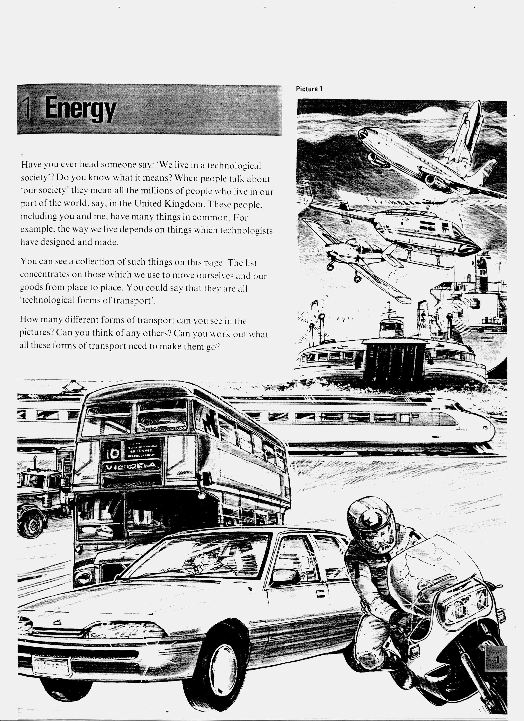

Appendix 2
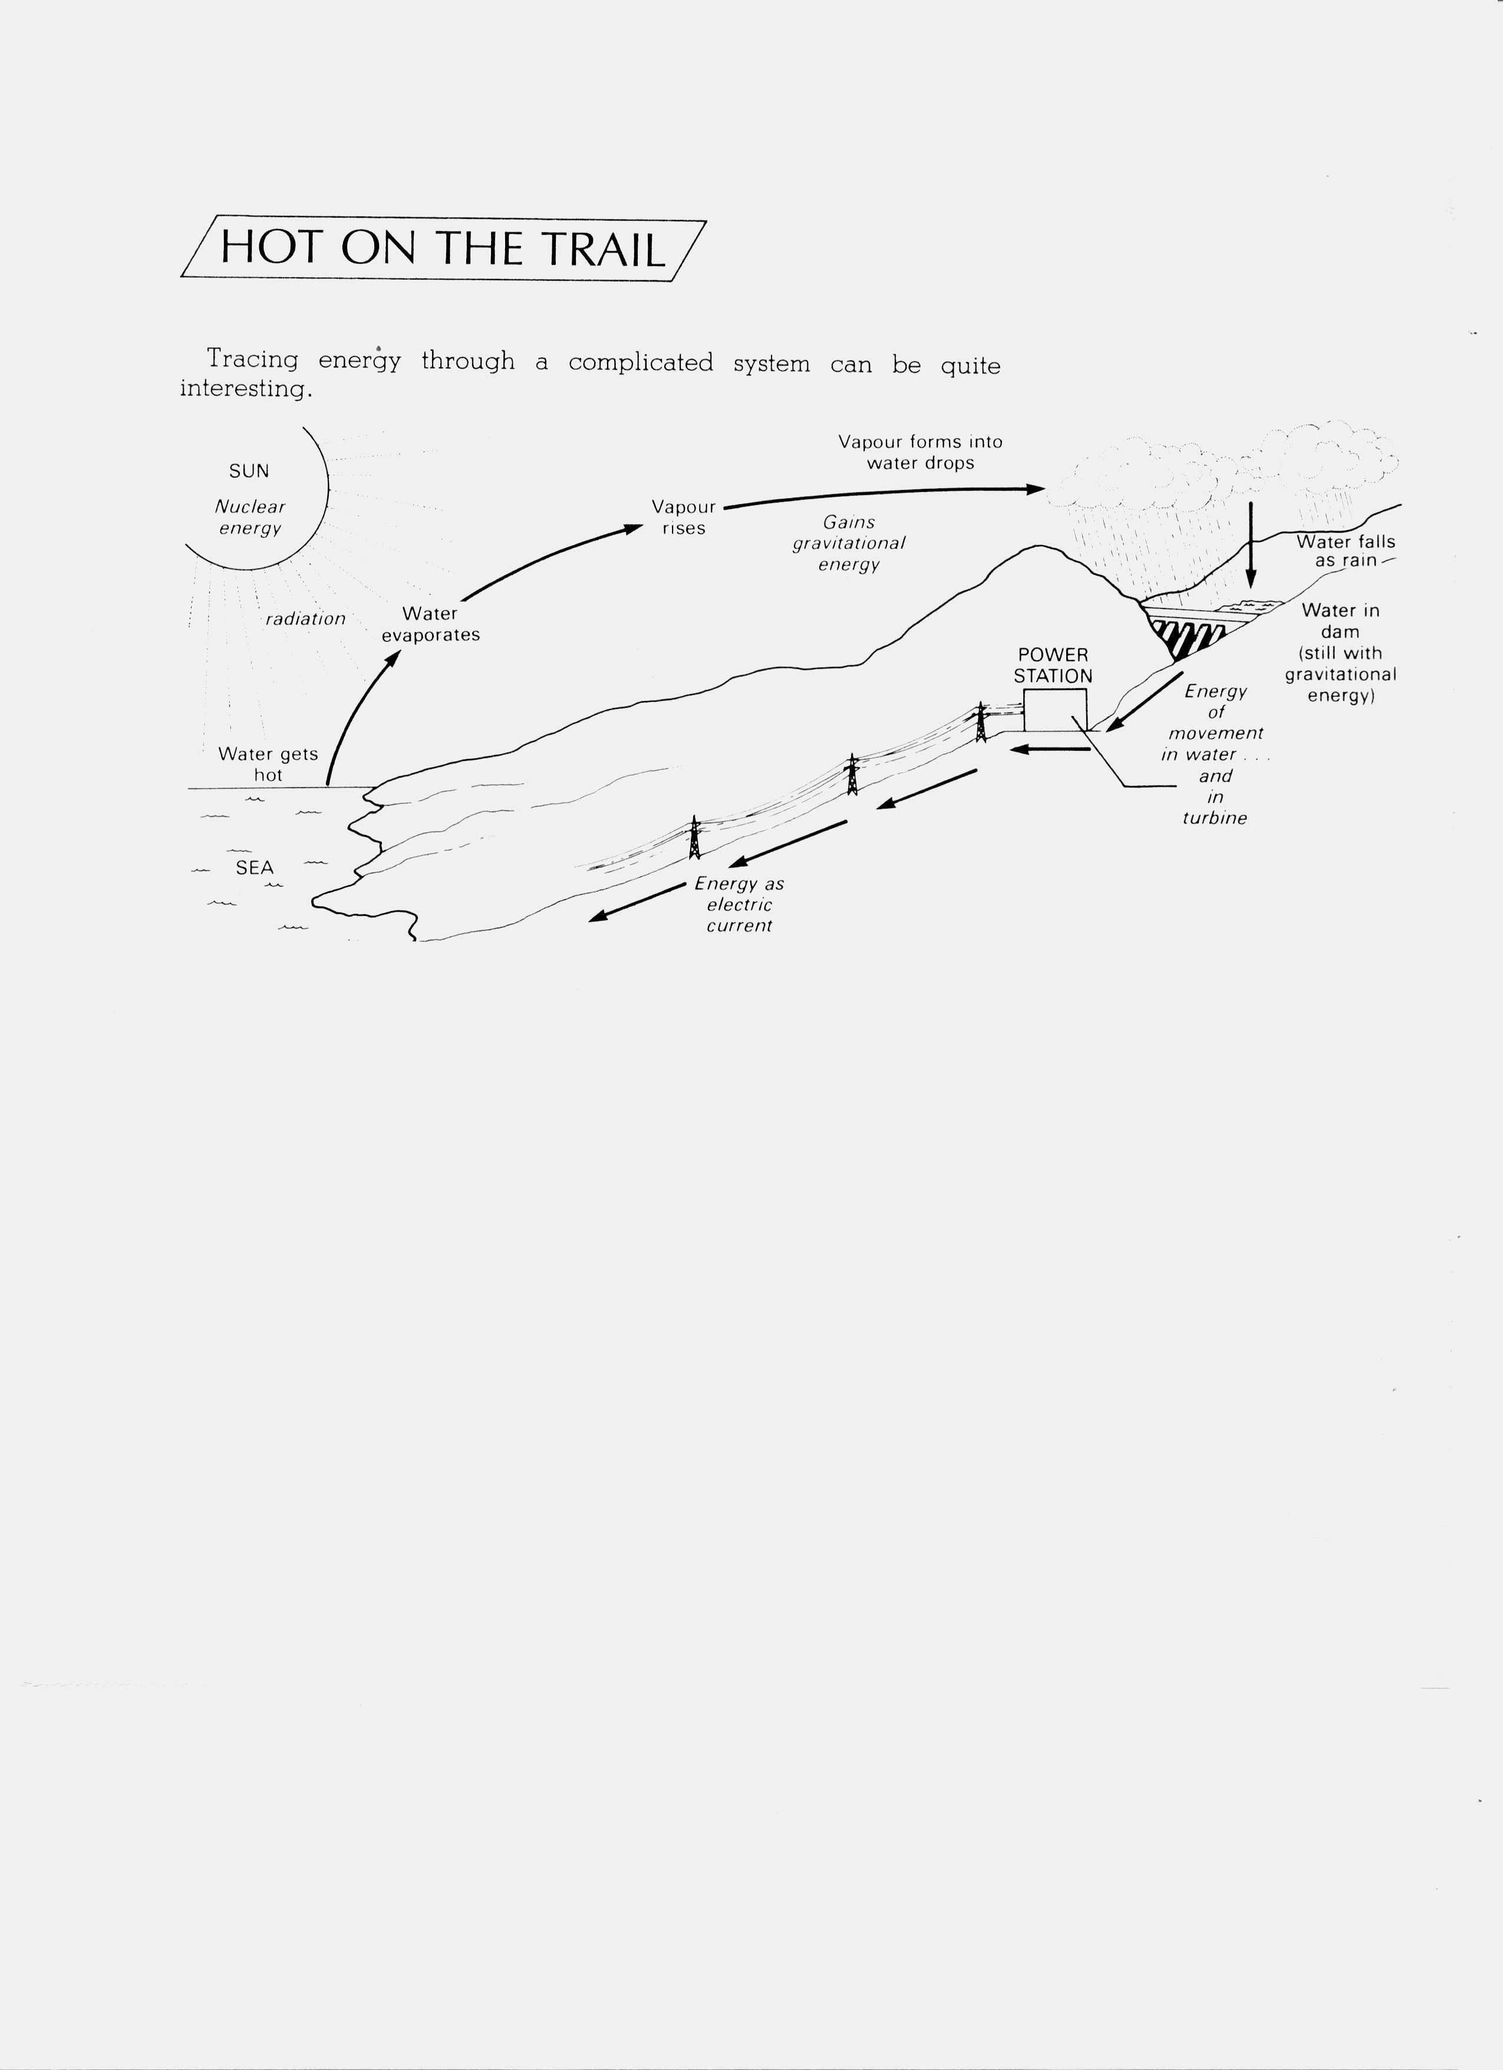

Appendix 3
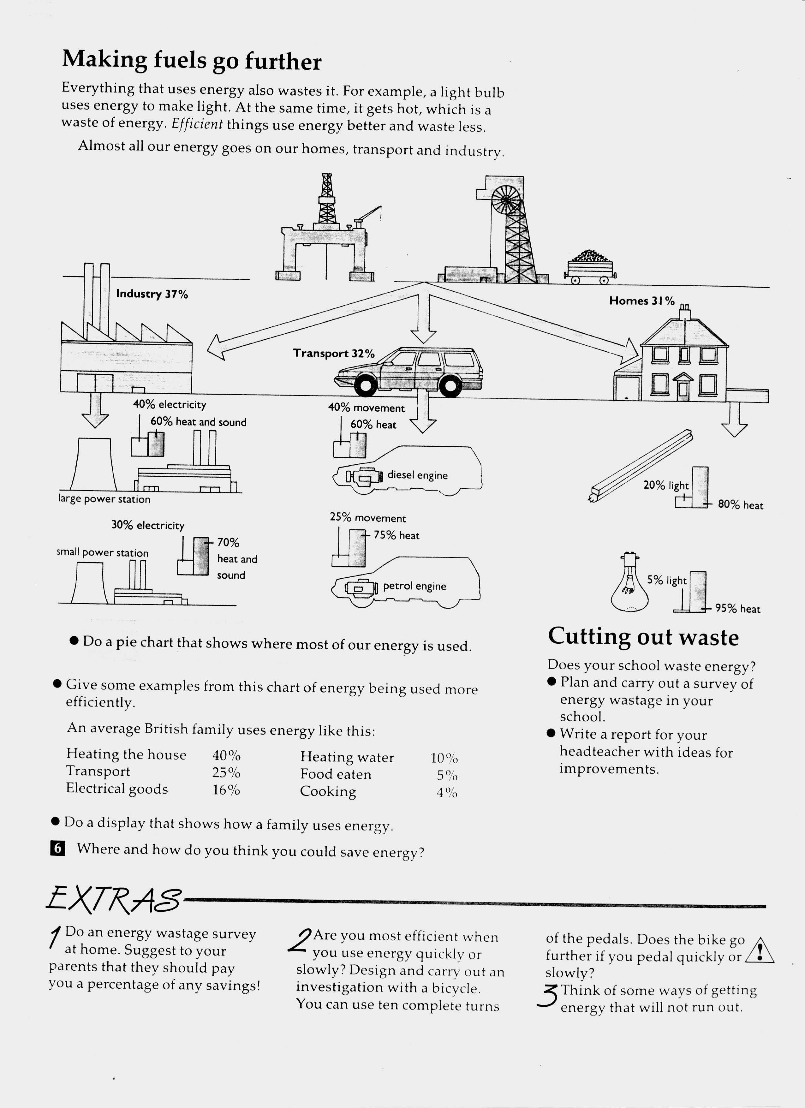
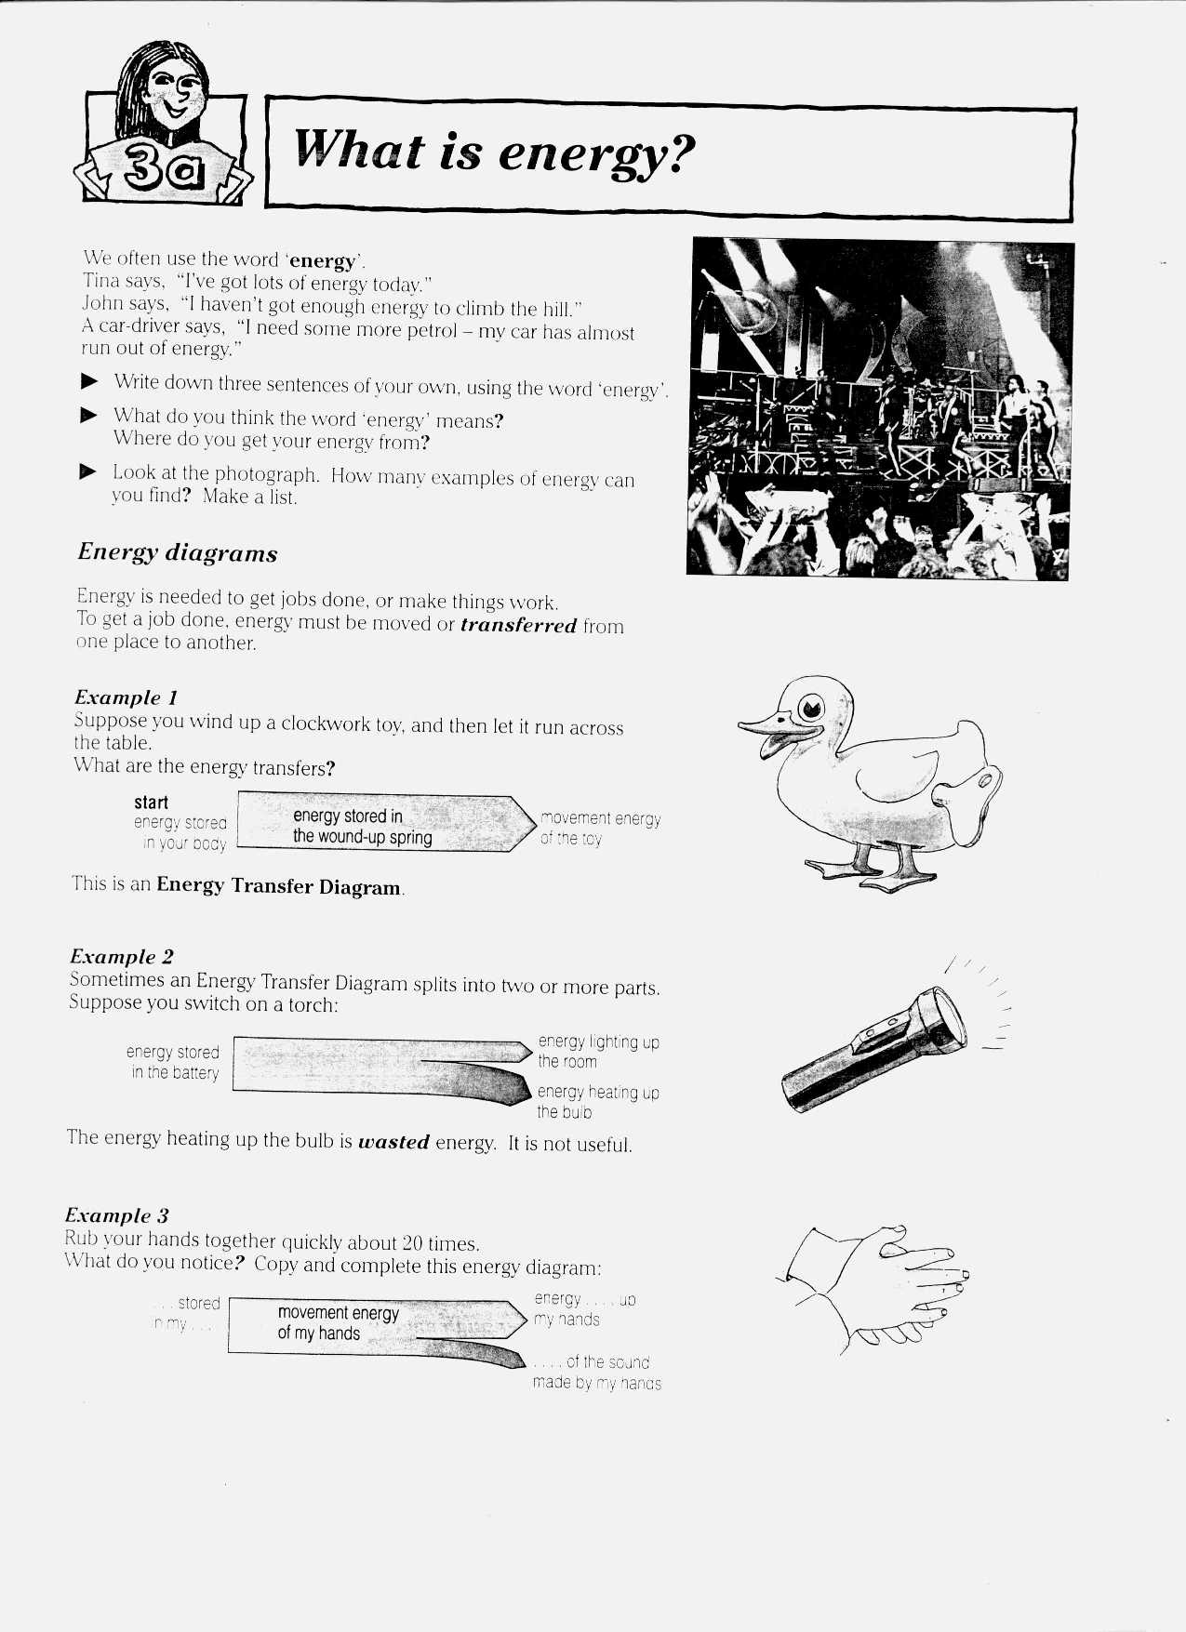
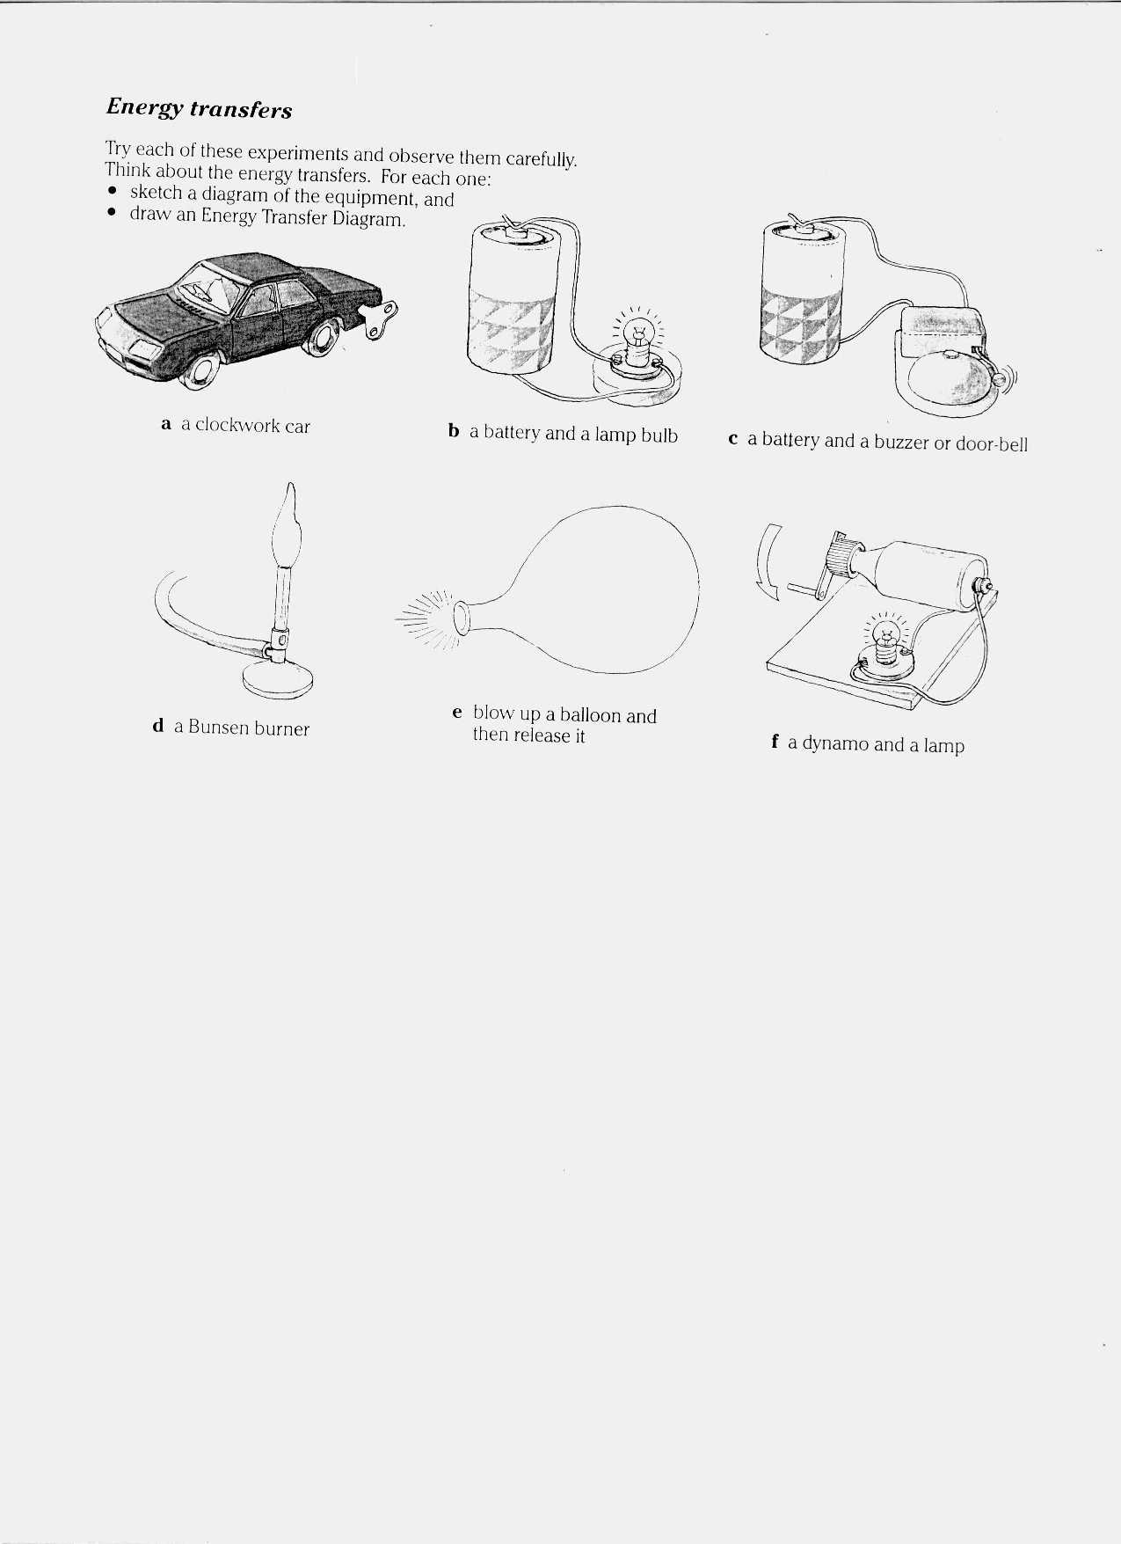
Appendix 5
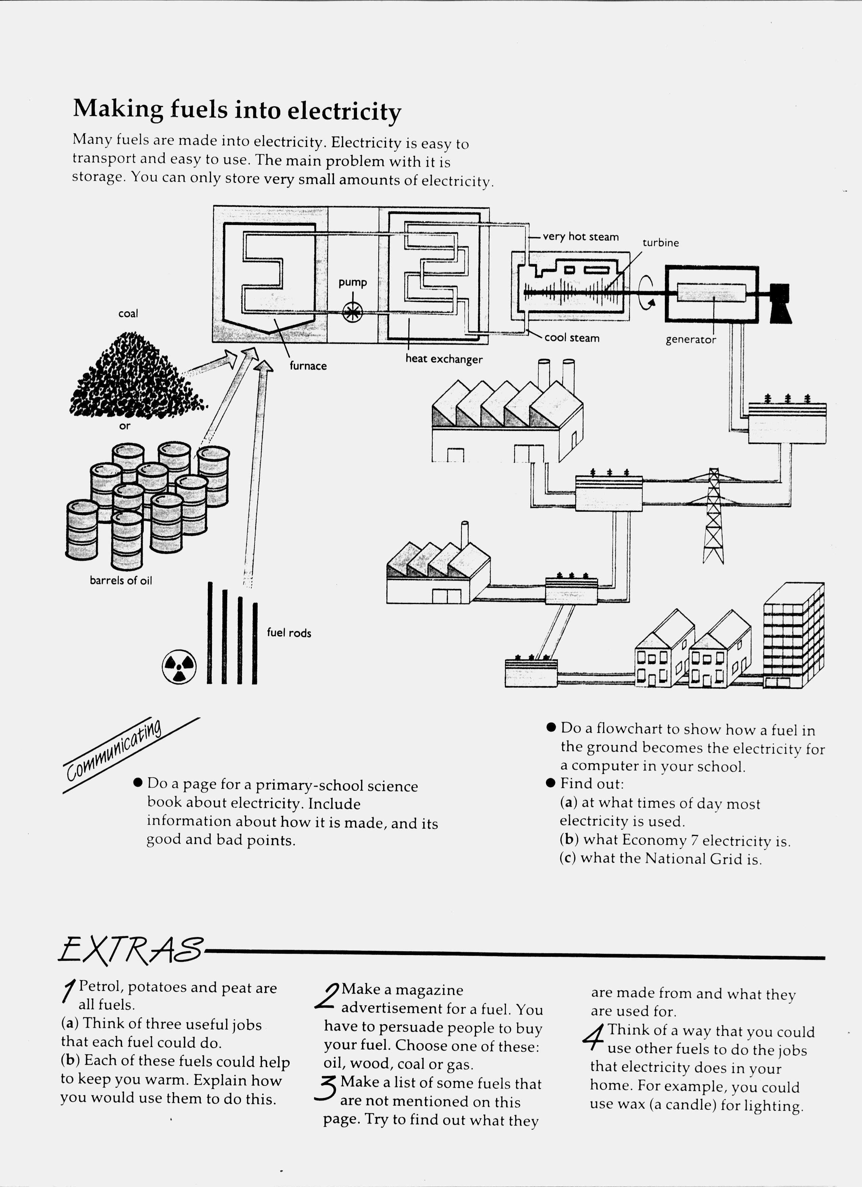
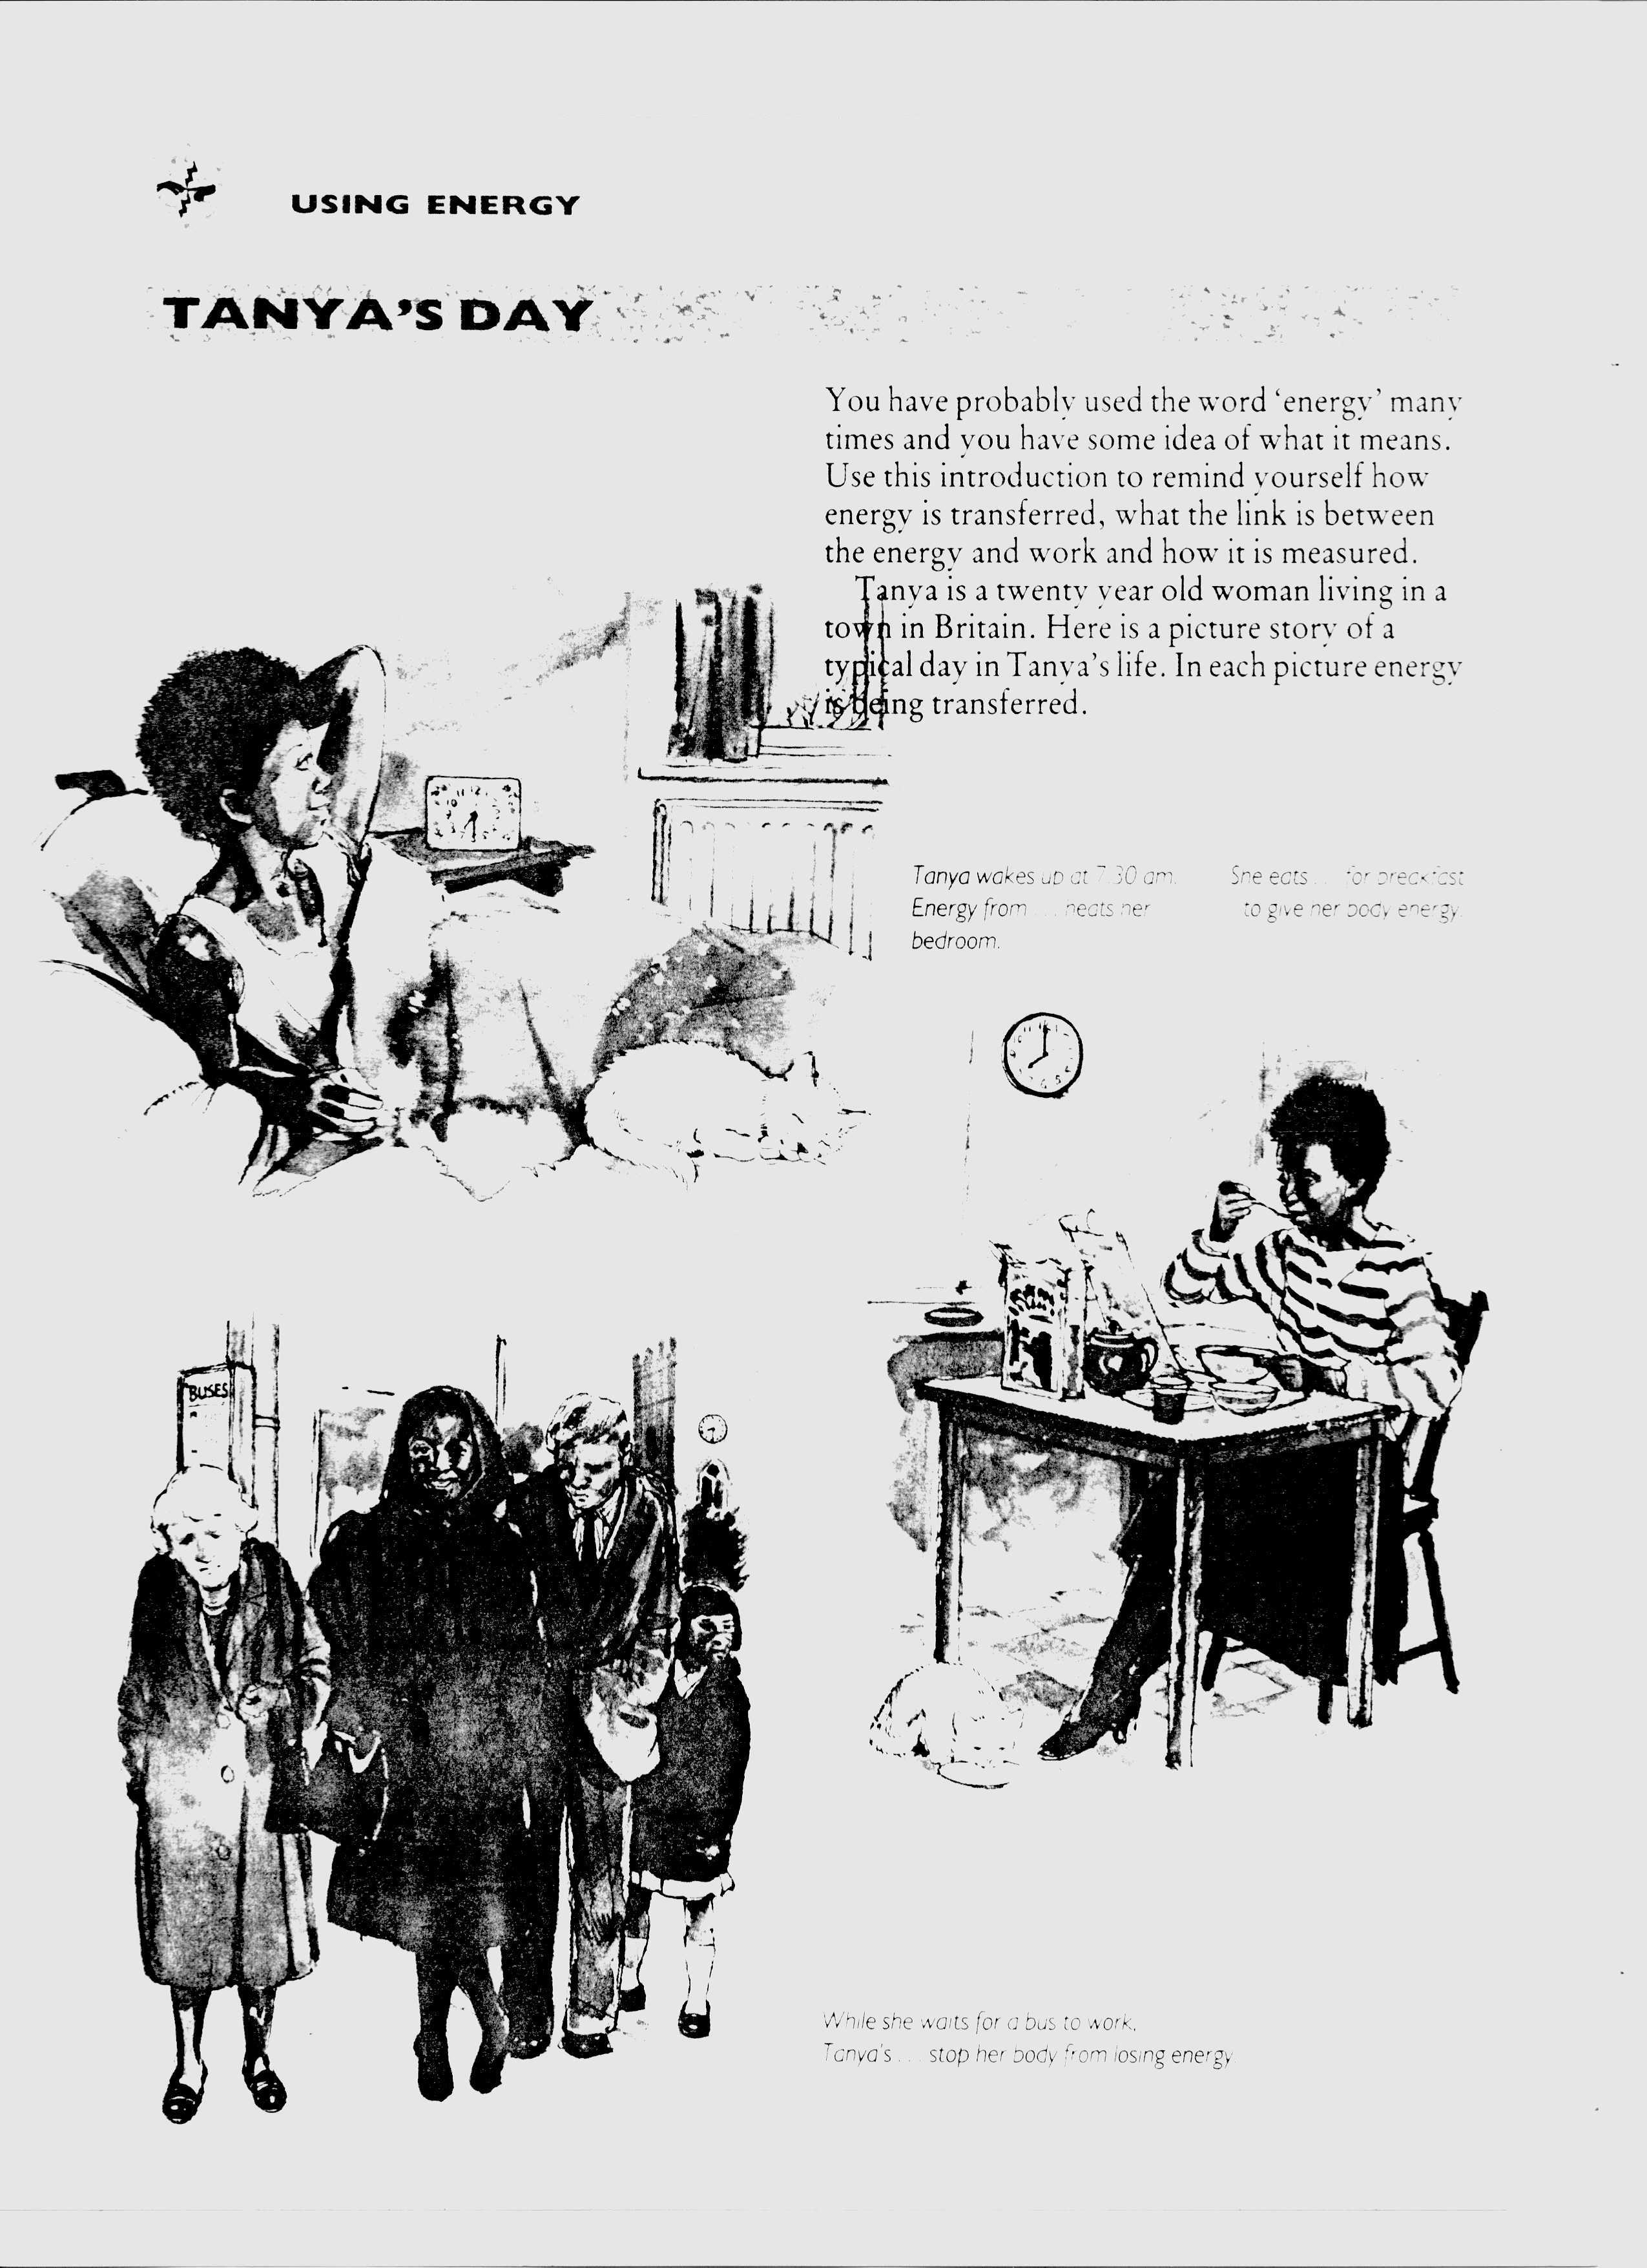
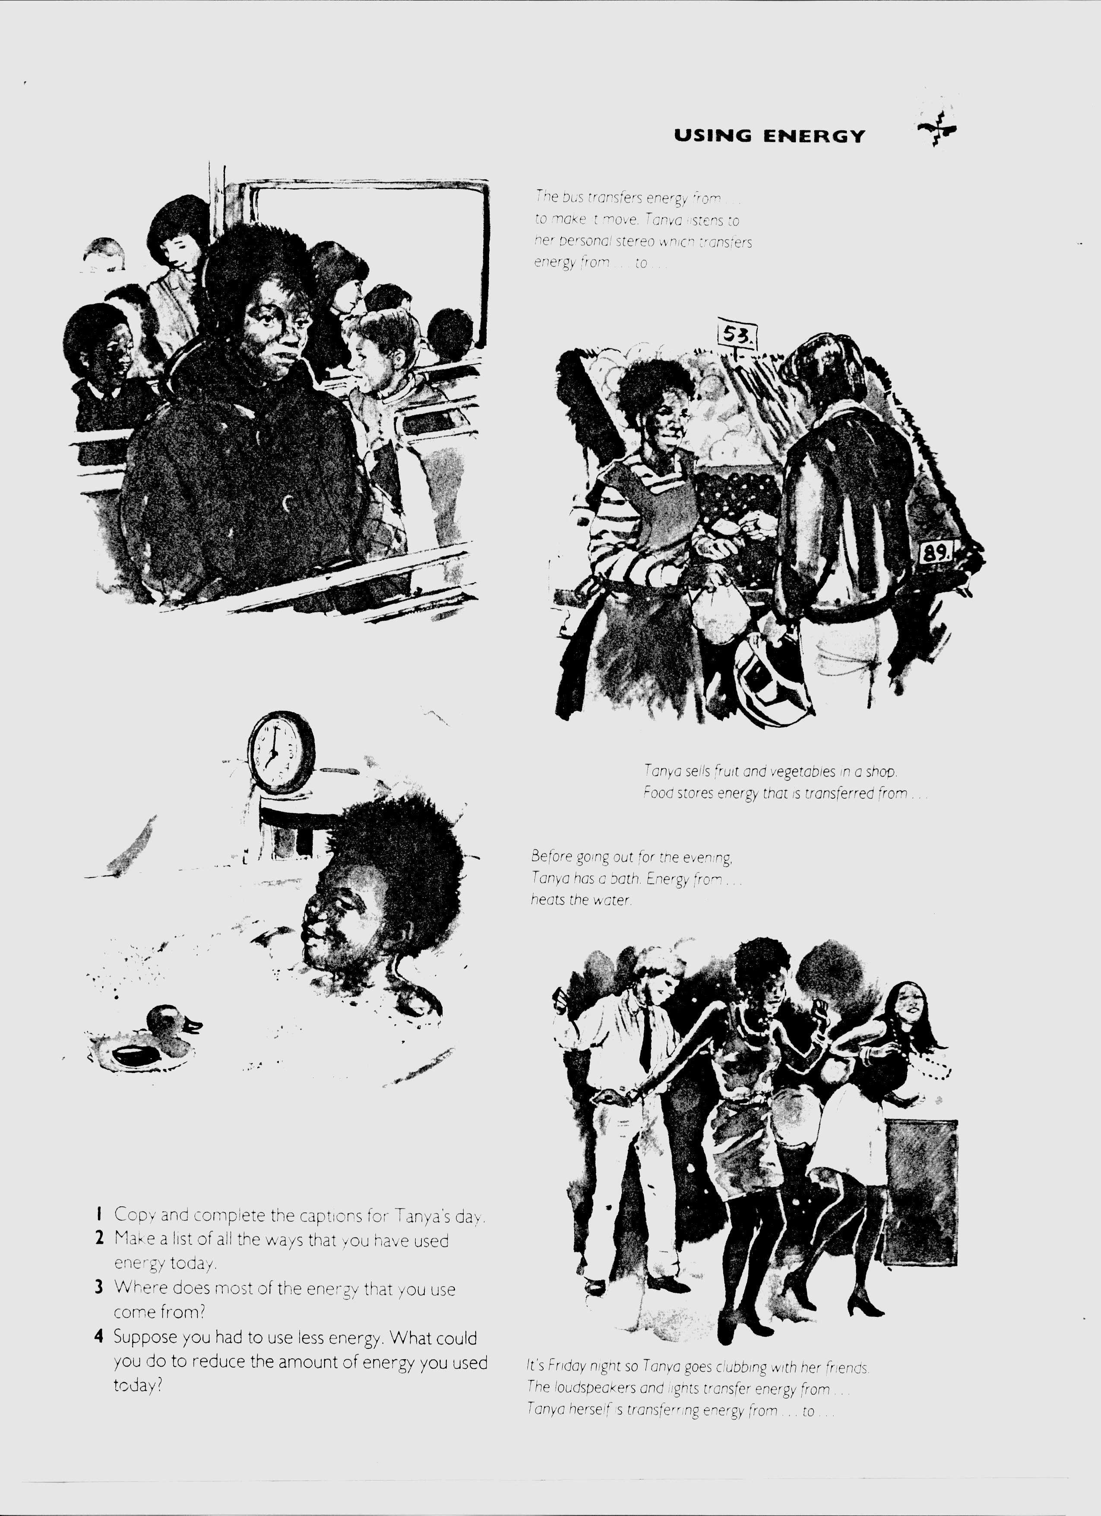
PICTURE A: What is energy?
The following questions are about the set of pictures ‘What is energy?’ named Picture A in the booklet. Please turn to Picture A - pages 1 and 2 in the ‘Booklet with sets of pictures’.
1. Would you expect students to have any difficulties with the set of pictures in the double-page-spread of Picture A? If yes, please explain the difficulties you expect them to have and the reasons why you expect these difficulties.
----------------------------------------------------------------------------------------------------------------------------------------------------------------------------------------------------------------------------------------------------------------------------------------------------------------------------------------------------------------------------------------------------------------------------------------------------------------------------------------------------------------------------------------------------------------------------------------------------------------------------------------------------------------------------------------------
2. If you had to present this set of pictures to your students, would you change any of its features? Would you add anything?
----------------------------------------------------------------------------------------------------------------------------------------------------------------------------------------------------------------------------------------------------------------------------------------------------------------------------------------------------------------------------------------------------------------------------------------------------------------------------------------------------------------------------------------------------------------------------------------------------------------------------------------------------------------------------------------------
3. Some Year 8 and Year 9 pupils were asked to draw Energy Transfer Diagrams for ‘a clockwork car’ and ‘a dynamo and a lamp’ (see activity on page 2) based on the section ‘Energy diagrams’ on page 1. Would you expect pupils to have any difficulties in doing this task? If yes, please explain the difficulties you expect them to have and the reasons why you expect these difficulties.
----------------------------------------------------------------------------------------------------------------------------------------------------------------------------------------------------------------------------------------------------------------------------------------------------------------------------------------------------------------------------------------------------------------------------------------------------------------------------------------------------------------------------------------------------------------------------------------------------------------------------------------------------------------------------------------------
4. How would you help them to understand how to do this task?
--------------------------------------------------------------------------------------------------------------------------------------------------------------------------------------------------------------------------------------------------------------------------------------------------------------------------------------------------------------------------------------------------------------------------------------------------------------------------------------------------------------------------------------------------------
PICTURE B: Energy
The following questions are about the picture ‘Energy’ named Picture B in the booklet. Please turn to Picture B - page 3 in the ‘Booklet with sets of pictures’.
1. Would you expect students to have any difficulties with Picture B? If yes, please explain the difficulties you expect them to have and the reasons why you expect these difficulties.
----------------------------------------------------------------------------------------------------------------------------------------------------------------------------------------------------------------------------------------------------------------------------------------------------------------------------------------------------------------------------------------------------------------------------------------------------------------------------------------------------------------------------------------------------------------------------------------------------------------------------------------------------------------------------------------------
2. If you had to present this picture to your students, would you change any of its features? Would you add anything?
----------------------------------------------------------------------------------------------------------------------------------------------------------------------------------------------------------------------------------------------------------------------------------------------------------------------------------------------------------------------------------------------------------------------------------------------------------------------------------------------------------------------------------------------------------------------------------------------------------------------------------------------------------------------------------------------

PICTURE C: Making fuels into electricity
The following questions are about the picture ‘Making fuels into electricity’ named Picture C in the booklet. Please turn to Picture C - page 4 in the ‘Booklet with sets of pictures’.
1. Would you expect students to have any difficulties with Picture C? If yes, please explain the difficulties you expect them to have and the reasons why you expect these difficulties.
----------------------------------------------------------------------------------------------------------------------------------------------------------------------------------------------------------------------------------------------------------------------------------------------------------------------------------------------------------------------------------------------------------------------------------------------------------------------------------------------------------------------------------------------------------------------------------------------------------------------------------------------------------------------------------------------
2. If you had to present this picture to your students, would you change any of its features? Would you add anything?
----------------------------------------------------------------------------------------------------------------------------------------------------------------------------------------------------------------------------------------------------------------------------------------------------------------------------------------------------------------------------------------------------------------------------------------------------------------------------------------------------------------------------------------------------------------------------------------------------------------------------------------------------------------------------------------------
PICTURE D: TANYA’S DAY
The following questions are about the set of pictures ‘Tanya’s day’ named Picture D in the booklet. Please turn to Picture D - pages 5 and 6 in the ‘Booklet with sets of pictures’.
1. Would you expect students to have any difficulties with the set of pictures in the double-page-spread of Picture D? If yes, please explain the difficulties you expect them to have and the reasons why you expect these difficulties.
----------------------------------------------------------------------------------------------------------------------------------------------------------------------------------------------------------------------------------------------------------------------------------------------------------------------------------------------------------------------------------------------------------------------------------------------------------------------------------------------------------------------------------------------------------------------------------------------------------------------------------------------------------------------------------------------
2. If you had to present this set of pictures to your students, would you change any of its features? Would you add anything?
----------------------------------------------------------------------------------------------------------------------------------------------------------------------------------------------------------------------------------------------------------------------------------------------------------------------------------------------------------------------------------------------------------------------------------------------------------------------------------------------------------------------------------------------------------------------------------------------------------------------------------------------------------------------------------------------
3. Some Year 8 and Year 9 pupils were asked to complete the captions for Tanya’s day by filling-in the spaces with the appropriate words (see question 1 on page 6). Would you expect pupils to have any difficulties in doing this task? If yes, please explain the difficulties you expect them to have and the reasons why you expect these difficulties.
----------------------------------------------------------------------------------------------------------------------------------------------------------------------------------------------------------------------------------------------------------------------------------------------------------------------------------------------------------------------------------------------------------------------------------------------------------------------------------------------------------------------------------------------------------------------------------------------------------------------------------------------------------------------------------------------
4. How would you help them to understand how to do this task?
----------------------------------------------------------------------------------------------------------------------------------------------------------------------------------------------------------------------------------------------------------------------------------------------------------------------------------------------------------------------------------------------------------------------------------------------------------------------------------------------------------------------------------------------------------------------------------------------------------------------------------------------------------------------------------------------
PICTURE E: Making fuels go further
The following questions are about the picture ‘Making fuels go further?’ named Picture E in the booklet. Please turn to Picture E - page 7 in the ‘Booklet with sets of pictures’.
1. Would you expect students to have any difficulties with Picture E? If yes, please explain the difficulties you expect them to have and the reasons why you expect these difficulties.
----------------------------------------------------------------------------------------------------------------------------------------------------------------------------------------------------------------------------------------------------------------------------------------------------------------------------------------------------------------------------------------------------------------------------------------------------------------------------------------------------------------------------------------------------------------------------------------------------------------------------------------------------------------------------------------------
2. If you had to present this picture to your students, would you change any of its features? Would you add anything?
----------------------------------------------------------------------------------------------------------------------------------------------------------------------------------------------------------------------------------------------------------------------------------------------------------------------------------------------------------------------------------------------------------------------------------------------------------------------------------------------------------------------------------------------------------------------------------------------------------------------------------------------------------------------------------------------
3. Some Year 8 and Year 9 pupils were asked to use the picture to sketch a pie chart that shows where most of our energy is used (see activity on page 7). Would you expect pupils to have any difficulties in doing this task? If yes, please explain the difficulties you expect them to have and the reasons why you expect these difficulties.
----------------------------------------------------------------------------------------------------------------------------------------------------------------------------------------------------------------------------------------------------------------------------------------------------------------------------------------------------------------------------------------------------------------------------------------------------------------------------------------------------------------------------------------------------------------------------------------------------------------------------------------------------------------------------------------------
4. How would you help them to understand how to do this task?
----------------------------------------------------------------------------------------------------------------------------------------------------------------------------------------------------------------------------------------------------------------------------------------------------------------------------------------------------------------------------------------------------------------------------------------------------------------------------------------------------------------------------------------------------------------------------------------------------------------------------------------------------------------------------------------------
PICTURE F: HOT ON THE TRAIL
The following questions are about the picture ‘Hot on the trail’ named Picture F in the booklet. Please turn to Picture F - page 8 in the ‘Booklet with sets of pictures’.
1. Would you expect students to have any difficulties with Picture F? If yes, please explain the difficulties you expect them to have and the reasons why you expect these difficulties.
----------------------------------------------------------------------------------------------------------------------------------------------------------------------------------------------------------------------------------------------------------------------------------------------------------------------------------------------------------------------------------------------------------------------------------------------------------------------------------------------------------------------------------------------------------------------------------------------------------------------------------------------------------------------------------------------
2. If you had to present this picture to your students, would you change any of its features? Would you add anything?
----------------------------------------------------------------------------------------------------------------------------------------------------------------------------------------------------------------------------------------------------------------------------------------------------------------------------------------------------------------------------------------------------------------------------------------------------------------------------------------------------------------------------------------------------------------------------------------------------------------------------------------------------------------------------------------------
PICTURE A: What is energy?
The following questions are about the set of pictures ‘What is energy?’ named Picture A in the booklet. Please turn to Picture A - pages 1 and 2 in the ‘Booklet with sets of pictures’.
Here are some pupils’ interpretations of this set of pictures.
1. “The pictures are showing the ways that energy is used, and how the energy is used - is it used by wounding it up or with a battery.”
Do you think this is a good answer or does it reveal difficulties? _ _ _ _ _ _ _ _ _ _ _ _ _ _ _
If you think it reveals difficulties, please explain:
a. what you think these are;

b. in what way(s) the images might have contrbuted to these difficulties;

c. any other possible reasons for these difficulties.

3. “The story behind the picture is all the objects are using energy. They all have or give different energy.”
Do you think this is a good answer or does it reveal difficulties? _ _ _ _ _ _ _ _ _ _ _ _ _ _ _
If you think it reveals difficulties, please explain:
a. what you think these are;

b. in what way(s) the images might have contributed to these difficulties;

c. any other possible reasons for these difficulties.

3. “All of these pictures form energy to make them move or work.”
Do you think this is a good answer or does it reveal difficulties? _ _ _ _ _ _ _ _ _ _ _ _ _ _ _
If you think it reveals difficulties, please explain:
a. what you think these are;

b. in what way(s) the images might have contributed to these difficulties;

c. any other possible reasons for these difficulties.
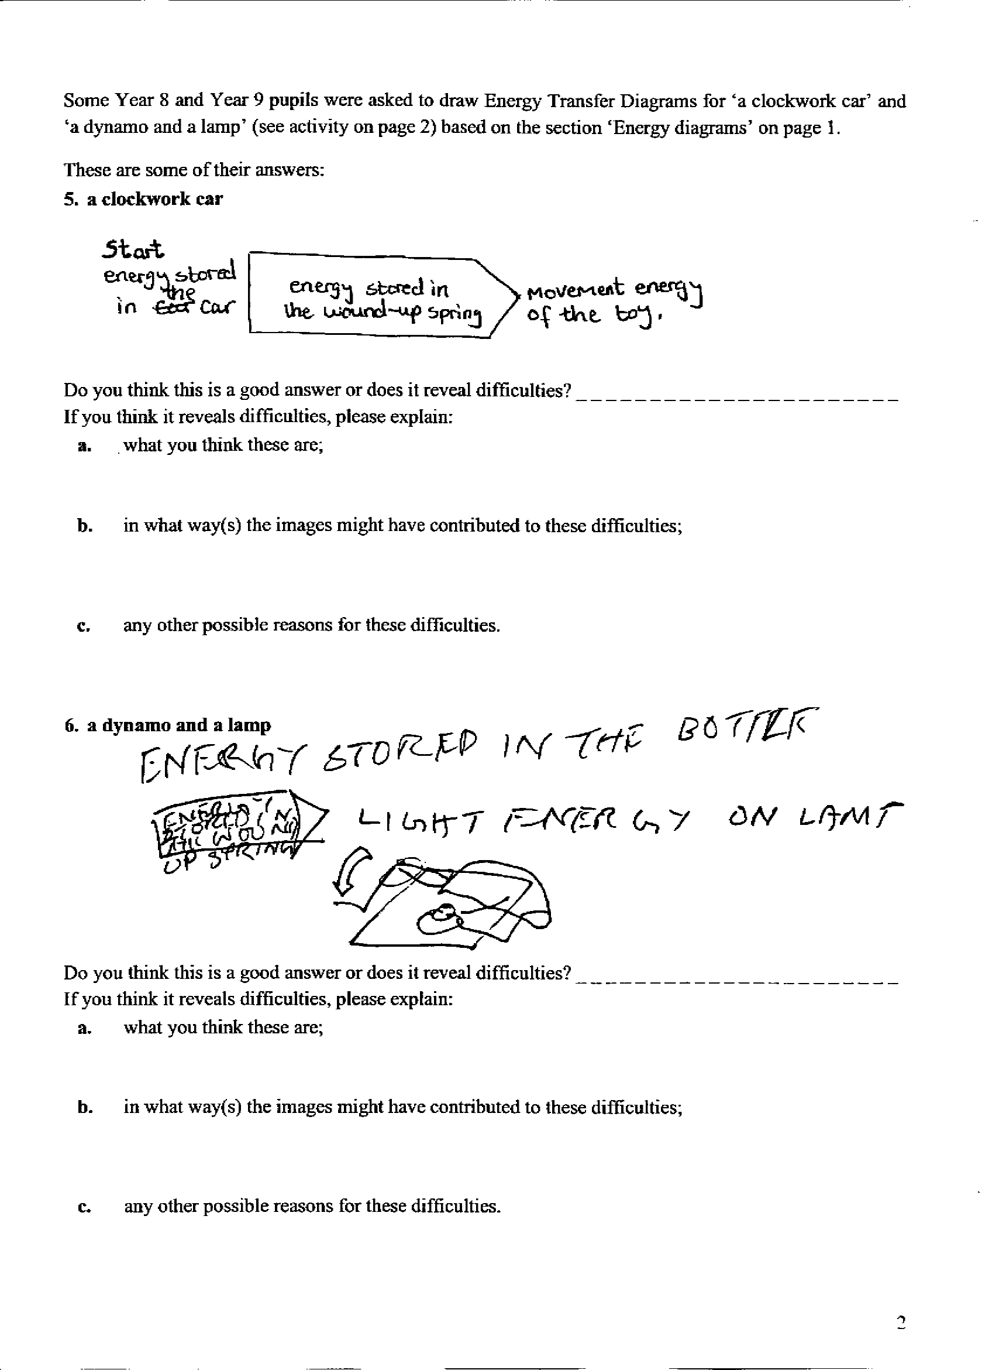

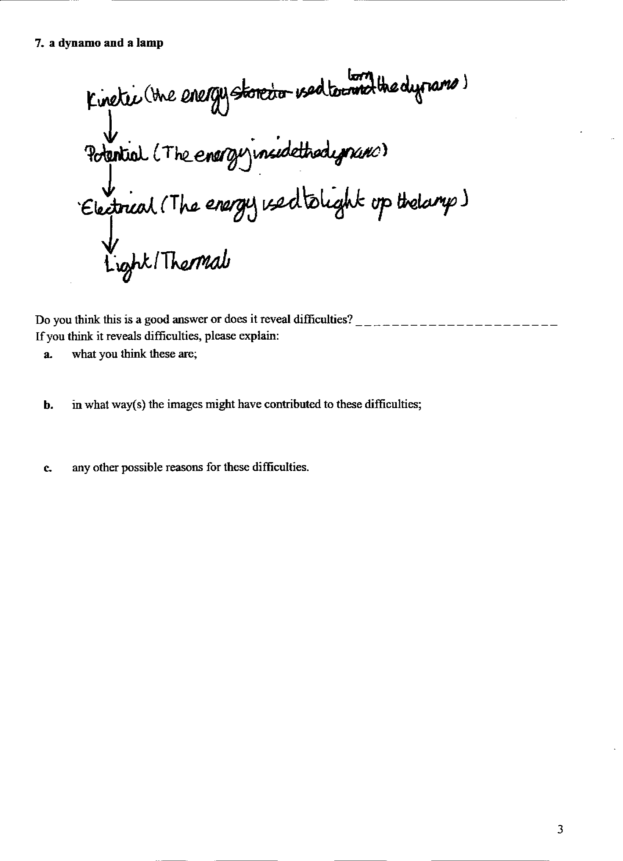

PICTURE B: Energy
The following questions are about the picture ‘Energy’ named Picture B in the booklet. Please turn to Picture B - page 3 in the ‘Booklet with sets of pictures’.
Here are some pupils’ interpretations of this picture.
1. “This picture tells you that transport is very hectic and busy. It shows that things need energy.”

Do you think this is a good answer or does it reveal difficulties? _ _ _ _ _ _ _ _ _ _ _ _ _
If you think it reveals difficulties, please explain:
a. what you think these are;

b. in what way(s) the image might have contributed to these difficulties;

c. any other possible reasons for these difficulties.

2. “The story behind this picture is different types of transport and how it’s developed over the years.”
Do you think this is a good answer or does it reveal difficulties? _ _ _ _ _ _ _ _ _ _ _ _ _ _ _
If you think it reveals difficulties, please explain:
a. what you think these are;

b. in what way(s) the image might have contributed to these difficulties;

c. any other possible reasons for these difficulties.

3. “Behind all of the pictures is that they all form energy in different ways; some have faster and slower energy than others.”
Do you think this is a good answer or does it reveal difficulties? _ _ _ _ _ _ _ _ _ _ _ _ _ _ _
If you think it reveals difficulties, please explain:
a. what you think these are;

b. in what way(s) the image might have contributed to these difficulties;

c. any other possible reasons for these difficulties.

PICTURE C: Making fuels into electricity
The following questions are about the picture ‘Making fuels into electricity’ named Picture C in the booklet. Please turn to Picture C - page 4 in the ‘Booklet with sets of pictures’.
Here are some pupils’ interpretations of this picture.
1. “The story is you start with two or more fuels and end with electricity. It is like a chemical reaction.”
Do you think this is a good answer or does it reveal difficulties? _ _ _ _ _ _ _ _ _ _ _ _ _ _ _
If you think it reveals difficulties, please explain:
a. what you think these are;

b. in what way(s) the image might have contributed to these difficulties;

c. any other possible reasons for these difficulties.

2. “In this picture I am looking at how far the electric is travelling and which direction it’s travelling.”
Do you think this is a good answer or does it reveal difficulties? _ _ _ _ _ _ _ _ _ _ _ _ _ _ _
If you think it reveals difficulties, please explain:
a. what you think these are;

b. in what way(s) the image might have contributed to these difficulties;

c. any other possible reasons for these difficulties.

3. “It shows the energy sources are heated, exchanged and then cooled. The steam turns the generator. It goes to the pylons which passes it to a factory then to a smaller factory, then to the houses and flats.”
Do you think this is a good answer or does it reveal difficulties? _ _ _ _ _ _ _ _ _ _ _ _ _ _ _
If you think it reveals difficulties, please explain:
a. what you think these are;

b. in what way(s) the image might have contributed to these difficulties;

c. any other possible reasons for these difficulties.
PICTURE D: TANYA’S DAY
The following questions are about the set of pictures ‘Tanya’s day’ named Picture D in the booklet. Please turn to Picture D - pages 5 and 6 in the ‘Booklet with sets of pictures’.
Here are some pupils’ interpretations of this set of pictures.
1. “These pictures tell the story of a girl who wakes up, has breakfast, waiting for a bus, on the bus, sells fruit and veg, taking a bath and at a disco. These are all showing how you loose and gain heat.”
Do you think this is a good answer or does it reveal difficulties? _ _ _ _ _ _ _ _ _ _ _ _ _ _ _
If you think it reveals difficulties, please explain:
a. what you think these are;

b. in what way(s) the images might have contributed to these difficulties;

c. any other possible reasons for these difficulties.

2. “The story behind these pictures are that people use energy in everyday lives. People need energy to do things.”
Do you think this is a good answer or does it reveal difficulties? _ _ _ _ _ _ _ _ _ _ _ _ _ _ _
If you think it reveals difficulties, please explain:
a. what you think these are;

b. in what way(s) the images might have contributed to these difficulties;

c. any other possible reasons for these difficulties.

3. “The picture tells the story of a day in Tanya’s life.”
Do you think this is a good answer or does it reveal difficulties? _ _ _ _ _ _ _ _ _ _ _ _ _ _ _
If you think it reveals difficulties, please explain:
a. what you think these are;

b. in what way(s) the images might have contributed to these difficulties;

c. any other possible reasons for these difficulties.

PICTURE E: Making fuels go further
The following questions are about the picture ‘Making fuels go further?’ named Picture E in the booklet. Please turn to Picture E - page 7 in the ‘Booklet with sets of pictures’.
Here are some pupils’ interpretations of this picture.
1. “The story behind the picture is nuclear power stations and things like that produce energy which then goes to three main different places: industry, transport, homes. It then separates again and they are shown so much of the energy is wasted on heat and sound which is not needed.”
Do you think this is a good answer or does it reveal difficulties? _ _ _ _ _ _ _ _ _ _ _ _ _ _ _
If you think it reveals difficulties, please explain:
a. what you think these are;

b. in what way(s) the image might have contributed to these difficulties;

c. any other possible reasons for these difficulties.

2. “The story behind this picture relates to energy being wasted during the process of energy being made into a different form. The story also tries to tell the things that energy is used on.”
Do you think this is a good answer or does it reveal difficulties? _ _ _ _ _ _ _ _ _ _ _ _ _ _ _
If you think it reveals difficulties, please explain:
a. what you think these are;

b. in what way(s) the image might have contributed to these difficulties;

c. any other possible reasons for these difficulties.

3. “The story behind this picture is that fuels start off at mines and gradually end up everywhere. Fuel is very important. By using fuel it is helpful but at the same time we waste important energy.”
Do you think this is a good answer or does it reveal difficulties? _ _ _ _ _ _ _ _ _ _ _ _ _ _ _
If you think it reveals difficulties, please explain:
a. what you think these are;

b. in what way(s) the image might have contributed to these difficulties;

c. any other possible reasons for these difficulties.
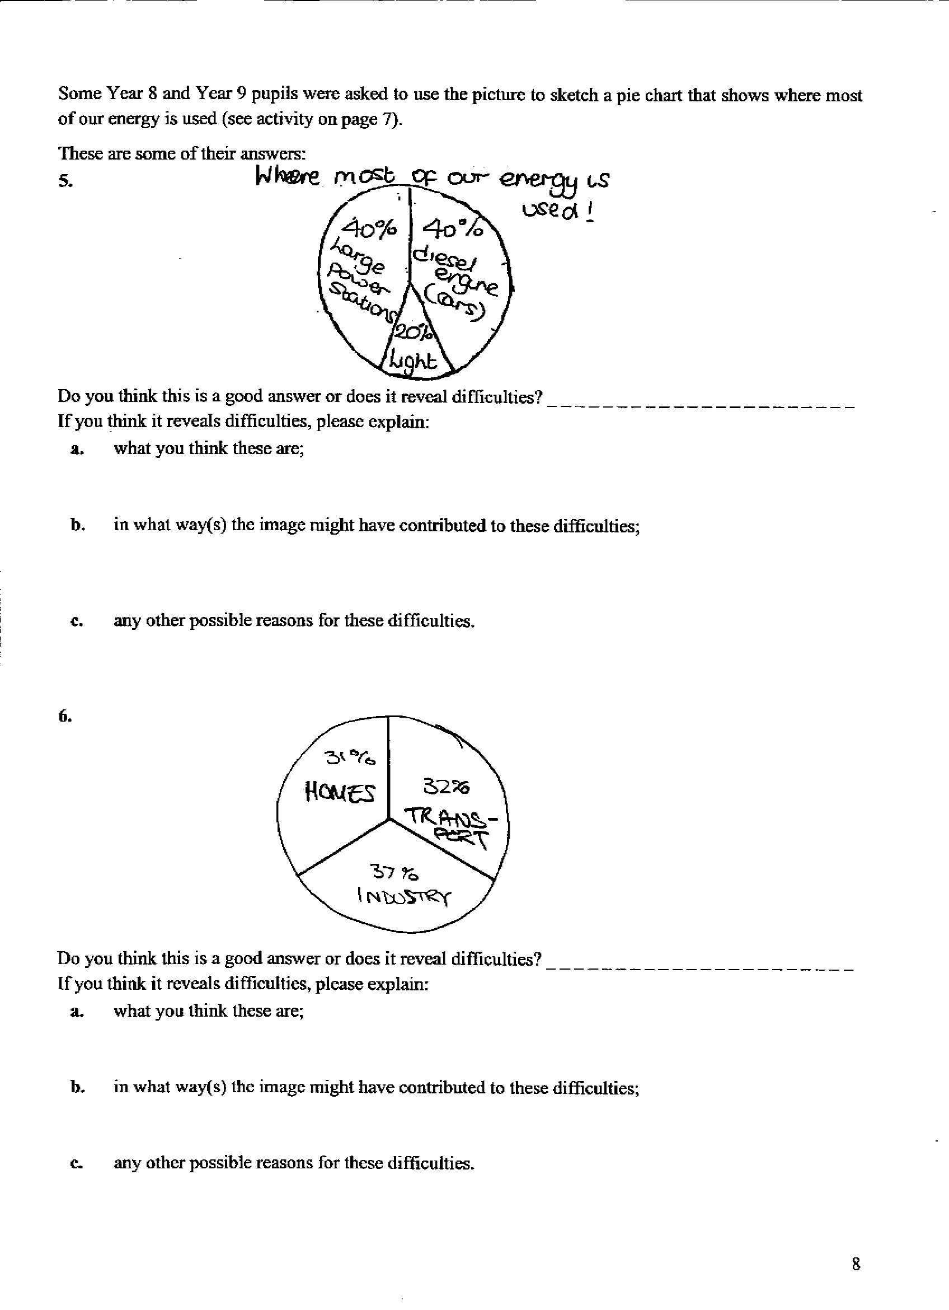

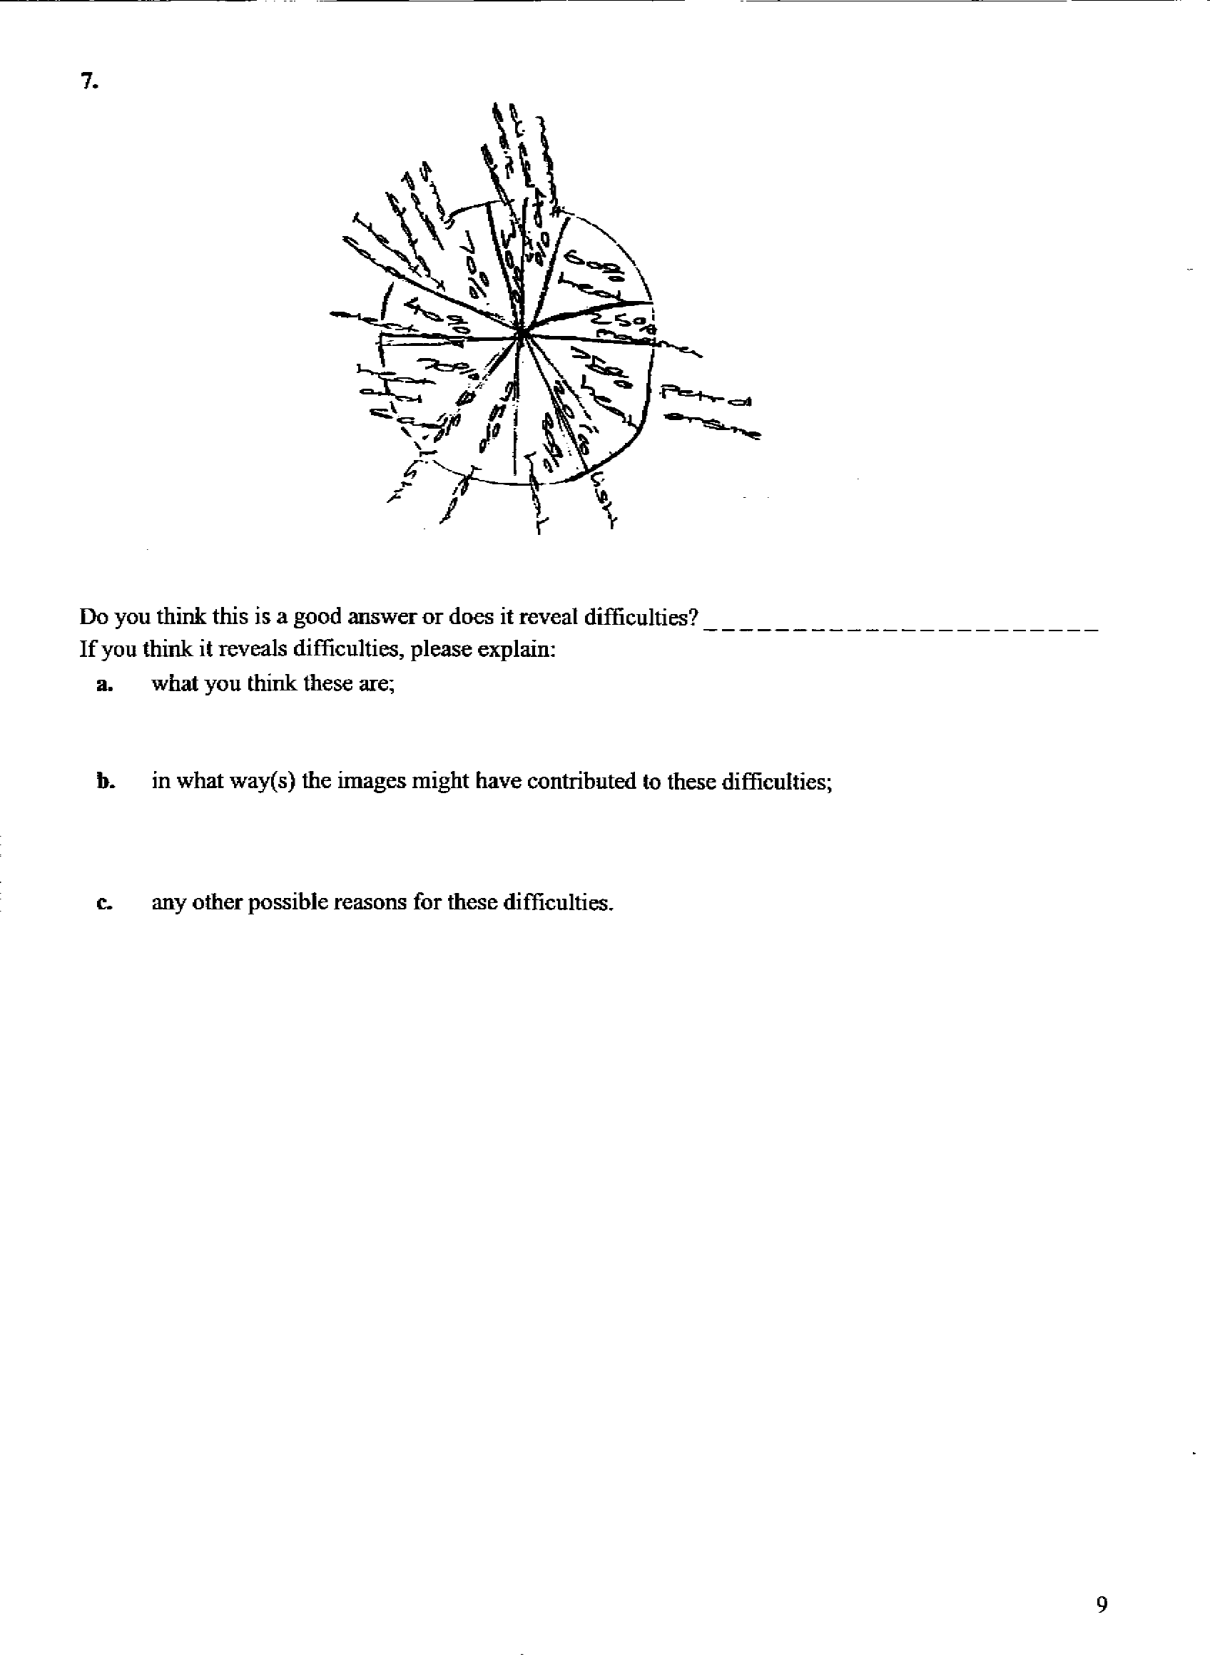

PICTURE F: HOT ON THE TRAIL
The following questions are about the picture ‘Hot on the trail’ named Picture F in the booklet. Please turn to Picture F - page 8 in the ‘Booklet with sets of pictures’.
Here are some pupils’ interpretations of this picture.
1. “The diagram is showing a water cycle. [...] The story behind this picture is that water can be very useful. It tells us that water is not wasted. It shows us how water takes each step. It shows us how it gets to the sea and how it becomes water vapour again.”
Do you think this is a good answer or does it reveal difficulties? _ _ _ _ _ _ _ _ _ _ _ _ _ _ _
If you think it reveals difficulties, please explain:
a. what you think these are;

b. in what way(s) the image might have contributed to these difficulties;

c. any other possible reasons for these difficulties.

2. “The story this picture seems to say: This energy chain will carry on as long as there is rain and Sun because there seem to be the two producers of the chain which is happening in the picture.”
Do you think this is a good answer or does it reveal difficulties? _ _ _ _ _ _ _ _ _ _ _ _ _ _ _
If you think it reveals difficulties, please explain:
a. what you think these are;

b. in what way(s) the image might have contributed to these difficulties;

c. any other possible reasons for these difficulties.

3. “It is trying to show how the water goes into a power station and how it is turned into electricity.”
Do you think this is a good answer or does it reveal difficulties? _ _ _ _ _ _ _ _ _ _ _ _ _ _ _
If you think it reveals difficulties, please explain:
a. what you think these are;

b. in what way(s) the image might have contributed to these difficulties;

c. any other possible reasons for these difficulties.

* The word ‘document’ is used in this report to refer to the combination of text and images on a page.

